Capability at SSP Adaptor level to allow max connections per user
Currently at SSP adaptor level there is configuration for Maximum Sessions like below. We are looking for configuration for Maximum Logins" per user. We have such configuration available at SI/SFG level but not available at adaptor level.
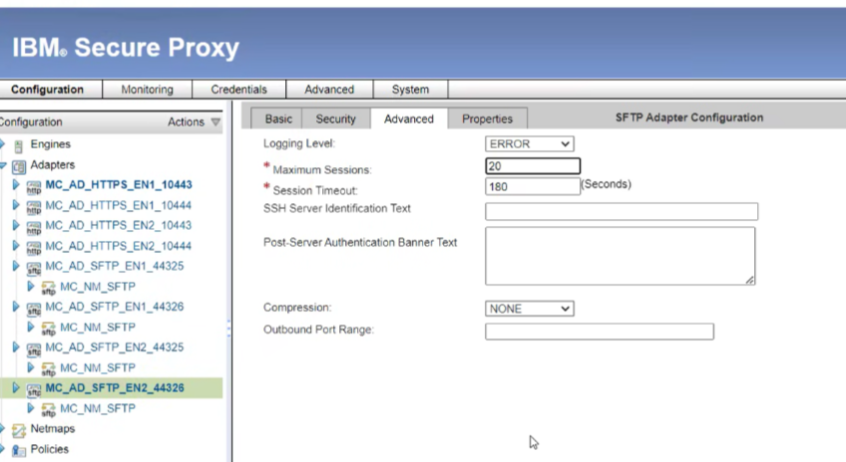
Please see below configurations for SI/SFG level.
