When migrating an EDI id to a Centre mailslot, it must be done one id at a time.
When clicking on the Mailbox Migration tool, if would be faster if multiple EDI ids could be migrated at the same time instead of just one.
For example, if multiple ids needed to be migrated for San Antonio Express to GXS, we first click on Mailbox Migration link.
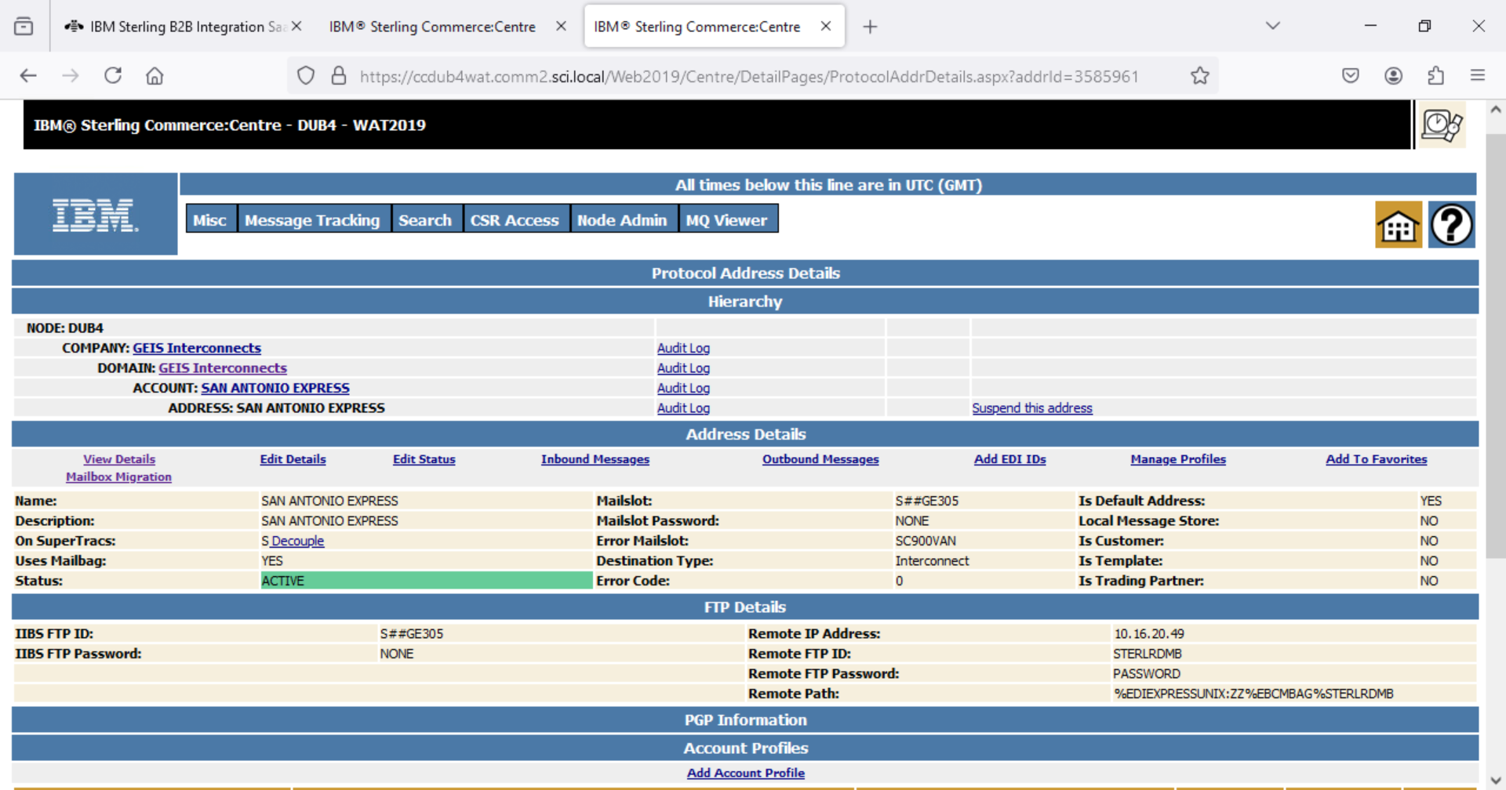

Only one EDI id at a time can be entered to be migrated to the Destination Mailslot.
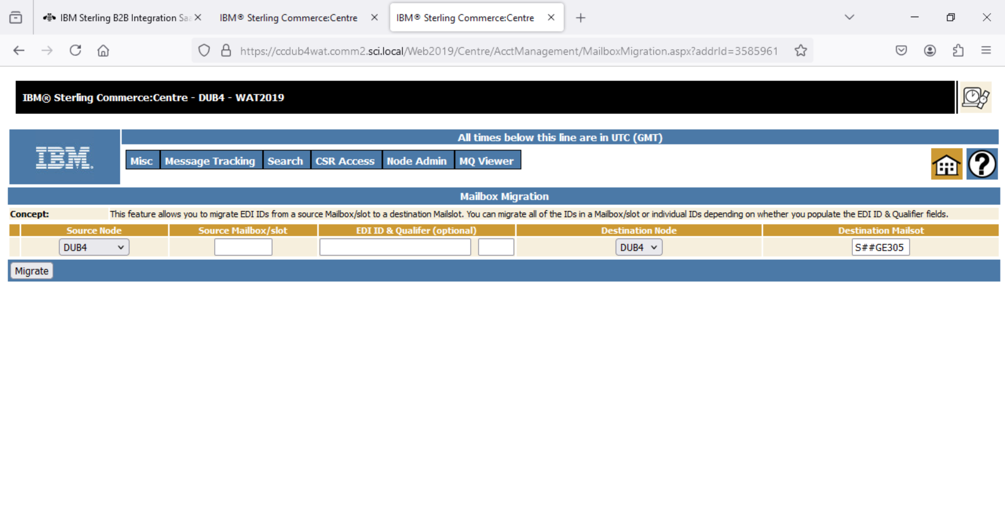
After entering the id to migrate and clicking on Migrate, the steps must be repeated until all ids have been migrated to the Destination Mailslot.
Choosing to do a Source Mailbox/slot migration is not an option as when a migration is done that way, it deletes the source mailbox/slot and that should not be done when migrating an EDI id from one VAN to another VAN – many times the customer does not want to migrate all their ids or the customer wants to migrate their ids over a period or the ids to be migrated are set up under multiple mailslots or VANs. Also, sometimes after migration has been completed the customer will ask to have the migration reversed due to unexpected issues at their new VAN. In these cases, we migrate the ids back to their former mailslot.
If multiple EDI ids need to be migrated, the migration could be completed faster if the ability to migrate multiple ids at once could be done and helps to prevent less data from being sent to the former VAN during the migration process.
The ability to migrate multiple EDI ids at once would also be helpful for IBM customers that are migrating ids from one mailslot to another. As with VAN migrations, we do not want to delete the source Mailbox/slot when migrating the ids as due to business reasons, the customer is not migrating all their ids to the other mailslot or is doing the migration over a period instead of all at once. Also, sometimes after migration has been completed the customer will ask to have either all or an id or two moved back to the former mailslot due to some unexpected issue at their side.

