We have a requirement to view product details in SBC without any edit or modify access. However, with current user group permissions, if Item Administration permission is enabled for IBM Sterling Business Centre, we are able to modify item properties.
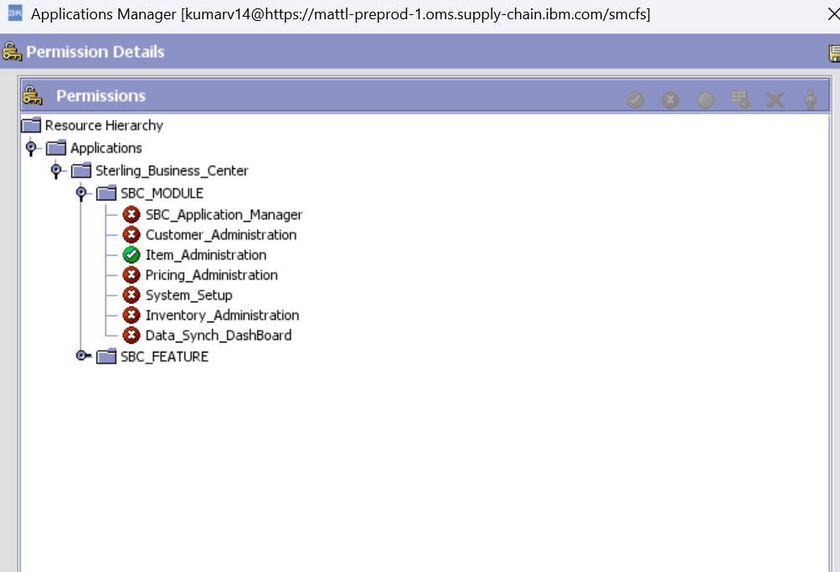
As shown below, I am able to modify short description of the product.
