- Ability to resend mailbags from the MBER screen. The MBER will show expired mailbags - mailbags that haven't been acknowledged by another VAN within the time window. Van Admin then contacts the other VAN to confirm if they received and processed the mailbags or if they need resent. If the other VAN says they require a resend, it will save time to allow for an R next to each one to resend it. If there are numerous mailbags to resend, thus saving time. Currently, it must be done one at a time via either the AUDI screen or in DUB4 depending on the interconnect protocol.

- What is the problem we are trying to solve? Not having to manually resend one mailbag at a time and from different screens. This would give us the function to resend right from the MBER screen.
- What is the impact of how it is currently working? We are required to manually resend one mailbag at a time and go to multiple screens and sometimes Centre to do the resends.
- What is the desired enhancement? To be able to resend multiple mailbags from the MBER screen under Action.
- What is the impact to Customers? Their data could be sitting there for a while if there are multiple mailbags to be resent and the data would be delayed.
- What is the impact to Support? It would save hours of work when there are multiple mailbags that need to be resent instead of having to manually send them one by one.

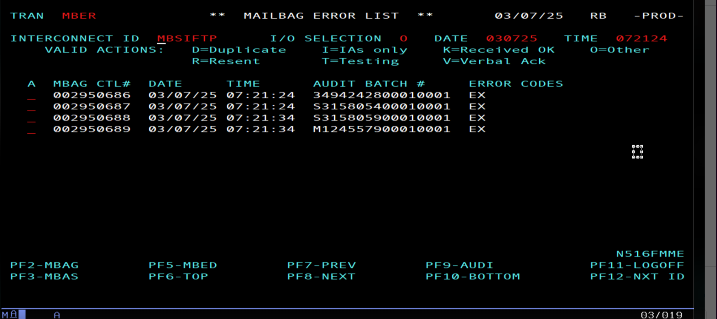

- Bulk ID Migrations – competitor VANS have this functionality.

- What is the problem we are trying to solve? Not having to manually migrate one id at a time when there is a large migration as it can be very time consuming.
- What is the impact of how it is currently working? Migrate one id at a time. With a large migration, it is very time consuming.
- What is the desired enhancement? Bulk migrations instead of migrating one id at a time.
- What is the impact to Customers? Data will go to the proper VAN at the time of the scheduled migration and not keep going to the old VAN as they wait for us to complete the migration.
- What is the impact to Support? Save hours of time where we could be working on support cases.

- Automatic Proactive Notifications – If we have failure to VANs, we require the functionality to email a notification. Also, to have this cover inbound data processing errors on data received from other VANs.

- What is the problem we are trying to solve? If data received from another VAN should fail during inbound data processing, no error notification is sent to the sending VAN.
- What is the impact of how it is currently working? It is left to our customer to contact customer support to report that they are missing data from their trading partner and ask support to track it. Also, the sending VAN does not realize the data failed and we continue to get data from other VANs failing due to the same reason (missing segment terminator for example). This failure to notify the other VAN of a data processing error delays the sender correcting and resending the data and therefore delays the data getting to our customer.
- What is the desired enhancement? The ability to have an email error notification sent to the sending VAN is data received from that VAN should fail during inbound data processing.
- What is the impact to customers? The failure to notify the sending VAN of an inbound data processing error delays the sender correcting and resending the data and therefore delays the data getting to our customer.
- What is the impact to support? To have VAN admin proactively notify the sending VANs of inbound data processing errors would require having two full time support reps work Van Admin due to the other task Van Admin is responsible for.

