Table of Contents
Application 2
Feature Implementation: Auto-convert User Input to Uppercase 2
Area of Implementation 3
Home Screen - Quick Search Box 3
Home Screen – General Search Box 4

Application
Call Center Application
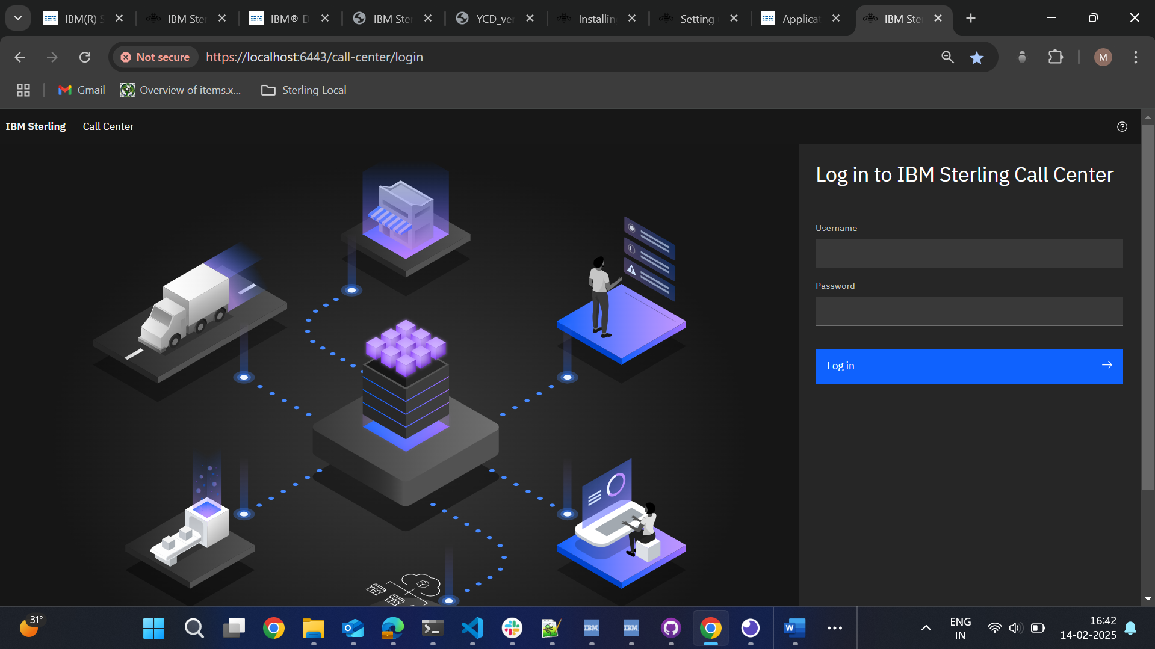

Feature Implementation: Auto-convert User Input to Uppercase
We need to implement a feature in the application where any text entered by the user in input fields is automatically converted to uppercase.

Area of Implementation

Home Screen - Quick Search Box
Business requirement: Ensure that any text entered in the quick search box is converted to uppercase dynamically as the user types or when they navigate away from the input field.
Current Scenario:
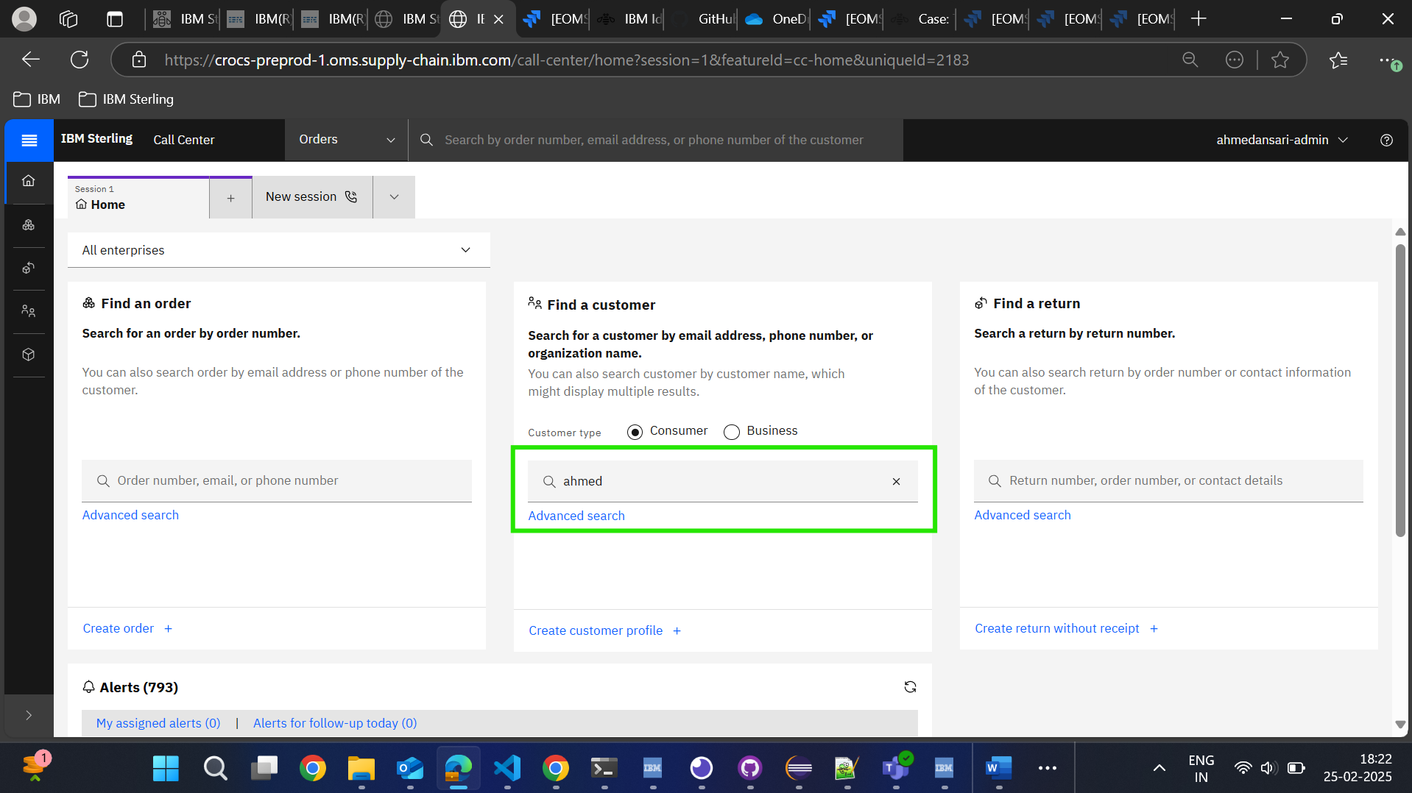
Our requirement:
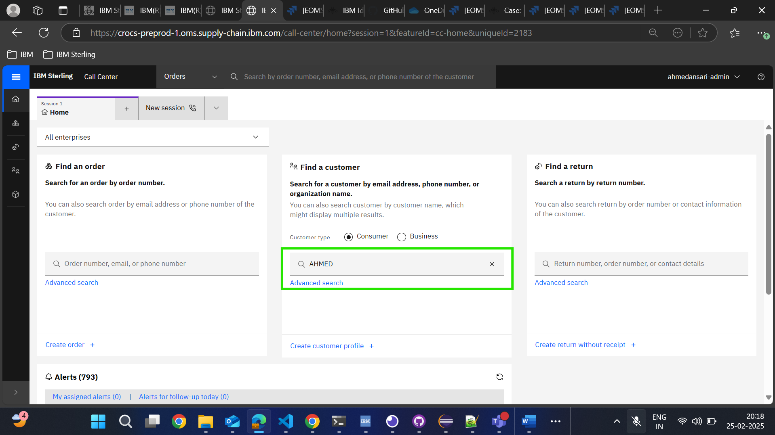

Home Screen – General Search Box
Business requirement: Ensure that any text entered in the search box is converted to uppercase dynamically as the user types or when they navigate away from the input field.
Current Scenario:
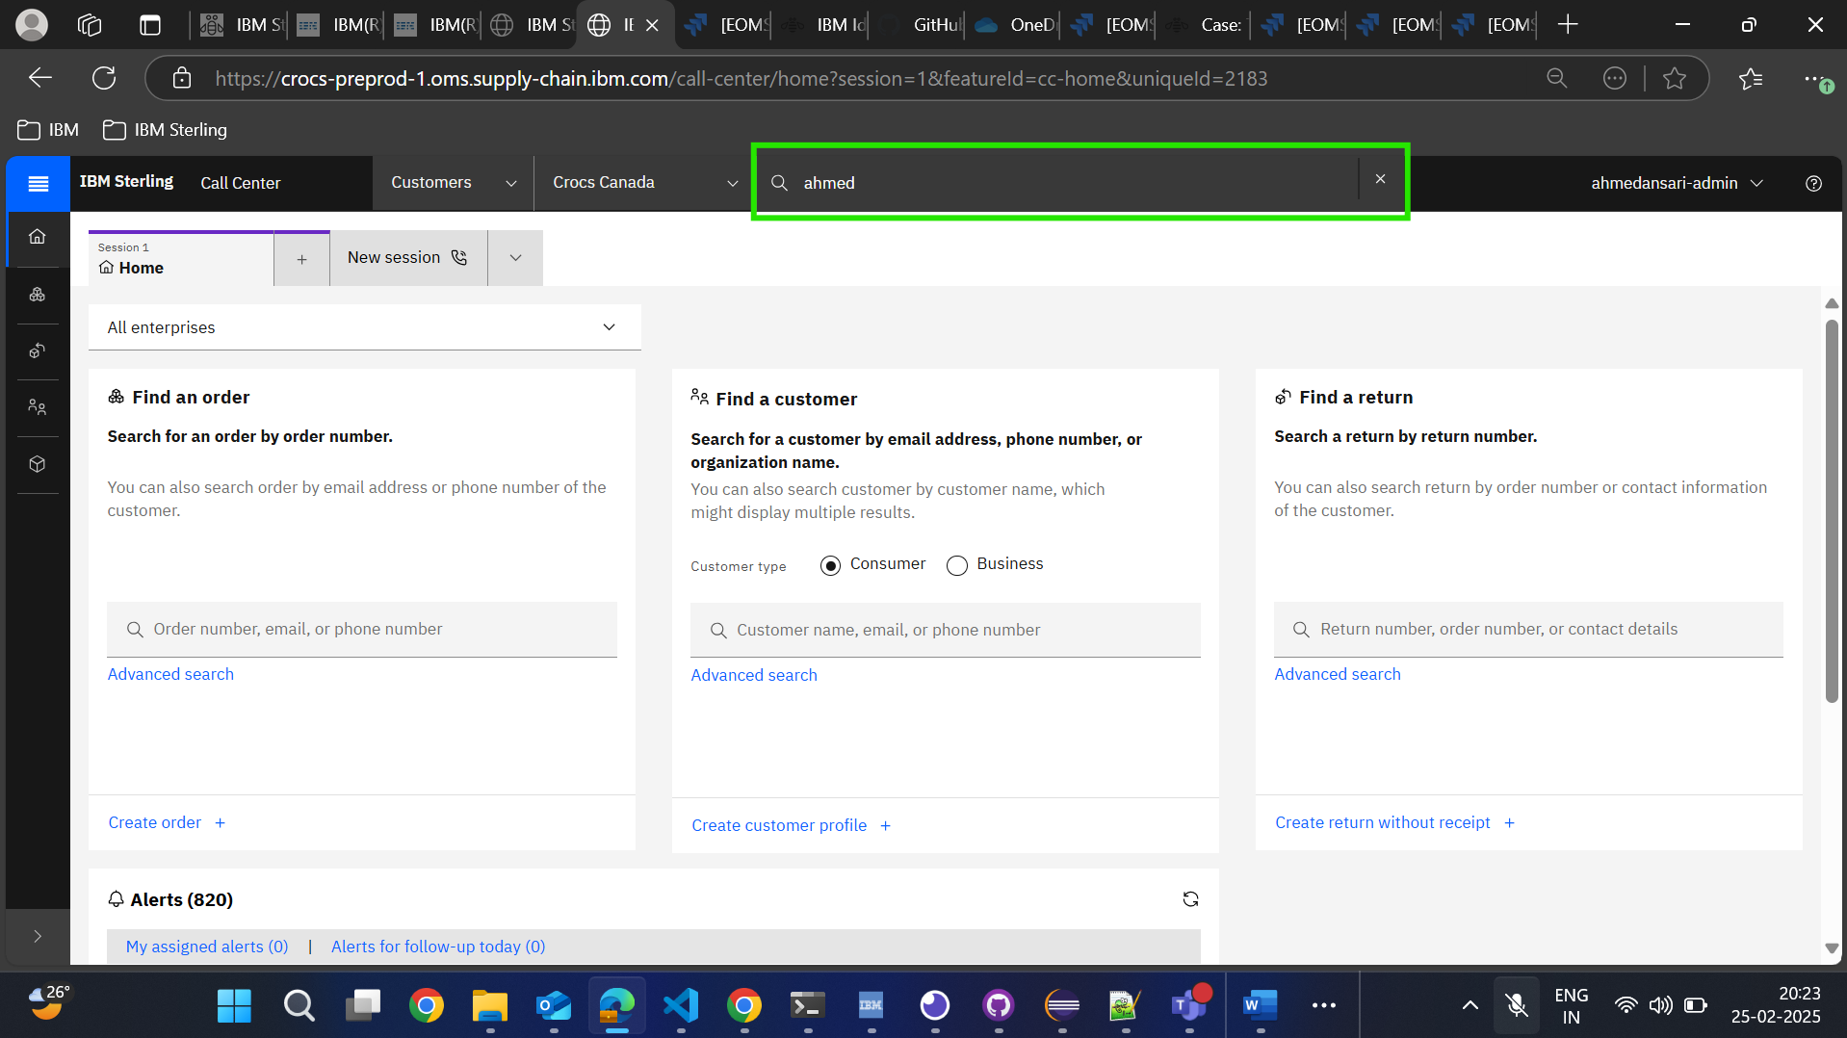
Our requirement:
