Projected Demand widget Concept

Item request is raised, in the request, have a flag (maybe a checkbox) for “have forecast?”, that if checked, opens a box within the request where user defines their estimated Annual Usage, Set Size, and Projected Trend (either Annual, Semi-Annual, Quarterly, Monthly, Seasonal (would need user to define the season if selected), or Even Distribution), and Forecast Mode (New Trend or Use Actual & Projected), Projected Periods value and date (if also needed), or an option to upload a projected demand template would also be an option.

Here’s a mockup:

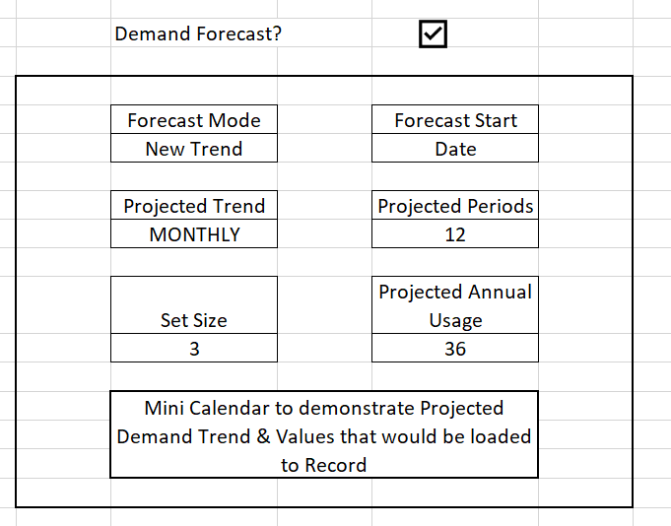

We would want this widget available in for item form view as well.

Below is an example of what Freeport does manually today, and what Newmont was asking if we could do in an automated way.

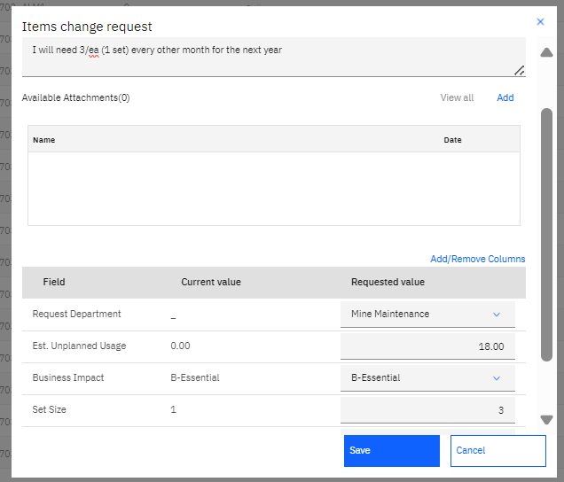

Based upon those entries, the Forecast Mode is updated, and all the projected demand entries are updated based on Change Request inputs, for example, if the Estimated Projected Demand is 18, and Set Size is 3 and Trend is Even Distributed, the system calculates the values that should go across the Projected Demand Periods evenly as possible based on the set size requirement.

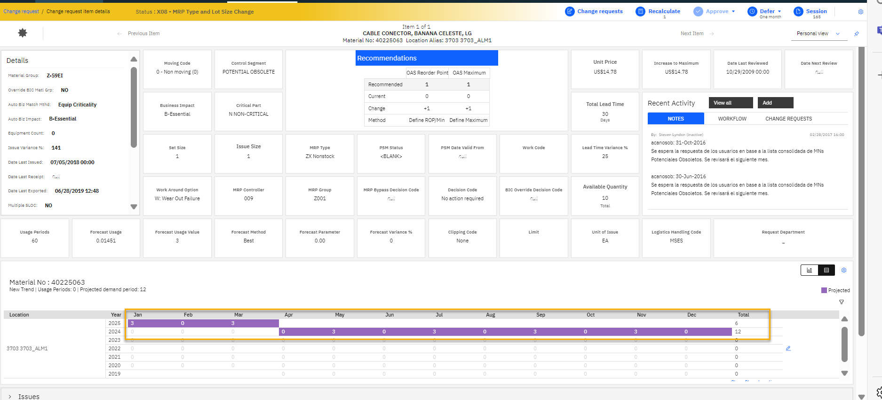

If the Trend selected was “Quarterly”, then the # of entries would be split in 4 issues over the 12 month window, in sequence of 3, 6, 3, 6.

User makes additional updates per the request, (in this case increasing set size) and recalculates the record.

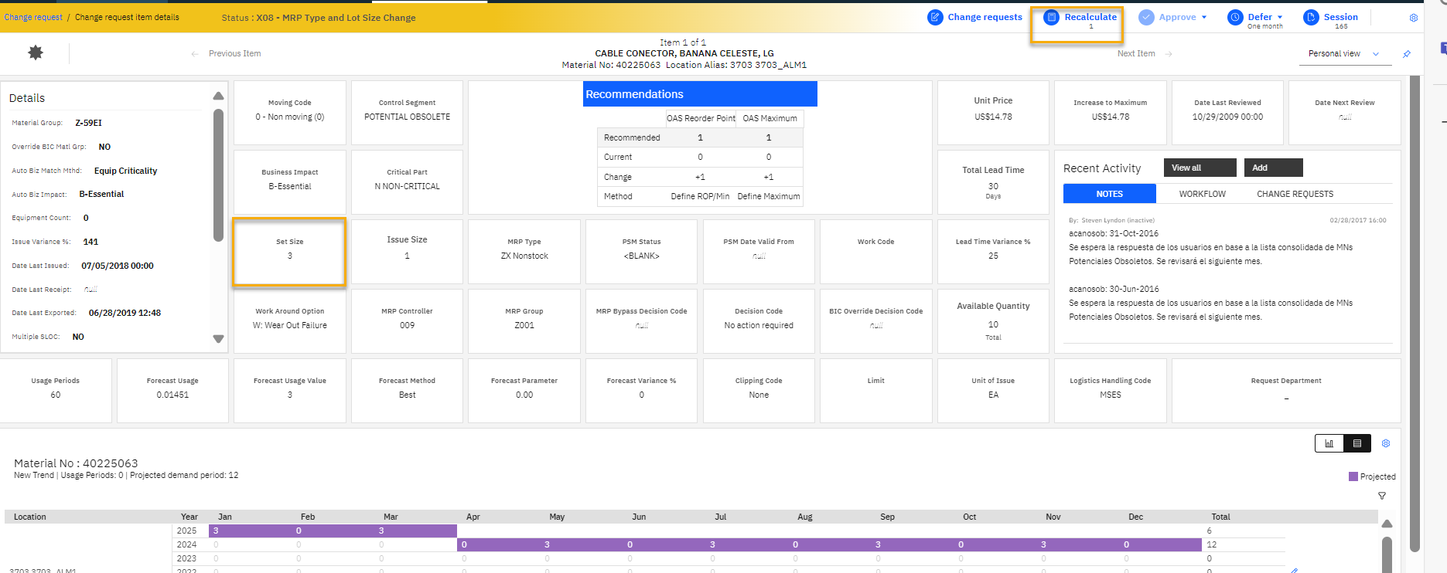

User sees the new recommendation based on the updated projected demand and responds accordingly to business process (either manually setting to what the User Requested, or processing with the higher values using the planned usage volume as justification for workflow approval.

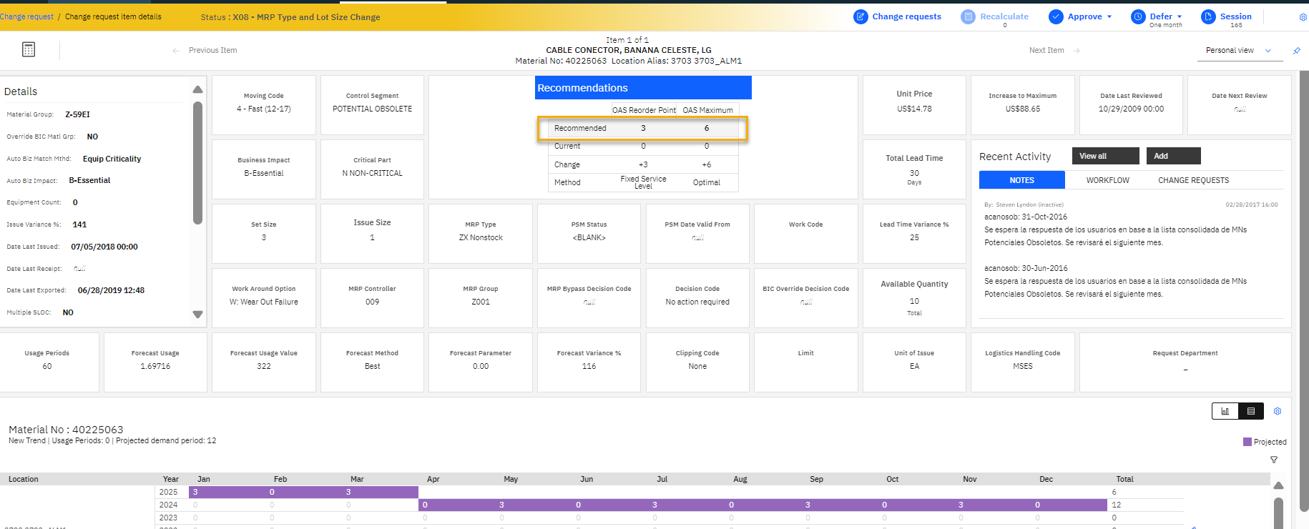

Keep in mind likely this might be something we could accomplish through DET, if the Item_Usage table was exposed to the DETs so that Projected Demand values could be updated (I put in an idea for this), but it would be cleaner process if it was a widget in the UI.