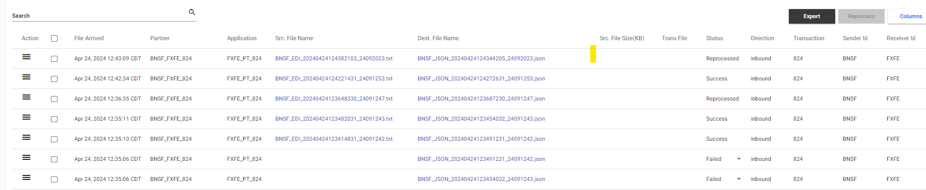

FedEx needs the ability to see the status updating with the appropriate status once a file has been reprocessed. Example when a file has been reprocessed FedEx would like to see the different stages the file is flowing though (Processed, Timed Out, Waiting, Complete, etc).

Current behavior, only shows the status' of "Reprocessed", "Failed", and "Success".

The desired behavior FedEx would like to see is, In the event of mass restarts over a threshold, they should be handled via an offline job of some sort that goes back and updates the status of the document in PCM. E.g. the document can start with 'processing' then when its successful be set to 'complete' or if PCM times out waiting on B2B, the status would be set to 'Timed Out' or "Waiting". And if the reprocessing is successful it would shift to 'Complete' so that the status in PCM matches the status of the underlying system