Since the new screens have been provided, we've the following observations:

The **queue depth graph** isn't very useful. Whilst we can see the graphs as below, we can't easily see which queue is which.

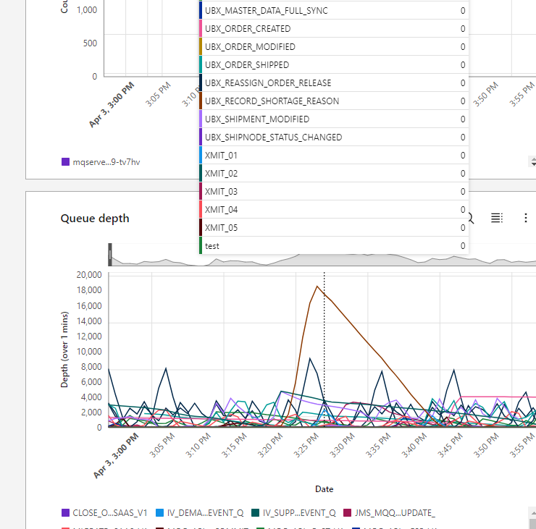

It might be more useful if the pop that appeared didn’t show queues that had 0 depth, and maybe was sorted lowest to highest (so the highest are visible nearest the pointer.

The same applies to the Queue depth full percentage graph

Also on the same 2 graphs, it’s hard to find the queue we are looking for for many of our queues as the names are middle truncated just showing the start and end. For our Sterling internal queues, we have a number on the end that it happens we can search for, and most of the time find the queue we are looking for. However for most of our external queues they are named with a format that means the start and end of the queue are the same and it is the middle that changes.   
  
Maybe this is a problem for us and we should be looking to change the names of our queue, but if there are options in how the queue names are displaced (and can be searched for in the browser it might help.

Also on the queue depths graph, it would be useful to be able to exclude a queue, i.e. if we have one queue that has high depth and we want to see the graph without that queue, is it possible to, ctrl-click or similar to not show it?

**On the queue statistics table**

For the current queue depths. we can check the queue statistics table on the JMS Metrics screen, and for historical numbers, it appears if we set the date / time in the past we get the maximum value during that period (or some kind of average, not managed to work that out yet).

Whilst I'm on this table, are there any plans to tidy it up? For example the queue depth and open output count aren't whole numbers, which, while not a major issue, is a little untidy. Also, are there plans to populate the Oldest message column, which would be useful to help highlight if a queue is not being read?

