# Message did not RETRY

TRANSACTION_ID = '7e7af5bb-0f18-4ad3-a7ab-b6d2d841cf92260949485'



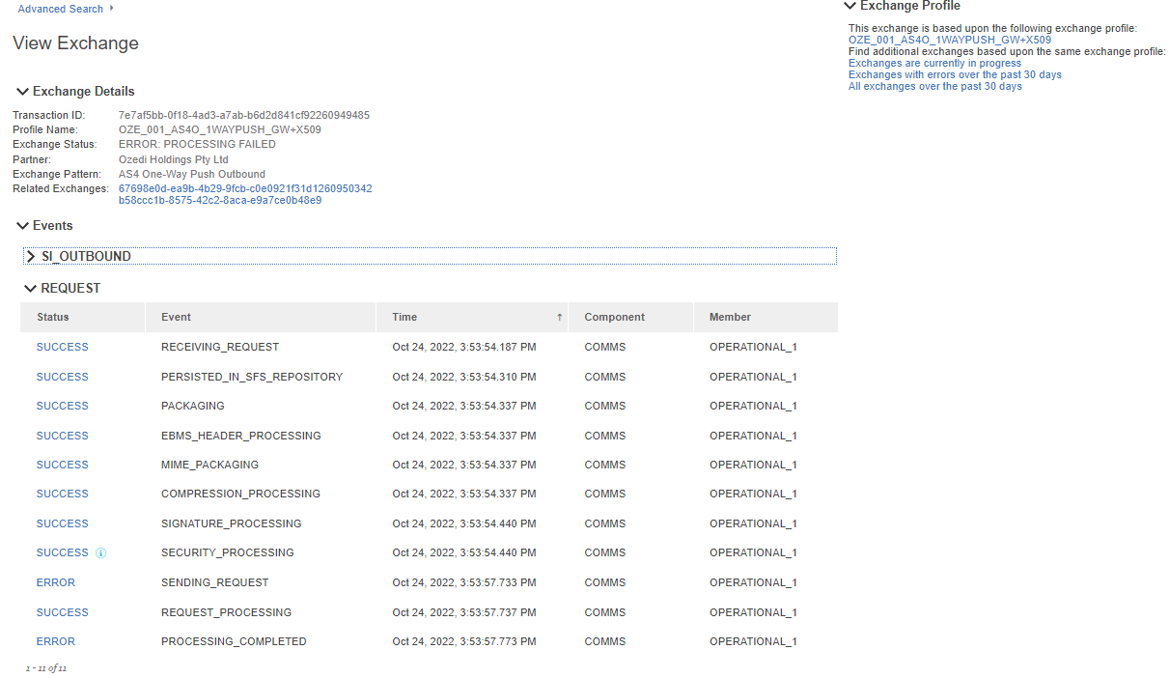

Error was

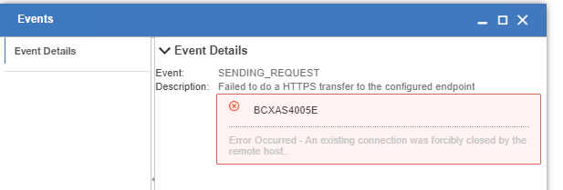

## SFS

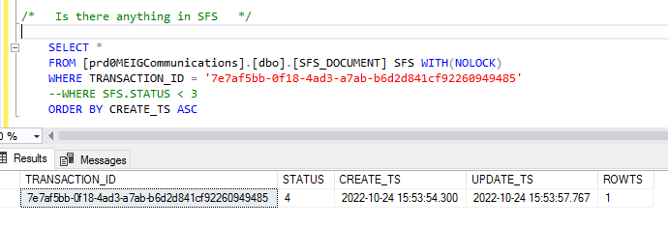

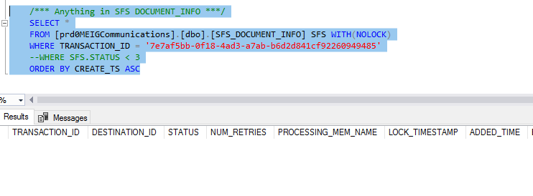

## MEIGUI/Exchange

|  |  |  |  |  |  |  |  |  |  |  |  |  |  |  |  |  |
| --- | --- | --- | --- | --- | --- | --- | --- | --- | --- | --- | --- | --- | --- | --- | --- | --- |
| ID | ADDDATETIME | ADDPERSONID | DOMAIN_ID | EXCHANGESTATECODE | EXCHANGEPROFILE_ID | GROUPID | PARENTCHILDCORRELATIONID | STARTDATETIME | ENDDATETIME | VERSION | UPDATEDATETIME | UPDATEPERSONID | REDELIVER_PARENT | REPLAY_PARENT | LASTREPLAYEXCHANGEID | LASTREDELIVEREXCHANGEID |
| 7e7af5bb-0f18-4ad3-a7ab-b6d2d841cf92260949485 | 24/10/2022 15:53:50.510 | person-0001 | meg.masteraccount | ERROR | 8d5ce3a3-9607-422c-8bc9-c7f7b5cc8b51 | NULL | NULL | 24/10/2022 15:53:50.000 | 24/10/2022 15:53:57.773 | 2 | NULL | NULL | NULL | NULL | NULL | NULL |

## MEIGUI/Events

|  |  |  |  |  |  |  |  |  |  |  |  |  |  |  |  |  |  |  |  |  |  |  |  |  |  |  |  |  |  |  |  |  |  |  |  |  |  |  |  |  |  |  |  |  |  |  |  |
| --- | --- | --- | --- | --- | --- | --- | --- | --- | --- | --- | --- | --- | --- | --- | --- | --- | --- | --- | --- | --- | --- | --- | --- | --- | --- | --- | --- | --- | --- | --- | --- | --- | --- | --- | --- | --- | --- | --- | --- | --- | --- | --- | --- | --- | --- | --- | --- |
| ID | ADDDATETIME | ADDPERSONID | COMPONENT | SERVICEINSTANCENAME | EXCHANGE_ID | PROCESSID | EVENTSTATUSCODE | EVENTDATA | EVENTDATETIME | EVENTSEQUENCE | FABRICSENDDATETIME | FABRICRECEIVEDATETIME | MEMBER | REFERENCEID | REQUESTREFERENCEID | EVENTACTION | STAGE | ROLE | ISFINAL | ISREPLAYABLE | ISREDELIVERABLE | BYPASSSFS | VISIBILITYEVENTSCOUNT | DOCPROCESSINGDEST | REFTOMESSAGEID | RAWREQUESTDATAID | FABRICRECEIVERID | BUSINESSDATAID | USERMSGHASHCODE | CUSTOMTEXT | ISPROCESSING | ERRORREASONCODE | ERRORBUNDLENAME | ERRORPARM1 | ERRORPARM2 | ERRORPARM3 | ERRORPARM4 | ERRORPARM5 | ERRORPARM6 | ERRORPARM7 | ERRORPARM8 | ISAUDITABLE | GROUPID | PARENTCHILDCORRELATIONID | VERSION | UPDATEDATETIME | UPDATEPERSONID |
| e95ce986-c82c-42ae-86cb-6a83f6d28f0b | 24/10/2022 15:53:54.210 | person-0001 | COMMS | Fabric Receiver | 7e7af5bb-0f18-4ad3-a7ab-b6d2d841cf92260949485 | NULL | SUCCESS | Received business document for processing(Visibility Retry) | 24/10/2022 15:53:54.187 | 1 | 01/01/1970 10:00:00.000 | 24/10/2022 15:53:54.183 | OPERATIONAL_1 | NULL | NULL | RECEIVING_REQUEST | PROCESSING_STARTED | REQUEST | 0 | NULL | NULL | NULL | NULL | NULL | NULL | NULL | NULL | NULL | NULL | SENT_TS=0; | 0 | NULL | NULL | NULL | NULL | NULL | NULL | NULL | NULL | NULL | NULL | 0 | NULL | NULL | 1 | NULL | NULL |
| b02cc872-a03b-431b-baa1-bfe7aabd277c | 24/10/2022 15:53:54.307 | person-0001 | COMMS | SFSProcess | 7e7af5bb-0f18-4ad3-a7ab-b6d2d841cf92260949485 | NULL | SUCCESS | Business document persisted in store and forward repository.Documents will be processed later for the destination in retry mode or disabled state. | 24/10/2022 15:53:54.310 | 2 | 24/10/2022 15:53:54.310 | 24/10/2022 15:53:54.307 | OPERATIONAL_1 | NULL | NULL | PERSISTED_IN_SFS_REPOSITORY | PROCESSING IN PROGRESS | REQUEST | 0 | NULL | NULL | NULL | NULL | NULL | NULL | NULL | NULL | NULL | NULL | NULL | 0 | NULL | NULL | NULL | NULL | NULL | NULL | NULL | NULL | NULL | NULL | 0 | NULL | NULL | 1 | NULL | NULL |
| ce237694-1112-468b-bbce-070d51f24d7b | 24/10/2022 15:53:54.360 | person-0001 | COMMS | AS4 | 7e7af5bb-0f18-4ad3-a7ab-b6d2d841cf92260949485 | NULL | SUCCESS | Marked attachments for compression successfully | 24/10/2022 15:53:54.337 | 5 | 24/10/2022 15:53:54.350 | 24/10/2022 15:53:54.360 | OPERATIONAL_1 | NULL | NULL | COMPRESSION_PROCESSING | PROCESSING_IN_PROGRESS | REQUEST | 0 | NULL | NULL | NULL | NULL | NULL | NULL | NULL | NULL | NULL | NULL | NULL | 0 | NULL | NULL | NULL | NULL | NULL | NULL | NULL | NULL | NULL | NULL | 0 | Contribution.24608708863.bd1f95e5-4d07-4472-abc0-bb3be18dde89 | NULL | 1 | NULL | NULL |
| e8873e01-0234-439a-9b21-3ebe2b6b2721 | 24/10/2022 15:53:54.350 | person-0001 | COMMS | AS4 | 7e7af5bb-0f18-4ad3-a7ab-b6d2d841cf92260949485 | NULL | SUCCESS | Prepared to create SOAP envelope | 24/10/2022 15:53:54.337 | 2 | 24/10/2022 15:53:54.337 | 24/10/2022 15:53:54.350 | OPERATIONAL_1 | NULL | NULL | PACKAGING | PROCESSING_IN_PROGRESS | REQUEST | 0 | NULL | NULL | NULL | NULL | NULL | NULL | NULL | NULL | NULL | NULL | NULL | 0 | NULL | NULL | NULL | NULL | NULL | NULL | NULL | NULL | NULL | NULL | 0 | Contribution.24608708863.bd1f95e5-4d07-4472-abc0-bb3be18dde89 | NULL | 1 | NULL | NULL |
| 2449b2ae-82fe-4570-8620-7130648d6548 | 24/10/2022 15:53:54.360 | person-0001 | COMMS | AS4 | 7e7af5bb-0f18-4ad3-a7ab-b6d2d841cf92260949485 | NULL | SUCCESS | Packaged ebMS headers in AS4 message | 24/10/2022 15:53:54.337 | 3 | 24/10/2022 15:53:54.350 | 24/10/2022 15:53:54.360 | OPERATIONAL_1 | 7b5903ea-ce5c-4e88-bb08-971e2e34e434260949485-1@gateway.pas | NULL | EBMS_HEADER_PROCESSING | PROCESSING_IN_PROGRESS | REQUEST | 0 | NULL | NULL | NULL | NULL | NULL | NULL | NULL | NULL | NULL | NULL | NULL | 0 | NULL | NULL | NULL | NULL | NULL | NULL | NULL | NULL | NULL | NULL | 0 | Contribution.24608708863.bd1f95e5-4d07-4472-abc0-bb3be18dde89 | NULL | 1 | NULL | NULL |
| f61ebf9f-f0d3-471e-84c7-cb3de8cf6aee | 24/10/2022 15:53:54.360 | person-0001 | COMMS | AS4 | 7e7af5bb-0f18-4ad3-a7ab-b6d2d841cf92260949485 | NULL | SUCCESS | Packaged ebMS headers in AS4 message | 24/10/2022 15:53:54.337 | 4 | 24/10/2022 15:53:54.350 | 24/10/2022 15:53:54.360 | OPERATIONAL_1 | 7b5903ea-ce5c-4e88-bb08-971e2e34e434260949485-1@gateway.pas | NULL | MIME_PACKAGING | PROCESSING_IN_PROGRESS | REQUEST | 0 | NULL | NULL | NULL | NULL | NULL | NULL | NULL | NULL | NULL | NULL | NULL | 0 | NULL | NULL | NULL | NULL | NULL | NULL | NULL | NULL | NULL | NULL | 0 | Contribution.24608708863.bd1f95e5-4d07-4472-abc0-bb3be18dde89 | NULL | 1 | NULL | NULL |
| 4c573afa-0c29-4ba8-b157-39864e6aa168 | 24/10/2022 15:53:54.453 | person-0001 | COMMS | AS4 | 7e7af5bb-0f18-4ad3-a7ab-b6d2d841cf92260949485 | NULL | SUCCESS | Security processing successful | 24/10/2022 15:53:54.440 | 7 | 24/10/2022 15:53:54.457 | 24/10/2022 15:53:54.453 | OPERATIONAL_1 | NULL | NULL | SECURITY_PROCESSING | PROCESSING_IN_PROGRESS | REQUEST | 0 | NULL | NULL | NULL | NULL | NULL | NULL | NULL | NULL | NULL | NULL | NULL | 0 | NULL | NULL | NULL | NULL | NULL | NULL | NULL | NULL | NULL | NULL | 1 | Contribution.24608708863.bd1f95e5-4d07-4472-abc0-bb3be18dde89 | NULL | 1 | NULL | NULL |
| 1412c16b-71f8-42ee-9295-68f8beb687d7 | 24/10/2022 15:53:54.450 | person-0001 | COMMS | AS4 | 7e7af5bb-0f18-4ad3-a7ab-b6d2d841cf92260949485 | NULL | SUCCESS | Added security header block with Signature to SOAP headers | 24/10/2022 15:53:54.440 | 6 | 24/10/2022 15:53:54.440 | 24/10/2022 15:53:54.450 | OPERATIONAL_1 | NULL | NULL | SIGNATURE_PROCESSING | PROCESSING_IN_PROGRESS | REQUEST | 0 | NULL | NULL | NULL | NULL | NULL | NULL | NULL | NULL | NULL | NULL | NULL | 0 | NULL | NULL | NULL | NULL | NULL | NULL | NULL | NULL | NULL | NULL | 0 | Contribution.24608708863.bd1f95e5-4d07-4472-abc0-bb3be18dde89 | NULL | 1 | NULL | NULL |
| 4197ac03-dc0e-4f4e-8aa5-2991a6accb76 | 24/10/2022 15:53:57.737 | person-0001 | COMMS | AS4 | 7e7af5bb-0f18-4ad3-a7ab-b6d2d841cf92260949485 | NULL | ERROR | Failed to do a HTTPS transfer to the configured endpoint | 24/10/2022 15:53:57.733 | 8 | 24/10/2022 15:53:57.737 | 24/10/2022 15:53:57.737 | OPERATIONAL_1 | NULL | NULL | SENDING_REQUEST | PROCESSING_IN_PROGRESS | REQUEST | 0 | NULL | NULL | NULL | NULL | NULL | NULL | NULL | NULL | NULL | NULL | NULL | 0 | BCXAS4005E | AS4VisibilityMessages | An existing connection was forcibly closed by the remote host. | NULL | NULL | NULL | NULL | NULL | NULL | NULL | 0 | Contribution.24608708863.bd1f95e5-4d07-4472-abc0-bb3be18dde89 | NULL | 1 | NULL | NULL |
| d12cd358-48b8-4bde-ab6a-829d33d318ee | 24/10/2022 15:53:57.747 | person-0001 | COMMS | AS4 | 7e7af5bb-0f18-4ad3-a7ab-b6d2d841cf92260949485 | NULL | SUCCESS | Business Document processed successfully | 24/10/2022 15:53:57.737 | 9 | 24/10/2022 15:53:57.747 | 24/10/2022 15:53:57.747 | OPERATIONAL_1 | NULL | NULL | REQUEST_PROCESSING | PROCESSING_SUCCESS | REQUEST | 0 | NULL | NULL | NULL | NULL | NULL | NULL | NULL | NULL | NULL | NULL | NULL | 0 | NULL | NULL | NULL | NULL | NULL | NULL | NULL | NULL | NULL | NULL | 0 | Contribution.24608708863.bd1f95e5-4d07-4472-abc0-bb3be18dde89 | NULL | 1 | NULL | NULL |
| 5d33b513-d73b-4430-9666-a6ae73b18c86 | 24/10/2022 15:53:57.770 | person-0001 | COMMS | SFSProcess | 7e7af5bb-0f18-4ad3-a7ab-b6d2d841cf92260949485 | NULL | ERROR | Business Document processing failed | 24/10/2022 15:53:57.773 | 2 | 24/10/2022 15:53:57.777 | 24/10/2022 15:53:57.770 | OPERATIONAL_1 | NULL | NULL | PROCESSING_COMPLETED | PROCESSING FAILED | REQUEST | 1 | NULL | NULL | NULL | NULL | NULL | NULL | NULL | NULL | NULL | NULL | NULL | 0 | NULL | NULL | NULL | NULL | NULL | NULL | NULL | NULL | NULL | NULL | 0 | NULL | NULL | 1 | NULL | NULL |

## Operational Logs

Searching Azure Log aggregation I only found this error for the transactionID

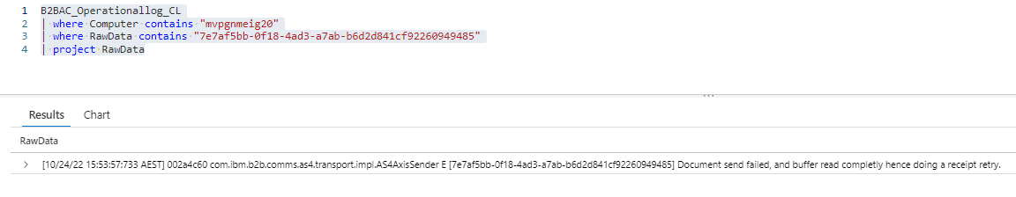

With excerpt from the log being:

|  |
| --- |
| [10/24/22 15:53:48:949 AEST] 00000b4d as4.core.activity.behavior.impl.BackendAsyncDeliveryBehavior I Setting SENT_TS in context to: 1666590828949  [10/24/22 15:53:48:949 AEST] 00000b4d as4.core.activity.behavior.impl.BackendAsyncDeliveryBehavior I Setting sentTS in delivered message to :1666590828949  [10/24/22 15:53:57:733 AEST] 002a4c60 com.ibm.b2b.comms.http.sender.impl.SenderImpl E Error during send  java.io.IOException: An existing connection was forcibly closed by the remote host.  at sun.nio.ch.SocketDispatcher.read0(Native Method)  at sun.nio.ch.SocketDispatcher.read(SocketDispatcher.java:55)  at sun.nio.ch.IOUtil.readIntoNativeBuffer(IOUtil.java:235)  at sun.nio.ch.IOUtil.read(IOUtil.java:204)  at sun.nio.ch.SocketChannelImpl.read(SocketChannelImpl.java:394)  at com.ibm.b2b.ws.tcpchannel.internal.NioSocketIOChannel.read(NioSocketIOChannel.java:201)  at com.ibm.b2b.ws.tcpchannel.internal.NioSocketIOChannel.attemptReadFromSocketUsingNIO(NioSocketIOChannel.java:111)  at com.ibm.b2b.ws.tcpchannel.internal.SocketIOChannel.attemptReadFromSocket(SocketIOChannel.java:140)  at com.ibm.b2b.ws.tcpchannel.internal.WorkQueueManager.attemptIO(WorkQueueManager.java:546)  at com.ibm.b2b.ws.tcpchannel.internal.WorkQueueManager.processWork(WorkQueueManager.java:311)  at com.ibm.b2b.ws.tcpchannel.internal.NioTCPReadRequestContextImpl.processSyncReadRequest(NioTCPReadRequestContextImpl.java:71)  at com.ibm.b2b.ws.tcpchannel.internal.TCPReadRequestContextImpl.read(TCPReadRequestContextImpl.java:98)  at com.ibm.b2b.ws.channel.ssl.internal.SSLReadServiceContext.read(SSLReadServiceContext.java:277)  at com.ibm.b2b.ws.http.channel.internal.outbound.HttpOutboundServiceContextImpl.parseResponseMessageSync(HttpOutboundServiceContextImpl.java:1611)  at com.ibm.b2b.ws.http.channel.internal.outbound.HttpOutboundServiceContextImpl.readSyncResponse(HttpOutboundServiceContextImpl.java:700)  at com.ibm.b2b.ws.http.channel.internal.outbound.HttpOutboundServiceContextImpl.startResponseReadSync(HttpOutboundServiceContextImpl.java:1733)  at com.ibm.b2b.ws.http.channel.internal.outbound.HttpOutboundServiceContextImpl.finishRequestMessage(HttpOutboundServiceContextImpl.java:1157)  at com.ibm.b2b.comms.http.sender.impl.channelfw.Worker.sendRequest(Worker.java:162)  at com.ibm.b2b.comms.http.sender.impl.channelfw.Worker.doConnectAndSend(Worker.java:125)  at com.ibm.b2b.comms.http.sender.impl.SenderImpl.send(SenderImpl.java:54)  at Proxy1a747a1d_8635_41a1_8c14_dec6e781ab2f.send(Unknown Source)  at Proxy8f7f2fbe_7280_401b_a79e_812324f6a9b9.send(Unknown Source)  at com.ibm.b2b.comms.as4.transport.impl.AS4AxisSender$4.call(AS4AxisSender.java:1128)  at com.ibm.b2b.comms.as4.transport.impl.AS4AxisSender$4.call(AS4AxisSender.java:1114)  at java.util.concurrent.FutureTask.run(FutureTask.java:277)  at java.util.concurrent.ThreadPoolExecutor.runWorker(ThreadPoolExecutor.java:1160)  at java.util.concurrent.ThreadPoolExecutor$Worker.run(ThreadPoolExecutor.java:635)  at java.lang.Thread.run(Thread.java:822)  [10/24/22 15:53:57:733 AEST] 002a4c60 com.ibm.b2b.comms.as4.transport.impl.AS4AxisSender E [7e7af5bb-0f18-4ad3-a7ab-b6d2d841cf92260949485] Document send failed, and buffer read completly hence doing a receipt retry.  [10/24/22 15:53:57:733 AEST] 000b7209 ibm.b2b.comms.as4.core.service.impl.AS4OutboundTargetService E Exception Occured while processing the request  org.apache.axis2.AxisFault: Sending or storing request failed  at com.ibm.b2b.comms.as4.transport.impl.AS4AxisSender.packagePersistSend(AS4AxisSender.java:1199)  at com.ibm.b2b.comms.as4.transport.impl.AS4AxisSender.invoke(AS4AxisSender.java:300)  at Proxyea55f8a7_834f_44b7_b039_f3b370c7caea.invoke(Unknown Source)  at Proxyea55f8a7_834f_44b7_b039_f3b370c7caea.invoke(Unknown Source)  at Proxy7fe07a41_05ad_44ea_bb33_91497a5bfa4f.invoke(Unknown Source)  at org.apache.axis2.engine.AxisEngine.send(AxisEngine.java:462)  at com.ibm.b2b.comms.as4.core.service.impl.AS4OutboundTargetService.processOutboundRequest(AS4OutboundTargetService.java:786)  at com.ibm.b2b.comms.as4.core.service.impl.AS4OutboundTargetService.processRequest(AS4OutboundTargetService.java:1841)  at com.ibm.b2b.comms.as4.core.service.impl.AS4OutboundTargetService.invokeService(AS4OutboundTargetService.java:360)  at Proxyc46bfdfe_ca42_40ec_bad5_8ffdad68833b.invokeService(Unknown Source)  at Proxyc46bfdfe_ca42_40ec_bad5_8ffdad68833b.invokeService(Unknown Source)  at com.ibm.b2b.comms.sfs.service.impl.DocumentProcessorTask.call(DocumentProcessorTask.java:264)  at com.ibm.b2b.comms.sfs.service.impl.DocumentProcessorTask.call(DocumentProcessorTask.java:79)  at java.util.concurrent.FutureTask.run(FutureTask.java:277)  at java.util.concurrent.ThreadPoolExecutor.runWorker(ThreadPoolExecutor.java:1160)  at java.util.concurrent.ThreadPoolExecutor$Worker.run(ThreadPoolExecutor.java:635)  at java.lang.Thread.run(Thread.java:822)  Caused by: java.util.concurrent.ExecutionException: java.util.concurrent.ExecutionException: Http Send of packed request failed  at java.util.concurrent.FutureTask.report(FutureTask.java:133)  at java.util.concurrent.FutureTask.get(FutureTask.java:203)  at com.ibm.b2b.comms.as4.transport.impl.AS4AxisSender.processResponse(AS4AxisSender.java:1229)  at com.ibm.b2b.comms.as4.transport.impl.AS4AxisSender.packagePersistSend(AS4AxisSender.java:1195)  ... 16 more  Caused by: java.util.concurrent.ExecutionException: Http Send of packed request failed  at com.ibm.b2b.comms.as4.transport.impl.AS4AxisSender.scheduleResendForSocketIOE(AS4AxisSender.java:1516)  at com.ibm.b2b.comms.as4.transport.impl.AS4AxisSender.access$500(AS4AxisSender.java:142)  at com.ibm.b2b.comms.as4.transport.impl.AS4AxisSender$4.call(AS4AxisSender.java:1177)  at com.ibm.b2b.comms.as4.transport.impl.AS4AxisSender$4.call(AS4AxisSender.java:1114)  ... 4 more  Caused by: java.io.IOException: An existing connection was forcibly closed by the remote host.  at sun.nio.ch.SocketDispatcher.read0(Native Method)  at sun.nio.ch.SocketDispatcher.read(SocketDispatcher.java:55)  at sun.nio.ch.IOUtil.readIntoNativeBuffer(IOUtil.java:235)  at sun.nio.ch.IOUtil.read(IOUtil.java:204)  at sun.nio.ch.SocketChannelImpl.read(SocketChannelImpl.java:394)  at com.ibm.b2b.ws.tcpchannel.internal.NioSocketIOChannel.read(NioSocketIOChannel.java:201)  at com.ibm.b2b.ws.tcpchannel.internal.NioSocketIOChannel.attemptReadFromSocketUsingNIO(NioSocketIOChannel.java:111)  at com.ibm.b2b.ws.tcpchannel.internal.SocketIOChannel.attemptReadFromSocket(SocketIOChannel.java:140)  at com.ibm.b2b.ws.tcpchannel.internal.WorkQueueManager.attemptIO(WorkQueueManager.java:546)  at com.ibm.b2b.ws.tcpchannel.internal.WorkQueueManager.processWork(WorkQueueManager.java:311)  at com.ibm.b2b.ws.tcpchannel.internal.NioTCPReadRequestContextImpl.processSyncReadRequest(NioTCPReadRequestContextImpl.java:71)  at com.ibm.b2b.ws.tcpchannel.internal.TCPReadRequestContextImpl.read(TCPReadRequestContextImpl.java:98)  at com.ibm.b2b.ws.channel.ssl.internal.SSLReadServiceContext.read(SSLReadServiceContext.java:277)  at com.ibm.b2b.ws.http.channel.internal.outbound.HttpOutboundServiceContextImpl.parseResponseMessageSync(HttpOutboundServiceContextImpl.java:1611)  at com.ibm.b2b.ws.http.channel.internal.outbound.HttpOutboundServiceContextImpl.readSyncResponse(HttpOutboundServiceContextImpl.java:700)  at com.ibm.b2b.ws.http.channel.internal.outbound.HttpOutboundServiceContextImpl.startResponseReadSync(HttpOutboundServiceContextImpl.java:1733)  at com.ibm.b2b.ws.http.channel.internal.outbound.HttpOutboundServiceContextImpl.finishRequestMessage(HttpOutboundServiceContextImpl.java:1157)  at com.ibm.b2b.comms.http.sender.impl.channelfw.Worker.sendRequest(Worker.java:162)  at com.ibm.b2b.comms.http.sender.impl.channelfw.Worker.doConnectAndSend(Worker.java:125)  at com.ibm.b2b.comms.http.sender.impl.SenderImpl.send(SenderImpl.java:54)  at Proxy1a747a1d_8635_41a1_8c14_dec6e781ab2f.send(Unknown Source)  at Proxy8f7f2fbe_7280_401b_a79e_812324f6a9b9.send(Unknown Source)  at com.ibm.b2b.comms.as4.transport.impl.AS4AxisSender$4.call(AS4AxisSender.java:1128) |

Logs indicate that this should have been a receipt retry triggered by the Conformance Policy retry mechanism. For some reason this did not happen!!!!

* There is no FFDC error in Operational member. There is no error in MQ log in Operational member
* There was no error in Informational logs
* There was no error in WXSContainer logs

## Getting it sent out

It was not able to be replayed from B2BAC as the icon was not showing AND the replay button was not available when I clicked on the row.

This message had to be redelivered by restarting the BP inside B2Bi. It has now gone out successfully

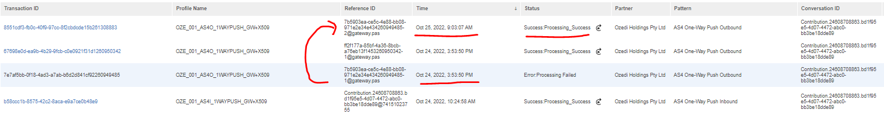

## PROBLEM

1. As a gateway operator, I am not bothered by why a message failed to send out. If its was not delivered and I don’t have a receipt for it, it should retry to deliver. This failed outbound message should have automatically retried to deliver
2. The message was not able to be replayed from B2BAC UI
3. For some reason Destination retry and Conformance retry was not observed for this message, the MEIGUI events also show that a retry was never attempted.
4. The delivery of this message is now outside our 6 hour SLA and this is now a reportable breach which was outside the controls of Australian Retirement Trust (Precision Administration Gateway).

**Stephen Milburn**

Asset Lead, Digital Transactions and Gateways

GPO Box 2924, Brisbane Qld 4001

30 Little Cribb Street Milton Qld 4064

**M** 0429 087 557 | **W** [australianretirementtrust.com.au](https://australianretirementtrust.com.au/)

](https://australianretirementtrust.com.au/)