NZ Customs(TSW) Security Changes
Currently Vanguard is sending OUT and ICR messages to NZ Customs using SOAP connectivity via HTTP. We have received the below security changes in the SOAP Outbound Security service.
TSW Update : Security Review
- Add Expiry to the Timestamp element to the WS-Security header on all SOAP requests (Submit Lodgement and Request Response) – the timestamp is present, but it is missing the Expiry element
- Include the Timestamp element in the message signature – both body (as per your current requests) and timestamp (new) are to be signed
- Change the way the Message Signing certificate is declared – currently declared using an x509Data element, however certificate needs to be declared using either a BinarySecurityToken or KeyIdentifier

Attached sample request with the above changes from customs
Changes have been done in VLS_Outbound_Submit_WS_Lodgement_NZ.bp.
We have achieved point #1 & #3 in SBI and could not able to achieve the 2nd point.
Point #1
Add Expiry to the Timestamp element to the WS-Security header on all SOAP requests (Submit Lodgement and Request Response) – the timestamp is present, but it is missing the Expiry element
By providing the value for TIME_TO_LIVE we could able to achieve expiry element in the Timestamp.
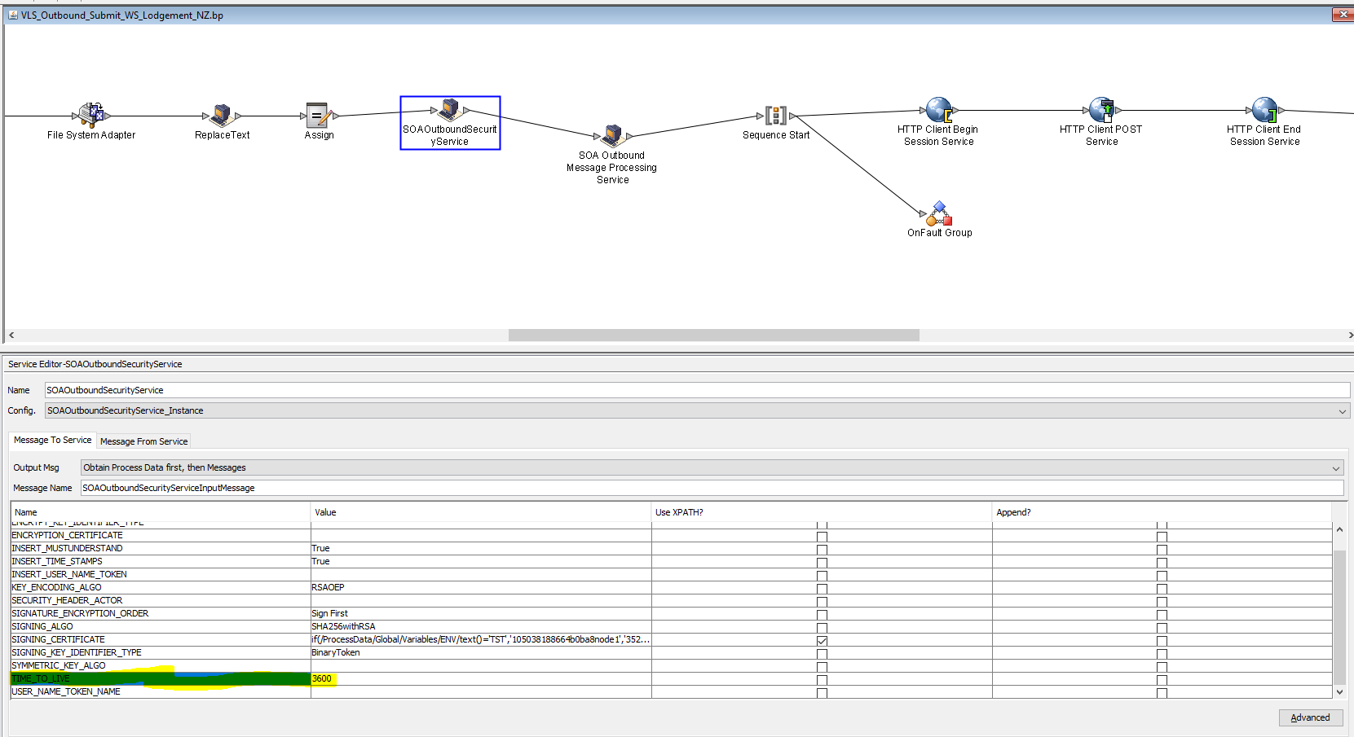
Point #3
Change the way the Message Signing certificate is declared – currently declared using an x509Data element, however certificate needs to be declared using either a BinarySecurityToken or KeyIdentifier.
Changed the SIGNING_KEY_IDENTIFIER_TYPE as Binary Token
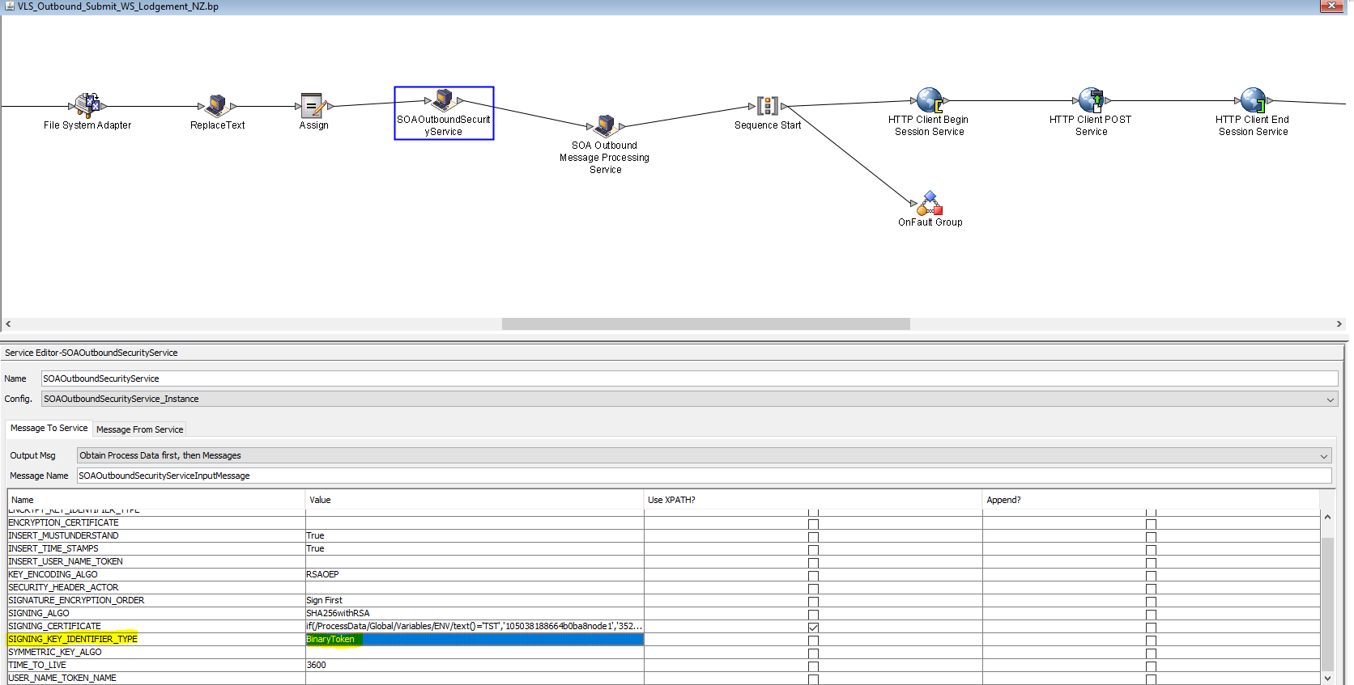
Attached sample request with the above two changes from SBI pre-prod.

For Point #2, we could not able to achieve the Timestamp element in the Message signature as highlighted below.
Also currently DigestMethod Algorithm is generated as sha1 instead of sha256.
