As we are moving to new HTTP Adapter on cloud & moving all the connection configurations to ConfigHub, we would like to request the below enhancement.
Enhancement # 2: Enable Certificate Extraction Utility & Supported Ciphers Display in ConfigHub
Requirement: Enable Certificate Extraction Utility in ConfigHub UI (like what we have in B2Bi PODS today). We are also requesting an option to display supported ciphers by the remote end point.
How does this help? IBM internal teams (Support & Services) uses this tool while troubleshooting issues related to SFTP and HTTPs connections. This will help in Improving the TTR and customer satisfaction for support & speed up onboarding time.
Do we have this functionality today in legacy applications? While legacy inflight UI doesn’t support Certificate extraction utility, we do have it available in B2Bi POD UI. Most of the support & services team members use this tool extensively… For supported ciphers, we are relying on L2 protocol team to fetch that information using openssl from command line.
Use cases:
We deal with more than 10,000 connection issues every year of which roughly 15% are related to SSL Certificate Handshake issues. Having this tool handy will help to avoid dependencies on waiting for customer (or) other support teams.
Existing Screens in B2Bi POD UI:
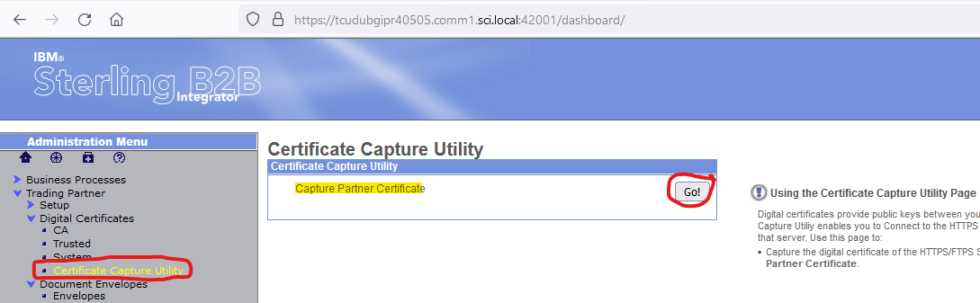

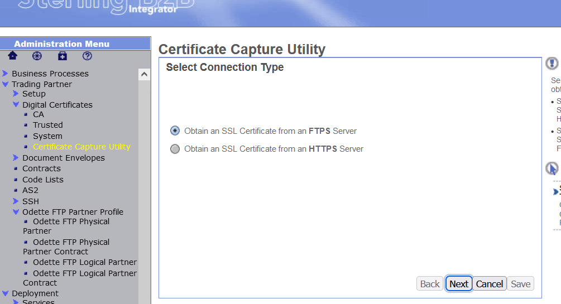

For SFTP:
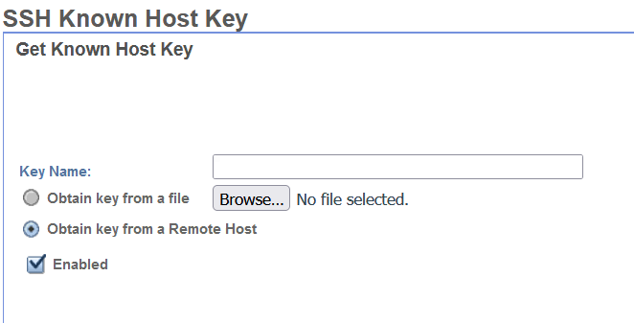
For HTTPS:
