As we are moving to new HTTP Adapter on cloud & moving all the connection configurations to ConfigHub, we would like to request the below enhancement

Enhancement # 1: Global Seach Capability across all customer/trading partner connections in ConfigHub
Requirement: For the benefit of IBM support & services teams, it is necessary to have a global search feature enabled with a capability to search for all existing connection details across all the customers.
How does this help? This enhancement will help IBM resources to perform day-to-day troubleshooting & maintenance activities easily and effectively.
Do we have this functionality today in legacy applications? While legacy inflight UI doesn’t allow global search across all companies/connections today, IBM support teams built a custom tool to extract dump of all available connection configurations and enable this global search. We would like to have this global search feature built into new gateway so that we don’t need to do any custom tool development.
Required Search Parameters: Url, userid, connection name, Connection identifier, folder path (for FTPS & SFTP), Customer Business Alias, TP business Alias, Description, SSID, SFID, list only Secure connections etc.
We are looking for this global search enabled in the home page of ConfigHub as shown below
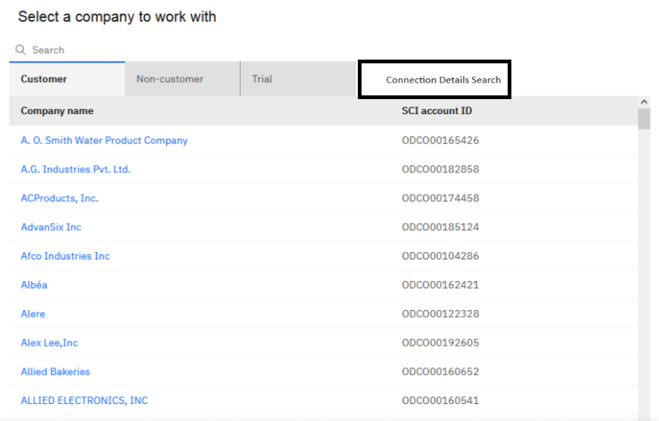
Use cases:
- Helps support team to get the list of relationships that are impacted by the Trading Partner change requests like domain name change, Certificate update requests etc.
- In case of communication issues/failures it helps support team to quickly getting the complete list of all effected customers.
- While configuring a new trading partner connection for any IBM customer, it can help as a reference for IBM internal teams (PER/Implementation/mailbox services).

