The application **test.onboard.b2b.dsv.com** is vulnerable to unrestricted file upload on page **/dsv/sponsor/module/fileManagement**, in the parameter **filename**.

Note: Although it is not possible to execute the file, other users can download it, which could be a malicious file.

Upload:

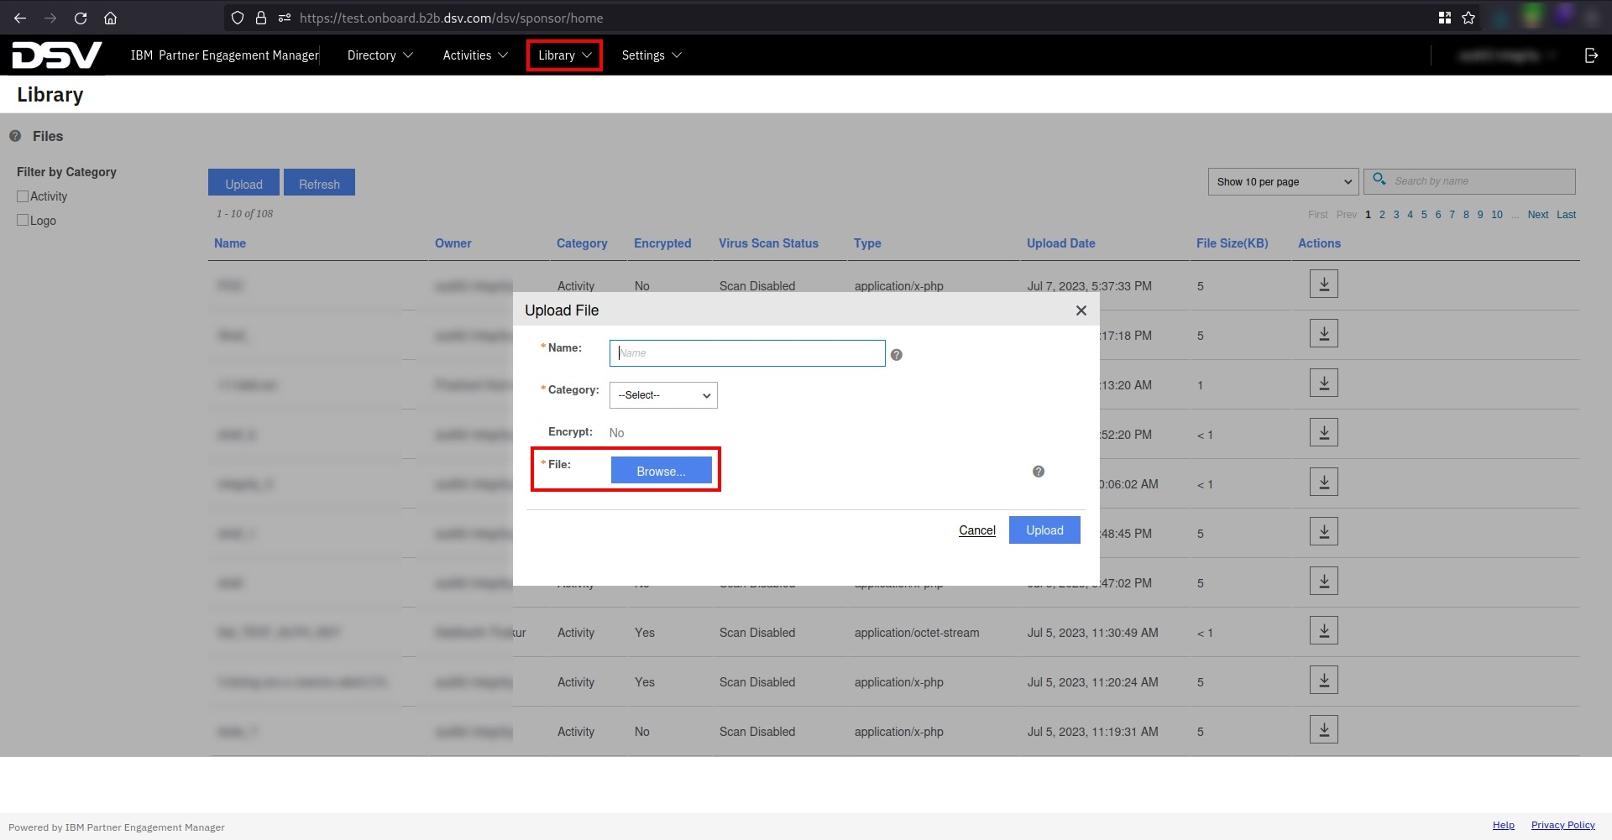 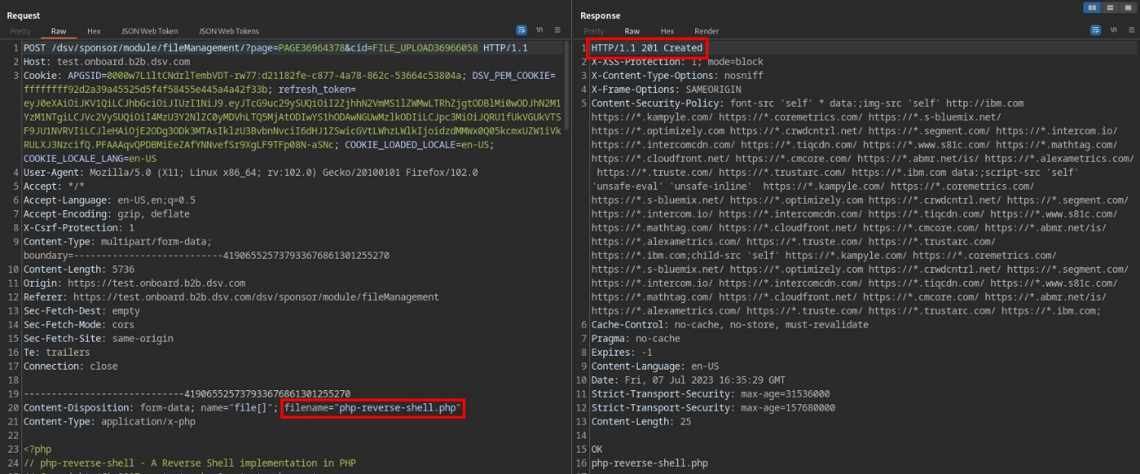

File uploaded:

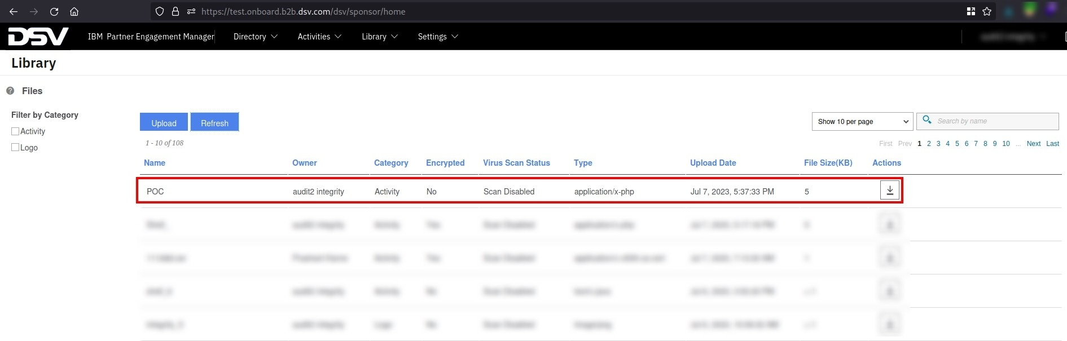

**Recommendations:**

* Use a whitelist approach to validate the file extension and name on the server side;

**References:**

* <https://owasp.org/www-community/vulnerabilities/Unrestricted_File_Upload>