# What Happens till now in ITXA:

1. Main Map opens in the main window.

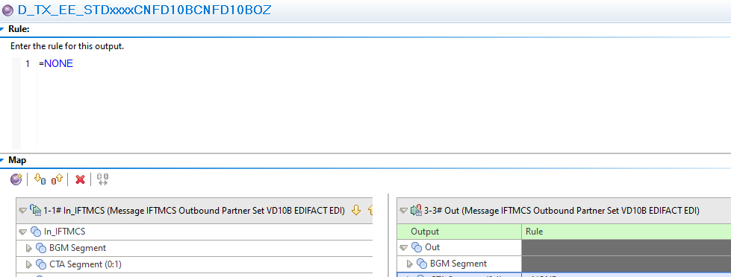

1. When we open the Functional Map. It opens in the same window, and we lost the main map view.

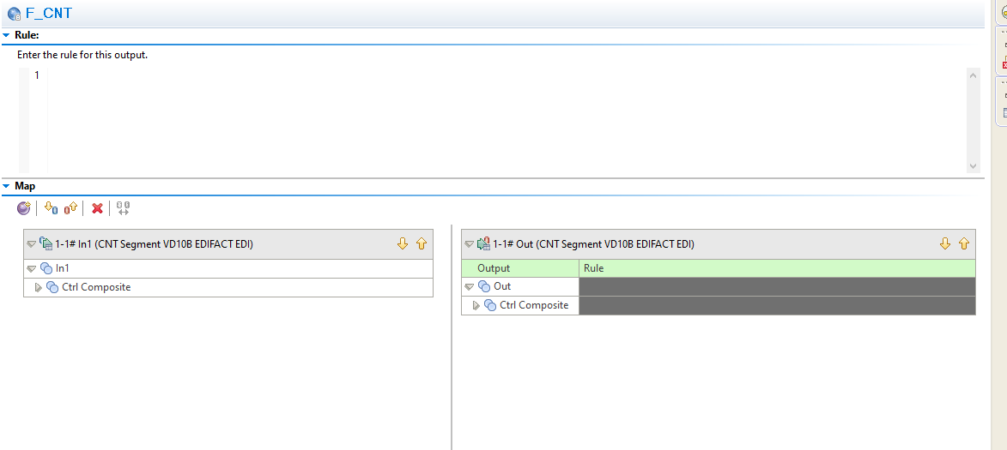

1. If we go back to main map, we will lose the Functional View.

# How we want to be done in ITXA.

1. When we open the main map. It should open the main window.

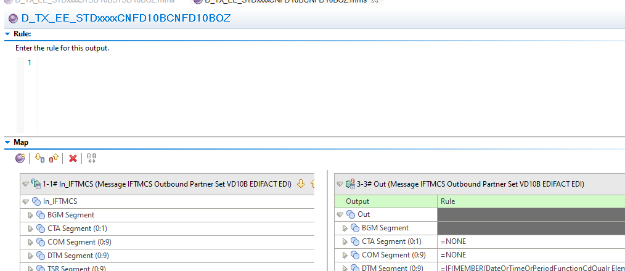

1. The moment we open the Functional map we should have two options.
   1. If we double-click, then the functional map should open in the new window (like a pop-up window and all the changes we save in that window it should be saved and become a part of main map).
   2. If we right-click on functional map, we should have an option like “open map” and when we click on that the map should open in the same window which the main map was opened in.