# How Functions must be used till now.

I have to type the function manually alphabet by alphabet.

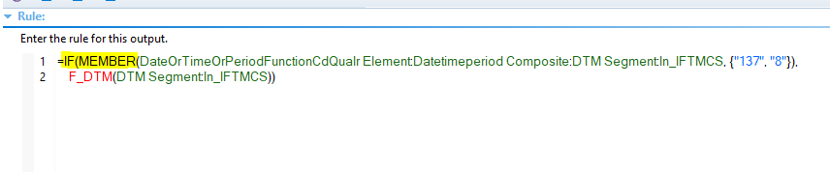

# How I want functions to used

I just typed s and the system showed me all the functions starting with s and how to use each function. All I have to do, is to select and press ENTER to use that function and the system automatically adds that function along with the brackets and all the stuff that FUNCTION is required to work. All I need to do is to the data there.

