Could you please share below details for investigation:

1. Screenshot of Financial Rule

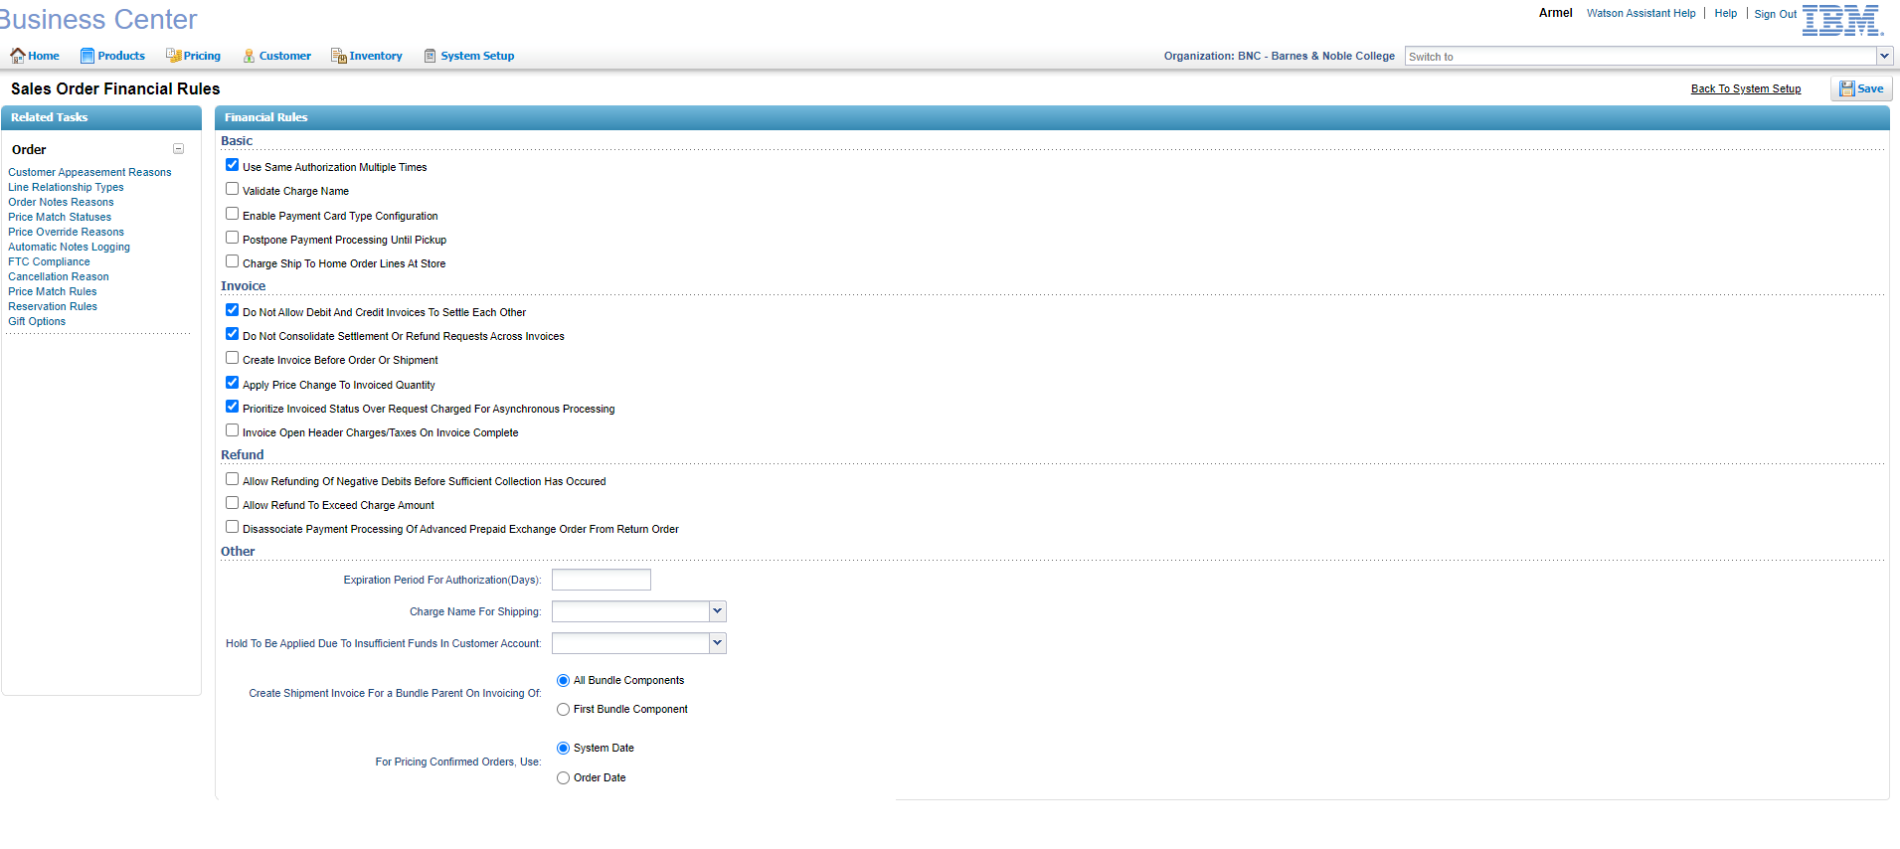

1. Screenshot of Payment Rule

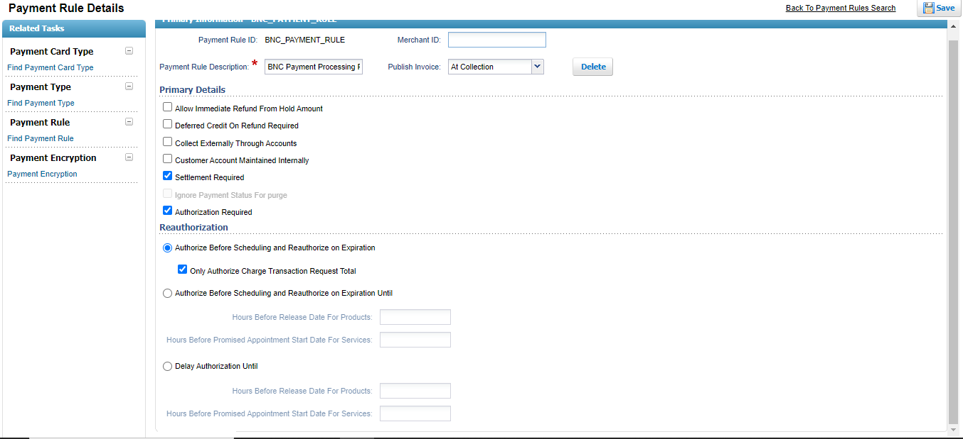

1. Screenshot of Payment Type

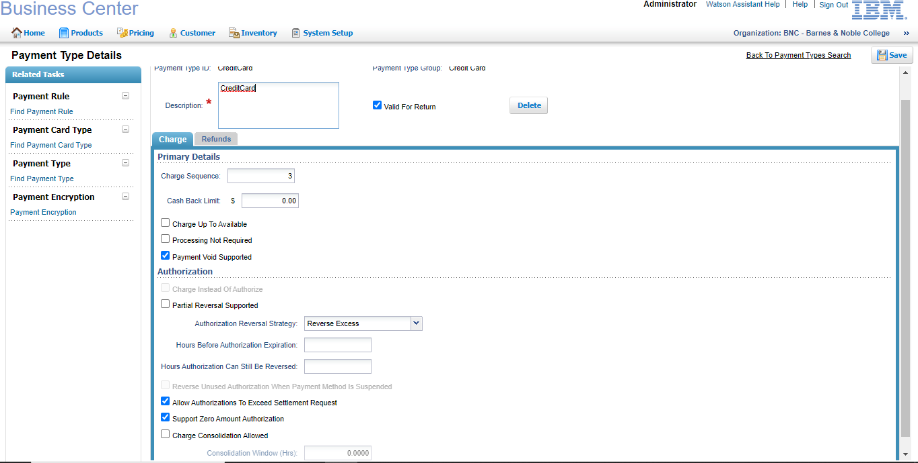

4) Complete step to replicate the issue including all API calls and input XMLs.

* Placed two line Dropship order (1st dropship line total 34.43, 2nd dropship linetotal 84.43 and shipping charges 15.15)
* Once order created Charge Transaction request will open for shipping charges(15.15) and 1st line total(34.43) and Charge Transaction table as (15.15)and (34.43)
* ProcessPaymentAgent will pick the records if processOrderPayment is success. Two Auth Id will be generated for shipping charge and 1st line total and 1st line will move to Payment Authorized status.
* Once order is scheduled, lines will move to Await Chained Order then chained order will move to POacknowledge.
* Once confirmation comes for 1st line shipment will get created and invoice will be generated(15.15+34.43=49.58) then settlement will happen.