OrderNo : 1000601052

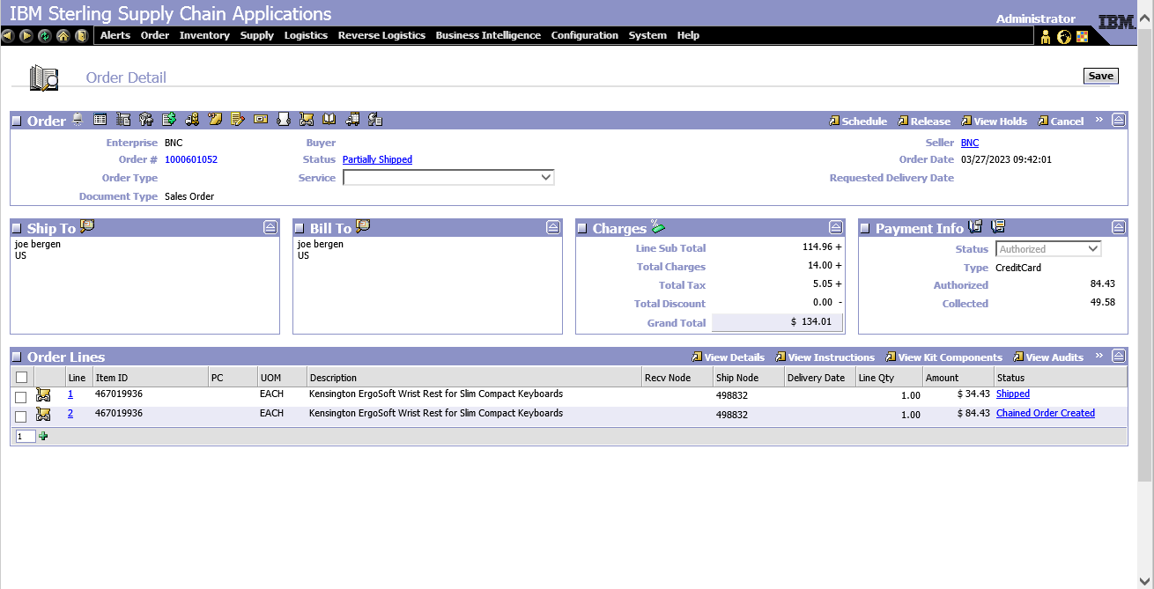

Scenario

Line 1 – Authorized (individual auth id) along with shipping charge (Authorized (individual auth id). Shipped and invoiced

Line 2 – Authorized with auth id.

As part of the settlement, a single charge record is opened for Line 1 total amount of 49.98(34.43 + 15.15) with the auth id of line 2.

Expected result:

2 charge record against 34.43 and 15.15 with their respective auth id should be created for settlement.

Below are the screen shots for the same.

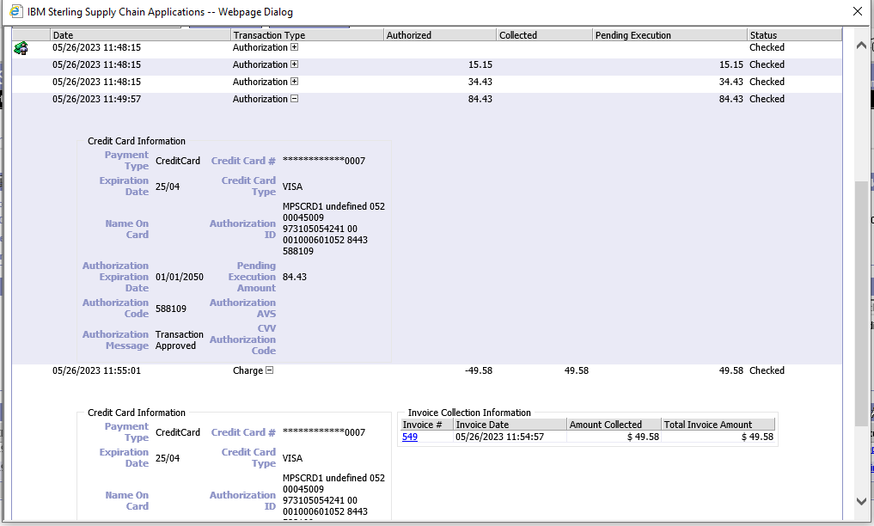

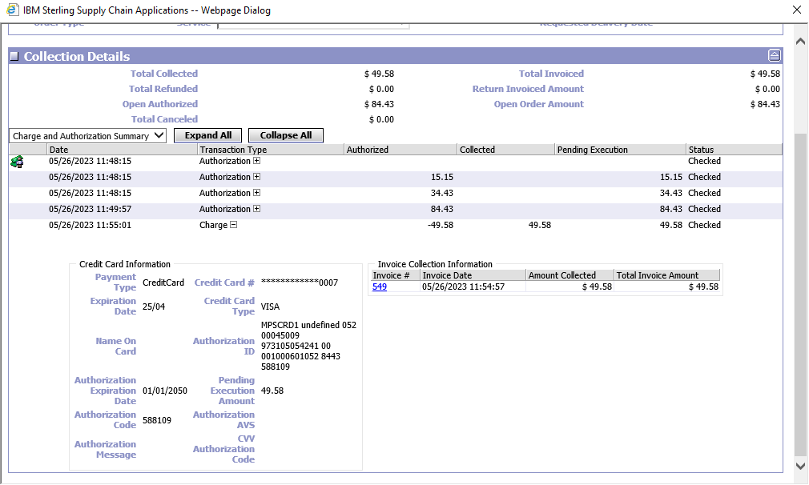

<Order DocumentType="0001" EnterpriseCode="BNC" OrderHeaderKey="20230526164814476920" OrderNo="1000601052"/>