MyFilegateway Requirement:
Req 1) On Upload files screen:
Rename File as option shouldn't be visible on Upload screen both Rename file as label and it's
corresponding text box.
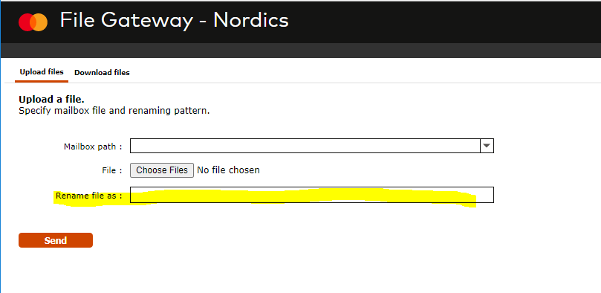

Req 2) Mailbox path on Upload files screen:
Either any one of the below options preferable at Master Card
Option 1) Preferably not be visible as it is always “/” .
Option 2) In the drop down we always need have "/" in the text box against Mailbox path.

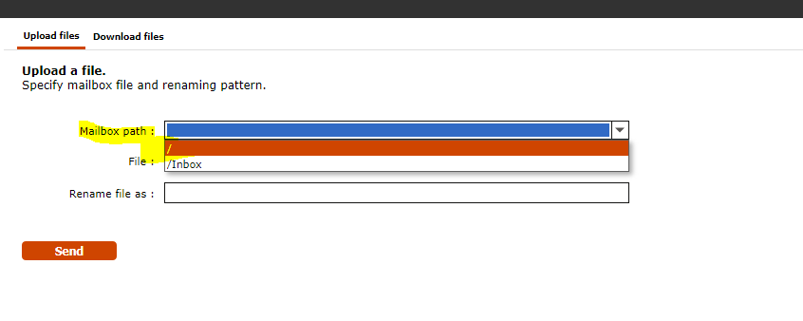

Req 3) Hover Text at Mailbox path on Upload files screen:
Mouse Hover text should be like customer need to select “/”. At present it is showing "Path to the mailbox".

NOTE: In case if the Req 2) is doable , Req 3) can be dropped/ignored.
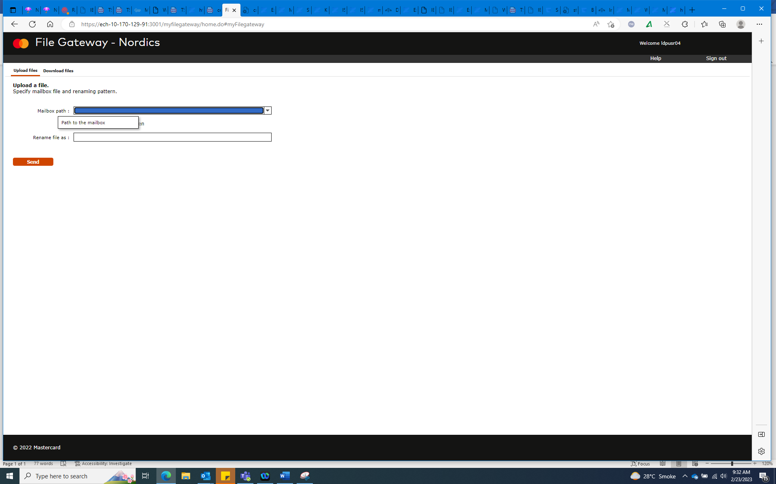

Req 4) Column Name Change on Download files:
Change the Column name from "Mailbox" to "Directory" on Download files screen table.

