Timeout issue
Issue Description:
When a system is deployed through ssftpdeploy, encountering the timeout error for a particular system as the map compilation takes more than 2 mins.
Screenshot:
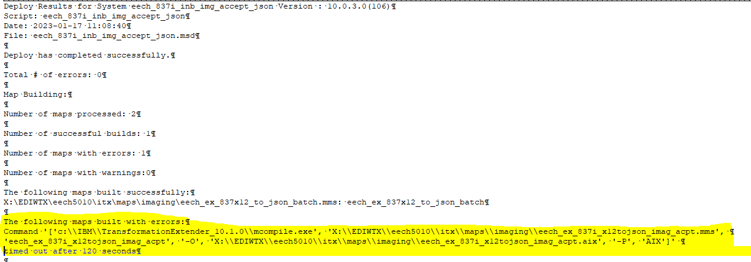
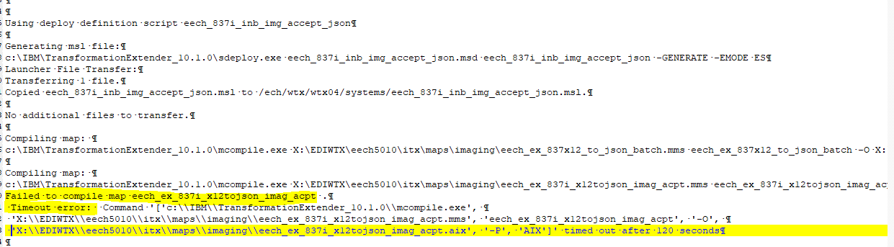
Ssftpdeploy command:
"C:\IBM\TransformationExtender_10.1.0\ssftpdeploy" -EMODE ES -USER ech -PW Sep@2019 -IP 10.154.60.22 eech_837i_inb_img_accept_json.msd eech_837i_inb_img_accept_json eech_837i_inb_img_accept_json -LOG eech_837i_inb_img_accept_json.txt

Question:
- Would like to know how the ssftpdeploy command works? Whether this command would first establish a server connection and then compiles the map in the system and then transfer it to server or compiles the map in the system and then establish the connectivity to the server for performing a file transfer?

