Special Service item considering weekend capacity

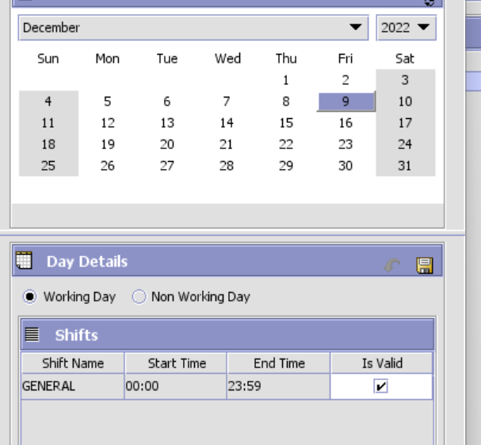

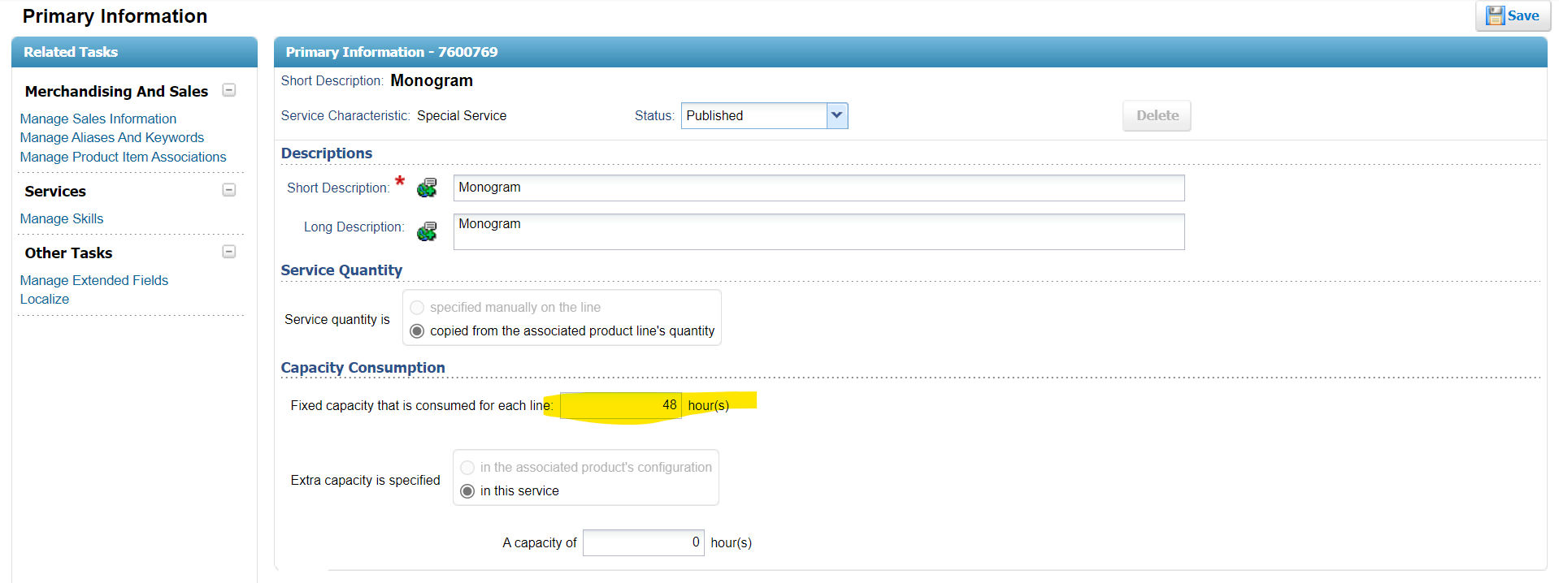

Product Service Association

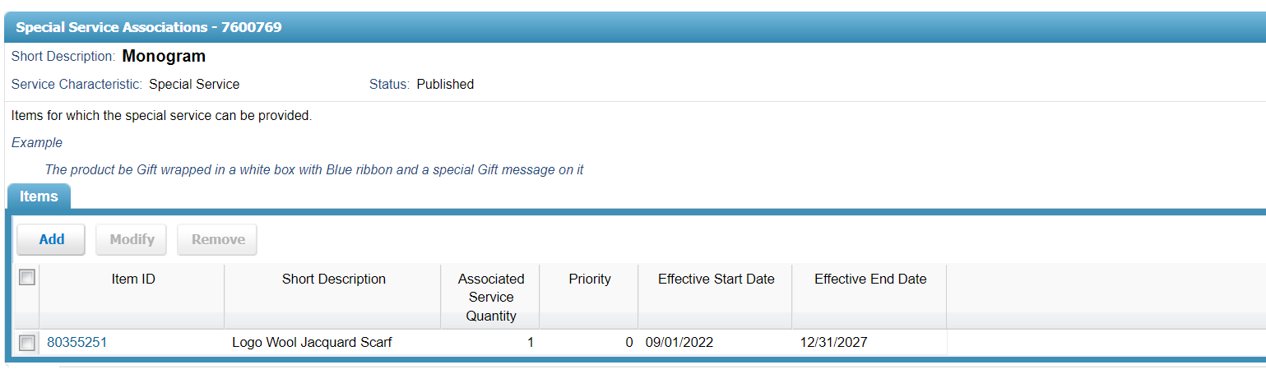

Order

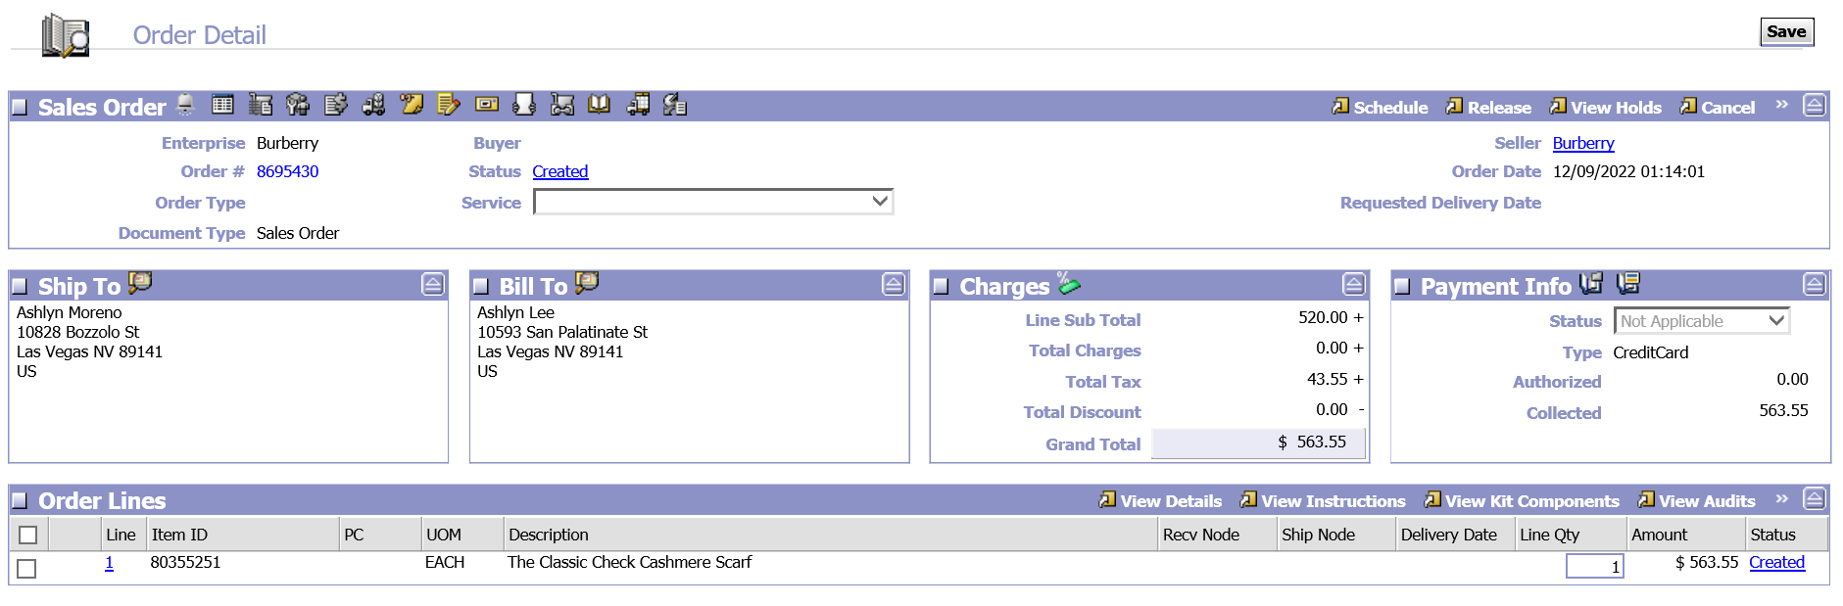

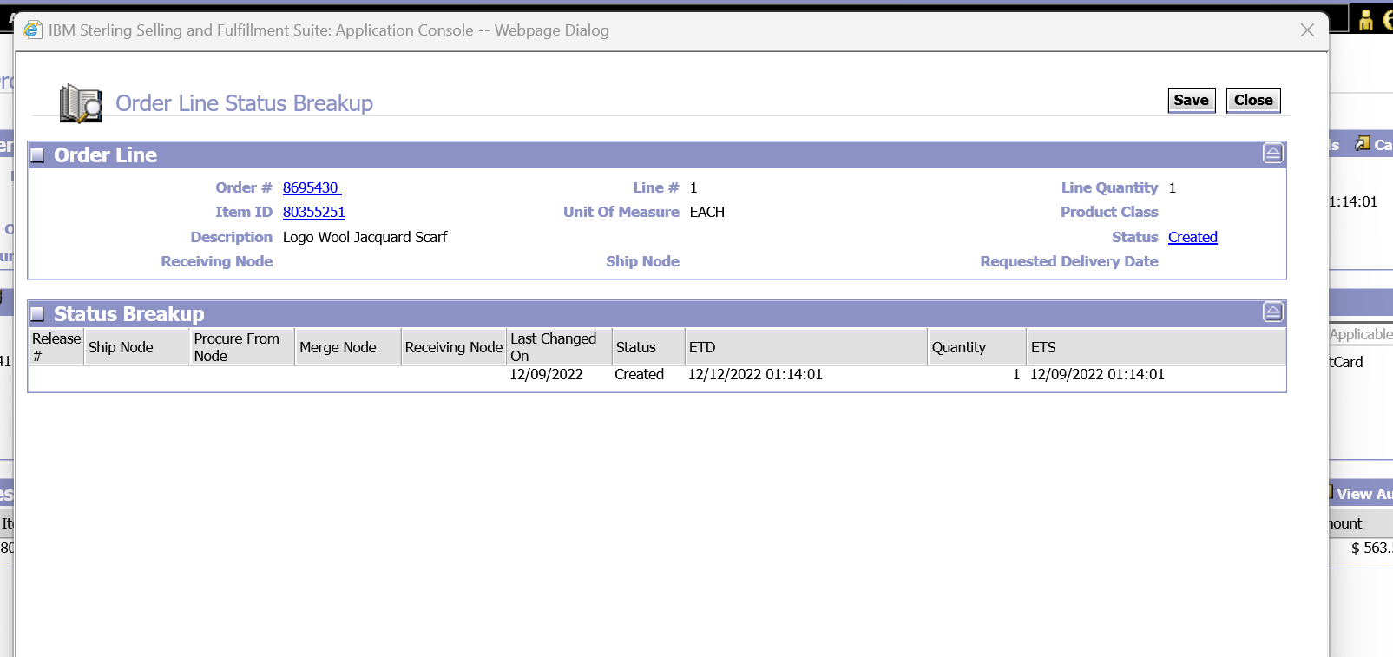

On Schedule

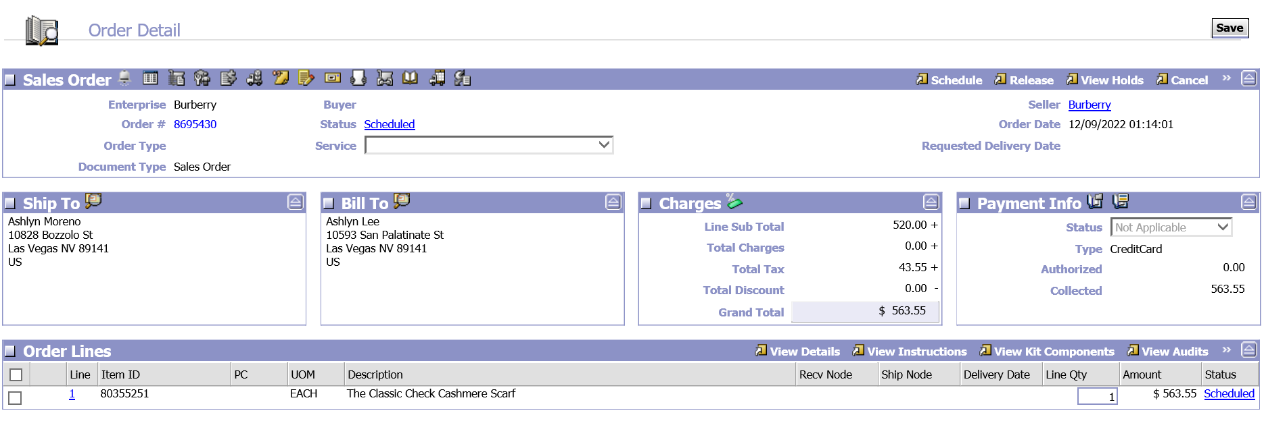

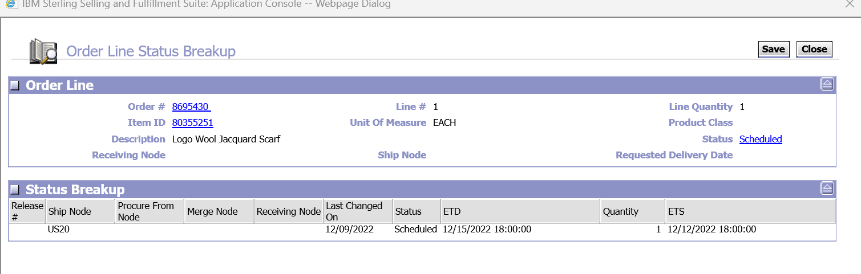

Expected Shipment Day – 12-12-2022

Expection - 14-12-2022(Considering the time taken for ServiceSku).