1. Today outbound HTTP connections use the below proxy:

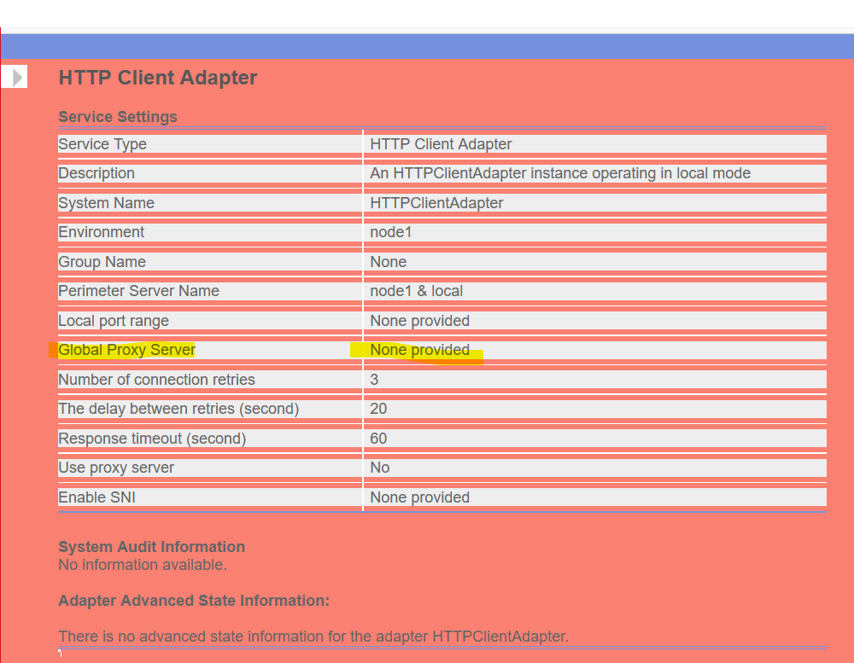

1. There is no Global proxy server configuration available for “B2B client”, which is needed for us to go outside the company network:

