ADJUSTINVENTORY
We need to open Store UI :- https://mattl-QA-1.oms.supply-chain.ibm.com/isf
Then need to open Inventory Management -> Lookup inventory
Need to Scan the Item for which we need to do adjustInventory.

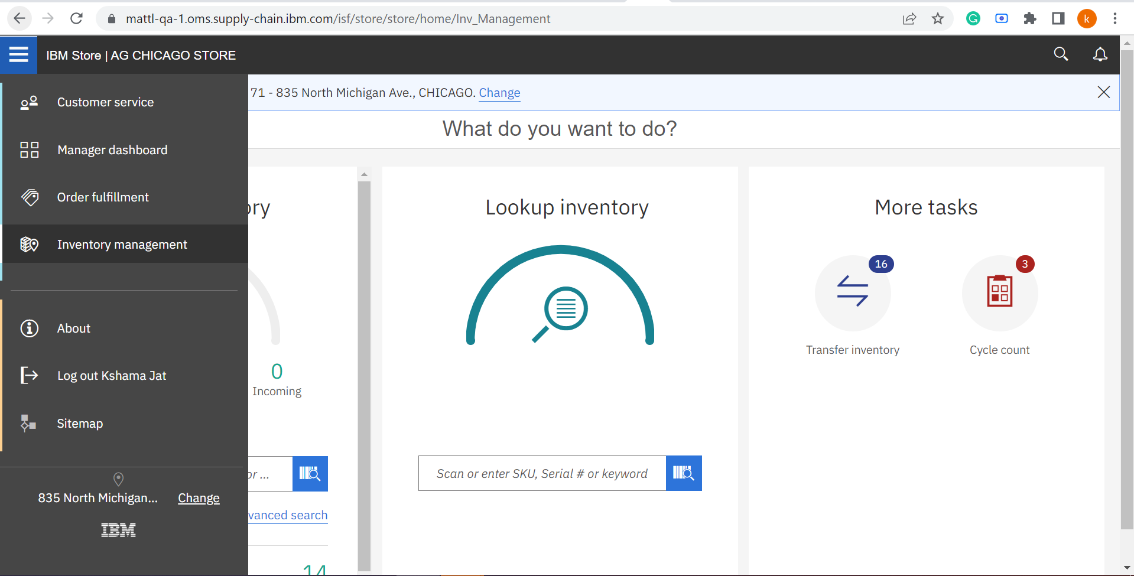

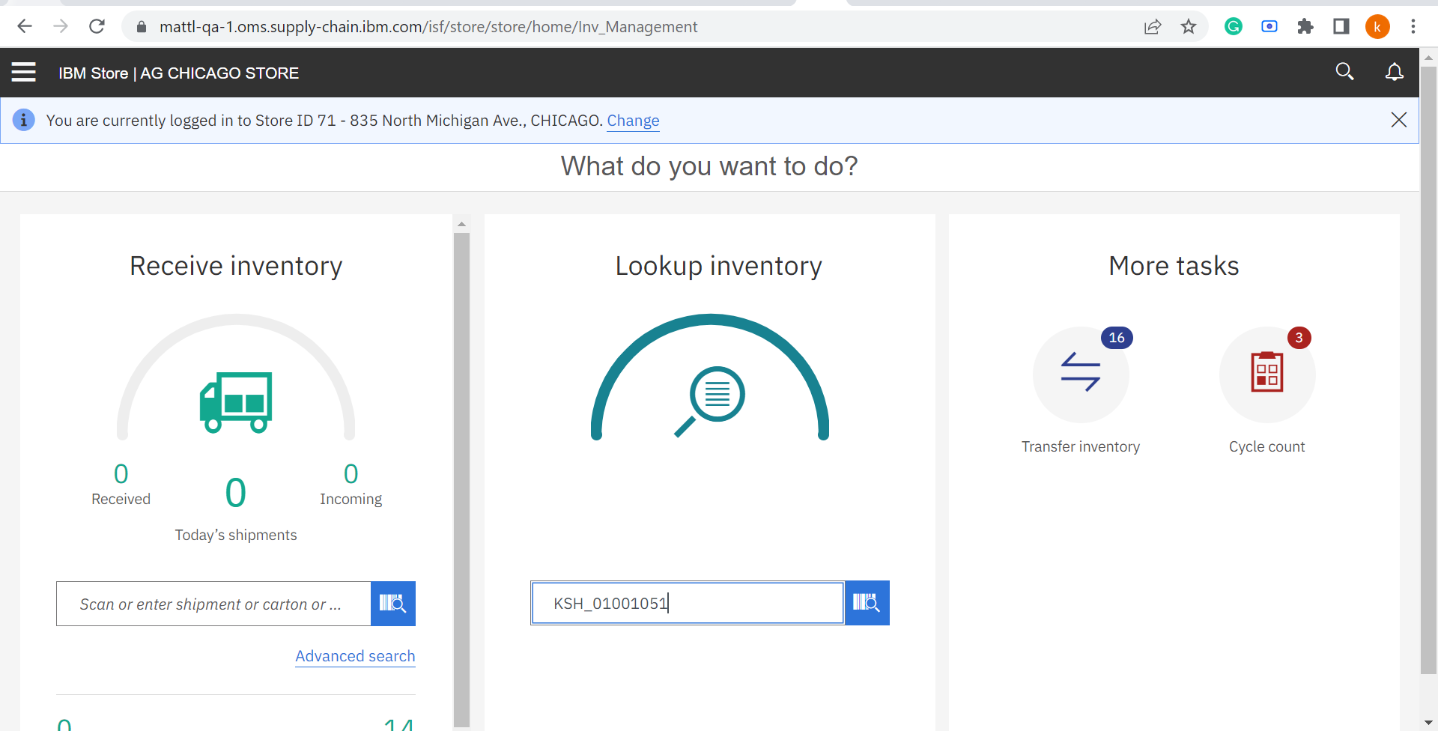

Then need to click on 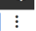 this then click on Add Inventory .
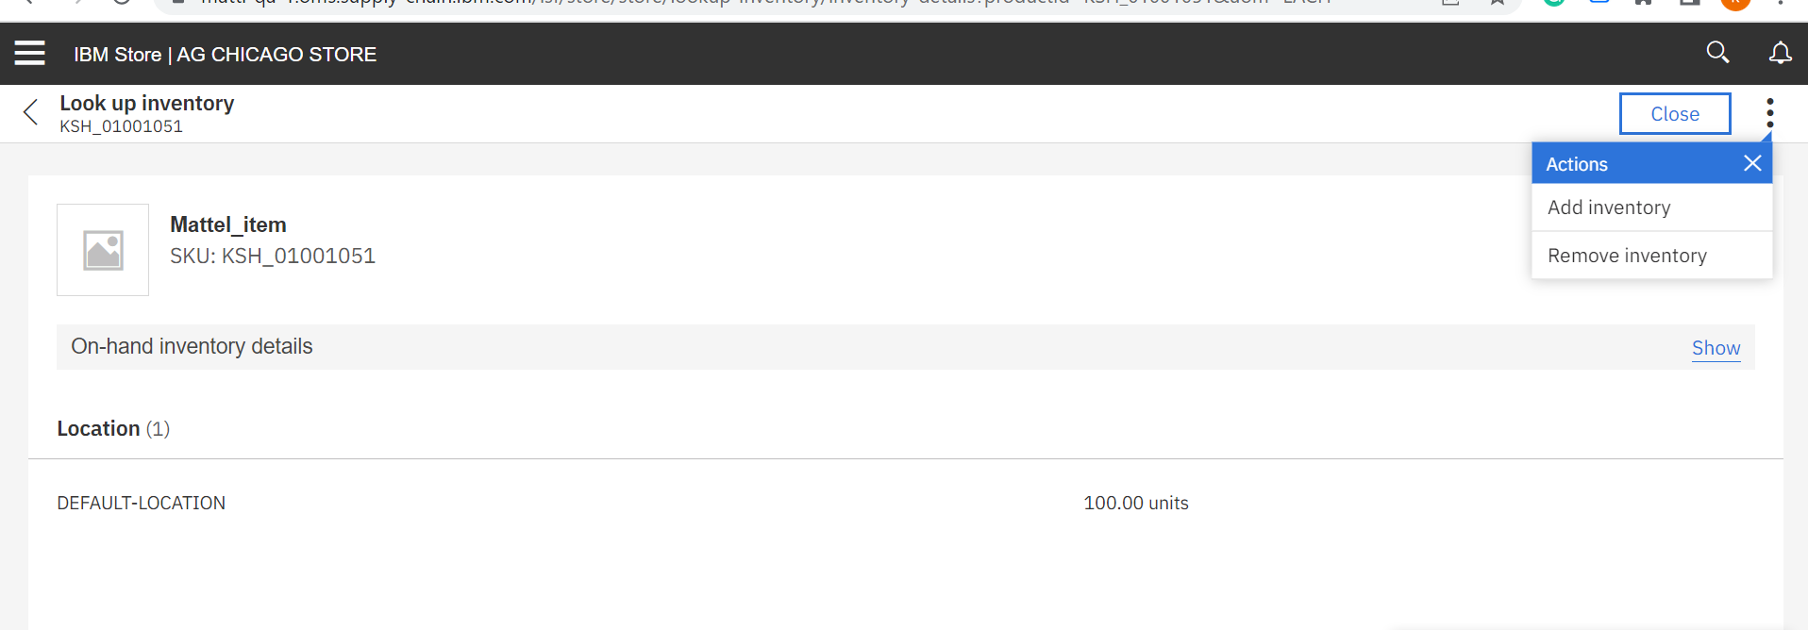
Need to fill the fields
Location, Quantity ,Product Class , Selected Reason, Comments.
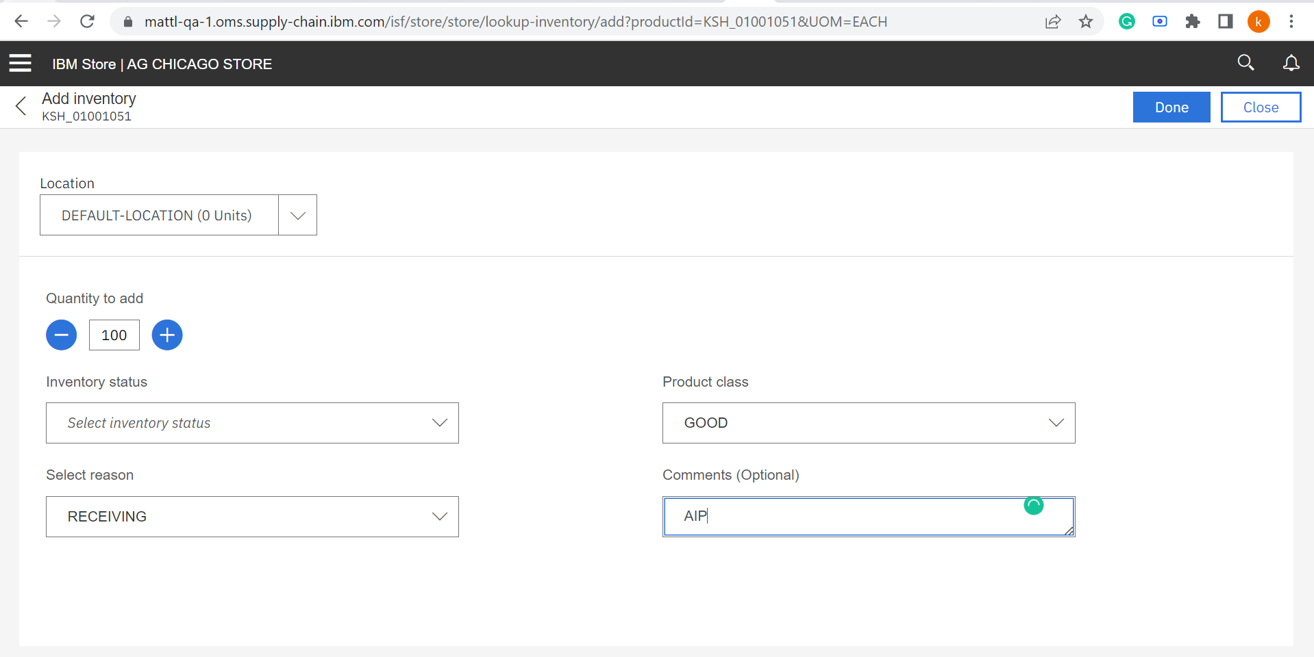

Then need to click on Done .

Then we can see Inventory Picture.
