Please find the list of certifcate which has the same serial numbers while the cerificate alias name is different.

When we create a relation ship we can either select the certificate or import.

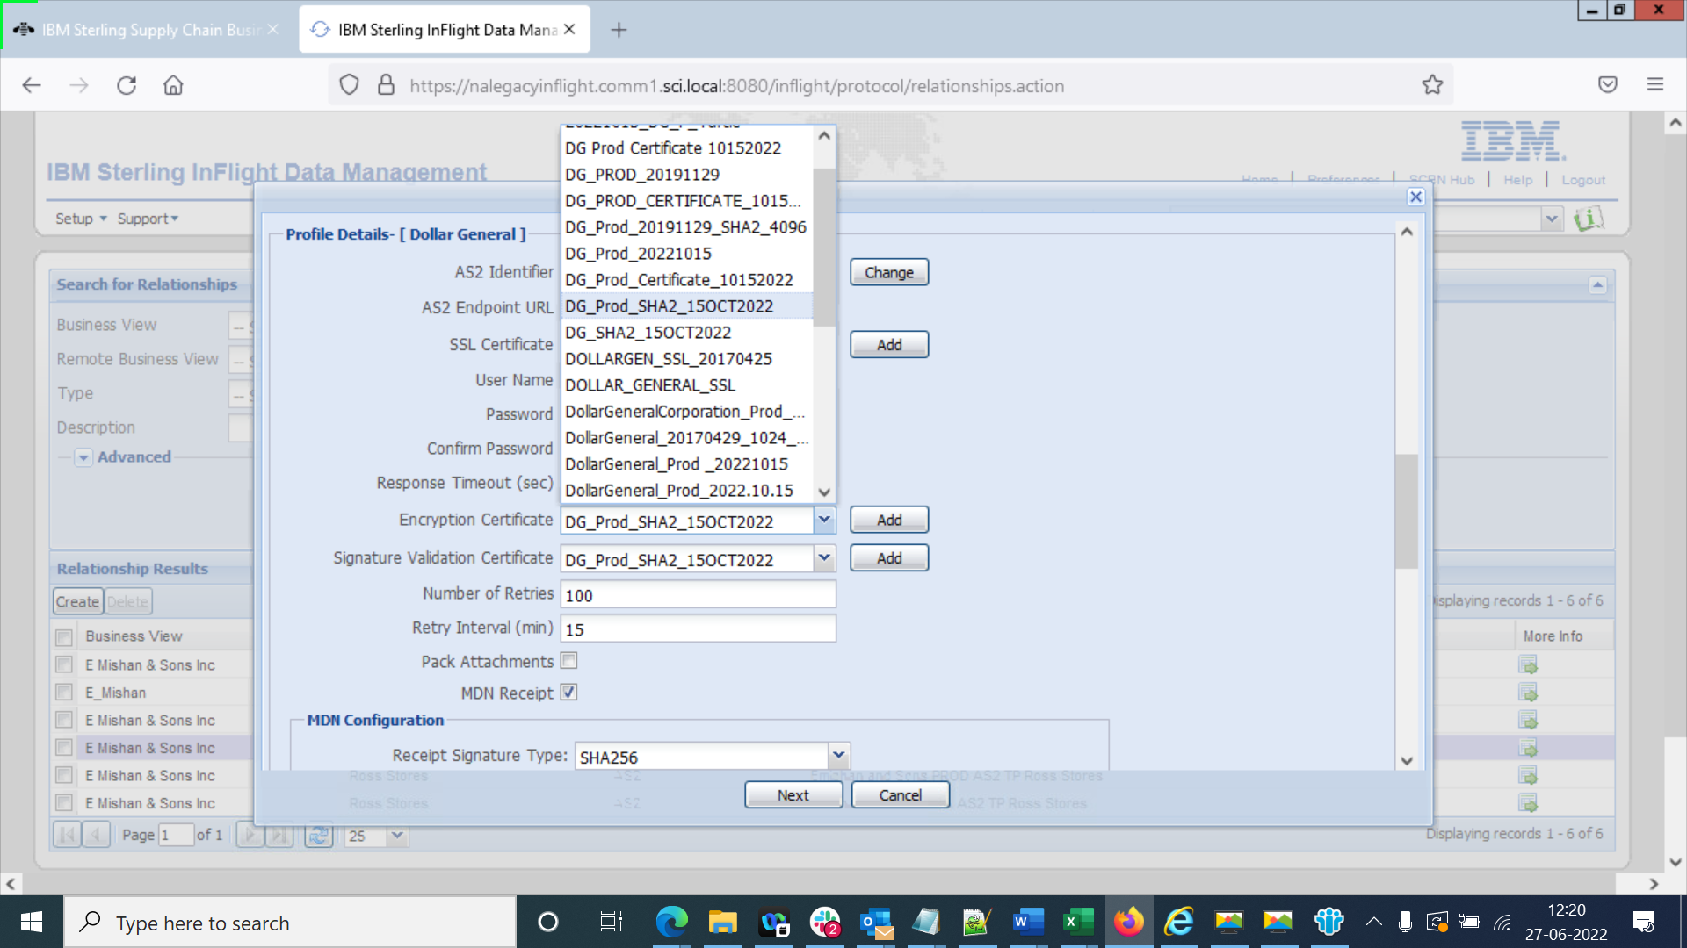

List of duplicate certifcates getting uploaded :

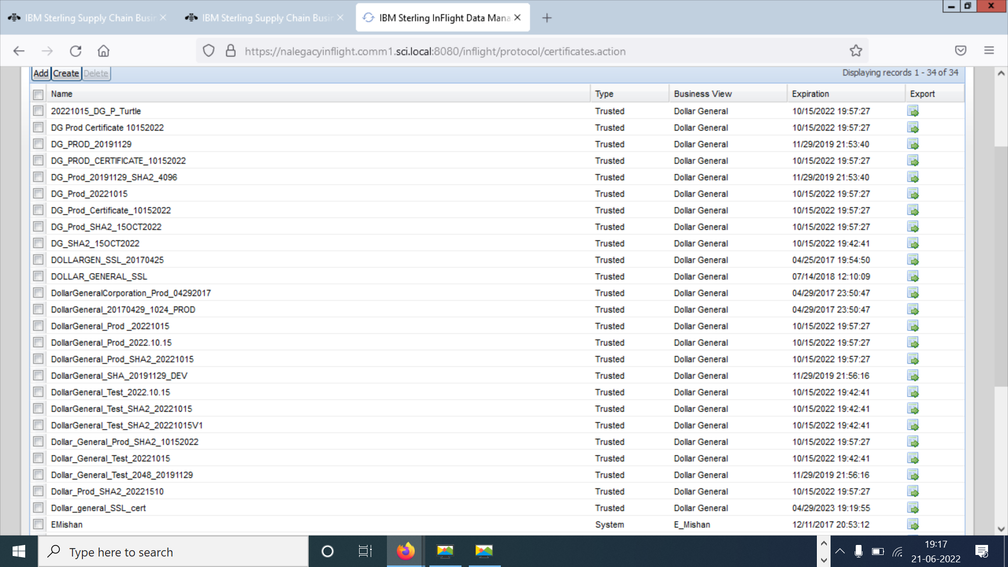

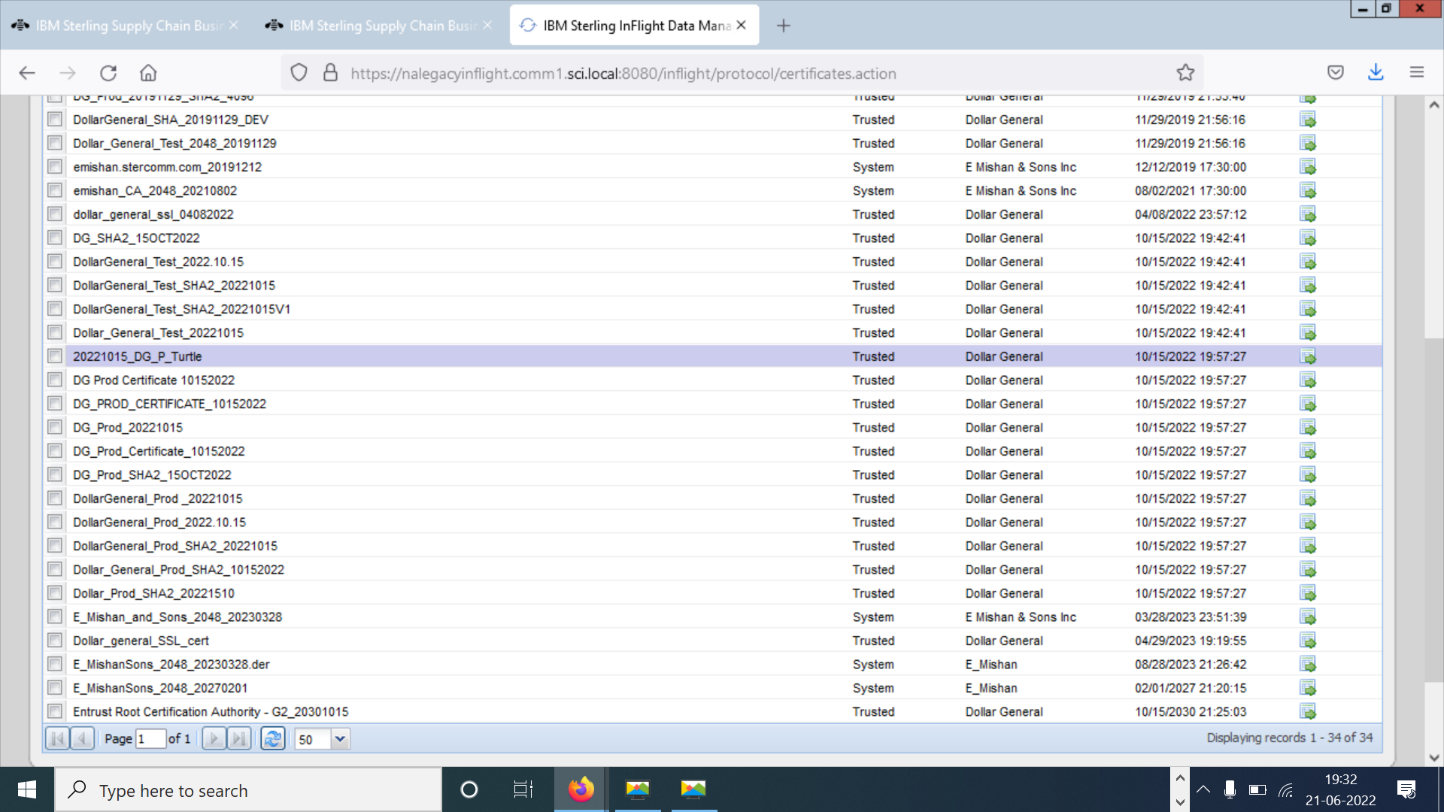

Here is the option to import , Multiple teams import various certificates into legacy inflight, which results in duplicate certificates getting uploaded with a different name while the serial numbers for most of the certificates are same. When we import the certificate into Inflight, System needs to validate serial number against the existing ones, in the certificate store (existing in legacy inflight) And serial number must be displayed, so that user can avoid importing duplicates while uploading and just select the existing one.

