**Realism About Ocean Energy**

**by**

**William Kingston**

**Abstract**

Exploitation of ocean energy has been the graveyard of countless hopes and a bottomless pit for those who financed any of them. Now, however, research in Trinity College, Dublin and the University of California has produced solutions that promise to be economic. Rock engineering can safely and invisibly capture wave energy *at* *the shoreline;* and offshore wind farms which are vulnerable to storms are replaceable by fleets of autonomous sailboats moving water turbines. These generate electricity for storage and use as hydrogen, and are the only way to capture most of the world’s wind energy, which is over the open oceans.

**Why has so much money been lost on ocean energy?**

In 2017, *Prometheus* published a review article on particularly thorough and unusual research from the University of Strathclyde on public financial support for ocean wave energy research in the UK.[1] This research was thorough, in that the authors studied no fewer than 444 publicly funded research awards to firms, from 2000 onwards. It was unusual, in that case studies inevitably tend to be about successes, but this one dealt with massive failure, because there was only scrap metal to show for public expenditure of £350 million. In fact, total British losses on wave energy research must have been well over a £billion, since public subvention only covered a part of firms’ costs.

The UK story reflects failure that has in fact been world-wide*.* Indeed, of all alternative energy sources, the huge potential of ocean energy is matched only by the losses incurred trying to harness it. More than twenty years ago, Bloomberg noted the enormous amount spent on it to no effect, one illustration of which is the record of the US Navy’s test center in Hawaii. Regular visitors to the annual All-Energy Exhibition in Scotland progressively sensed the deflation of the original optimism about this sector, as more and more money was lost in it.

The Strathclyde researchers provide many reasons for the British failure, but in addition to these, there seems to have been a lack of understanding (which indeed has been worldwide) of the tap root of the economic challenge which the harvesting of offshore energy faces. This is the huge variation between the energy of wind or waves that can be exploited, and that in storms which can destroy the equipment on which that energy capture depends. Both kinds of energy are linked, because wave energy is wind energy concentrated.

Meterologists distinguish between waves that are in the ‘mean’ range, ‘significant’ waves which are about twice this height, and ‘rogue’ waves, which are the result of storms and whose height is a multiple of both of these.

## This is illustrated in Fig. 1 below, which shows data from a buoy in the North Atlantic. For most of the month of February, 2022, the significant wave height was10m or lower, with individual waves somewhat higher. In the storm between 18 and 22 February, however, not alone did the significant wave height surpass 15m, but *an individual wave reached 28.1m*.

# 

Figure 1. *Wave data from North Atlantic buoy. provided by the Itish Meteorological Office.*

The problem for the economics of offshore wave energy arises from the fact that the energy in a water wave is proportional to the *square* of the wave’s height. If it is assumed that the capture equipment is designed to make money from the energy in waves up to 5m, the structure supporting it must still be able to withstand forces of more than 30 times what would be needed just for productive operation.

Oil and gas industries can justify the enormous cost of survivability for their offshore rigs because their output is both concentrated and continuous. Wave energy is both diffuse and intermittent, which is the very opposite. Moreover, the ratio cited above takes no account of the contingency factors which are normally applied to engineering projects.

In summary, if an investment in offshore energy is limited to what can obtain a return as long as wave heights are around the ‘mean’ level, it will inevitably be lost to exceptional storm waves; but if it has to finance structures that can withstand such waves. the return on it will be too low.

**Offshore wind energy**

As wind energy sites on land are becoming more scarce and subject to objections from environmentalists, developers are increasingly looking offshore for their sites, and are being encouraged in this by their Governments, even though this makes the energy up to three times more expensive. However, in this they face the same problem as wave energy developers do. This is the difficulty of making money in an environment where rogue waves put forces on the equipment which are such large multiples of those from waves low enough to be exploited. Turbine-makers have been trying to overcome this by going for scale (the largest unit on offer now is 13MW) but water depth must eventually put an end to this trend.

Offshore wind turbines cannot avoid being mounted on structures, whether bottom-fixed or floating, that are subject to wave forces. The height of waves depends not only on the strength of the wind, but on what is known as its ‘fetch,’ which is the distance over which it has blown to build up the wave. The fetch of the rogue wave in Fig. 1 was the entire width of the Atlantic ocean.

It is clear, therefore, that offshore wind developments will be confined to those areas near to land where fetch is low and wind strength has been reduced by friction with land surface. Denmark’s offshore environment is well protected in this way, but even that country, which has been a pioneer in the technology, is reported to be proposing to build two large artificial islands to overcome the problem of positioning turbines where their structures can be endangered by high waves built up by storm winds. It is significant that Scotland’s largest sea bottom-fixed wind farm is located off its East coast, where the whole of the country’s land mass protects it from rogue waves on the scale shown in Fig. 1.

**Alternatives**

The inevitability of destructive storms clearly places serious limitations on investment in offshore wave and wind energy exploitation in the ways that have already been tried. The objective of the present article is to draw attention to two promising alternative approaches whose time may have come. These are the result of long-term research in Trinity College, Dublin and the University of California at Davis.

In the case of wave energy, the change is to focus on capturing it *at the shoreline.* The energy in a wave is a circular movement, which ‘feels’ the sea bed at half the wavelength, causing the wave to break and lose its power. Consequently, wave energy at the shoreline is only half that offshore, but it is still prodigious. Much of it could be captured by modern rock engineering techniques. This type of energy also has an advantage over that of offshore wind, because waves generated by far-distant storms continue to deliver energy to the shoreline well after the wind has ceased to blow there.

For offshore wind energy, instead of fixing wind turbines individually to the sea bed or mounting multiples of them on large floats similarly anchored, the capture means can now be autonomous sailing boats moving turbines through the water. These are intrinsically more efficient than wind turbines, because the energy density of water is thirty times more than the wind blowing over it. Even more importantly, when threatened by a storm, the boats can simply furl their sails and ride it out, even over rogue waves.

Each of these alternatives will now be discussed in more detail.

**Shoreline wave energy**

Islands that are the result of volcanic action, such as the Canaries, have many natural ‘blowholes’ through which air is blown and sucked by the oscillating water column (OWC) of the waves at their lower end. The idea of capturing the energy in this movement is first found in 1976 Spanish patent No. 441706 (Fig. 2).

# 

# Figure 2. *Procedure for the use of sea energy in its natural agitation, from Spanish patent No. 441706 (1976)*

In the same year, Professor Alan Wells of Queens University. Belfast, invented an air turbine whose blades turn the same way irrespective of which side of them is impacted. This suited the reciprocal nature of the airflow from the oscillating water column (OWC) of wave movement, and in fact has been used in many attempts to capture wave energy since. His University secured UK Government funding to build a prototype (LIMPET­) on a cliff face in Scotland.[2] Although almost destroyed by a storm whilst being built, this delivered a small amount of energy into the Grid for many years, and was only finally decommissioned in 2018. A copy in the Azores, however, was destroyed by storm waves within a few years, which ended any idea of *building* on cliff faces.

**Man-made blowholes**

At much the same time as the LIMPET development,Trinity College Dublin (TCD) began research into a different approach to the capture of shoreline wave energy, with funding from the Irish Marine Institute. Instead of building on cliff faces, this uses rock engineering *inside* them to make artificial blowholes to capture the energy of wave movement. These OWC chambers would be invisible, their life would be indefinite because the rock of their cliffs has withstood erosion from waves over centuries, and they would require no maintenance nor undersea cabling. Depreciation charges on them would be either nil or close to it**,** and there would of course be no decommissioning costs. During exceptional storms, the airflow would be arranged to bypass the turbines, so that excess wave energy is dispersed in harmless waterspouts.

A US inventor obtained a patent for the same idea in 2005, see Fig. 3, but this was not exploited, probably because it did not show how to make the artificial blowholes, and lapsed in 2017. Since this capital cost is key to the economics of the concept, it was instead at the forefront of the TCD research at all stages.

# 

Figure 3. *Drawing from US patent No.6968683*

Making the OWC chambers could of course use the traditional method of drilling and blasting, but on the suggestion of a mining expert who was most helpful to TCD’s research, Paddy McConnell, the possibility of diamond wire cutting began to be investigated. This led to a design which uses pairs of cuts in intersecting planes that neatly excise a wedge of rock to make an OWC chamber. A way of eliminating wasteful drilling through high cliffs by enabling access just above the waterline to make OWC chambers of this kind, was also developed.[3] In rocks such as basalt and granite no reinforcement of the cliff around OWC chambers is needed, and inexpensive means of providing this for weaker rock structures can be envisioned.

These techniques make it possible to think of long stretches of cliff face being honeycombed with internal chambers within which ocean wave energy can be captured economically, invisibly and silently. At suitable sites, the technique of raise boring or even use of tunnel boring machines can be foreseen as means to reduce the cost of making a multiplicity of OWC chambers still further.

The Irish Lights Commissioners have offered the use of their site at Loop Head, Co. Clare, for the pilot application. This site scores highly in terms of its very strong wave power, which averages no less than 34kW per metre of cliff face. However, its rock would reed to be reinforced around the area of the OWC chamber, which would increase the cast compared with doing the pilot work where the rock is inherently stronger. Cliff sites where the rock is basalt or granite would obviously be better, and one of these may in fact preempt Loop Head for the pilot work. Wherever this work is done, the key results from it will be what proportion of the wave energy reaching the shoreline can be translated into usable pneumatic power, and at what cost.

When the TCD research first became known about, it was thought that disused coastal copper mineshafts in Cornwall could be ready-made OWC chambers, but Government-funded research showed that water depth at the cliff base is a necessary condition, and these sites did not have it.[4] Loop Head has more than enough depth, and the pilot installation there or elsewhere will be able to benefit from the expertise of the firm which developed very successful measurement of air throughput in the Cornwall research.

If a substantial proportion of the pilot location’s shoreline wave power can be captured for the capital costs which have been estimated, it will be clear that a new world-wide source of clean energy is in prospect. An important financial aspect of this is that the permanence of the OWC chambers makes investment in them a candidate for funders such as insurance firms, that look for safe returns in the long term.

**Two particularly appropriate ways of using shoreline energy**

Generating electricity may not be the ideal way to use shoreline wave energy. Many suitable sites are remote from populations and running the grid out to them may not be justified on cost grounds. It could also be the subject of objections by environmentalists.

On the other hand, there are two applications for this kind of energy which are neither location- nor time-dependent. The first of these is the production of hydrogen, which is the best prospective replacement for fossil fuels. It can be obtained by applying electrical energy to water (hydrolysis) to split it into hydrogen and oxygen. Fresh water is a scarce resource which is becoming scarcer, but sea water can now be directly split, and is effectively unlimited. Not alone is producing hydrogen an ideal use for shoreline wave energy, it is an obvious rival to battery storage for electrical energy from any source. It is also easily transportable in the form of ammonia.

The second particularly suitable way to use shoreline wave energy is to reduce the amount of carbon dioxide, one of the most important pollutants in the air. Direct removal of it is now being carried out on a commercial scale, but the process requires energy, and there would be little point in using fossil fuel to obtain this. Consequently, Climeworks, the Swiss firm involved, is exploiting Iceland’s hot springs.[5]

Because shoreline wave energy is an incomparably greater resource, the firm has offered to provide test equipment for TCD’s pilot research. As with hydrogen production, neither remoteness nor variability of output is a drawback to this application, since carbon dioxide can be extracted from the air anywhere, at any time.

**Energy from ‘wind over water’**

The idea of harvesting ocean wind energy by sailboats moving turbines through the sea was first advanced in 2009 by two researchers in the University of California at Davis, Max Platzer and Nesrin Sarigul-Klijn. They have continued their work on it, and recently published a comprehensive book.[6]

Quite independently in 2015, TCD led a proposal for EU funding of practical trials of the same concept, stressing autonomous control and including hydrogen storage of the energy.[7] Hydrogen is the best alternative to fossil fuels in sight and sea water is an inexhaustible source of it. Splitting this to obtain hydrogen requires energy, and the winds which blow over all the world’s oceans can provide this. The other partners in the proposed research were the German turbine manufacturer. Schottel, and the Polish and Canary Islands oceanographic Institutes. The Polish research vessel is unique in that it can be sail-driven, and Schottel had developed a suitable turbine:-

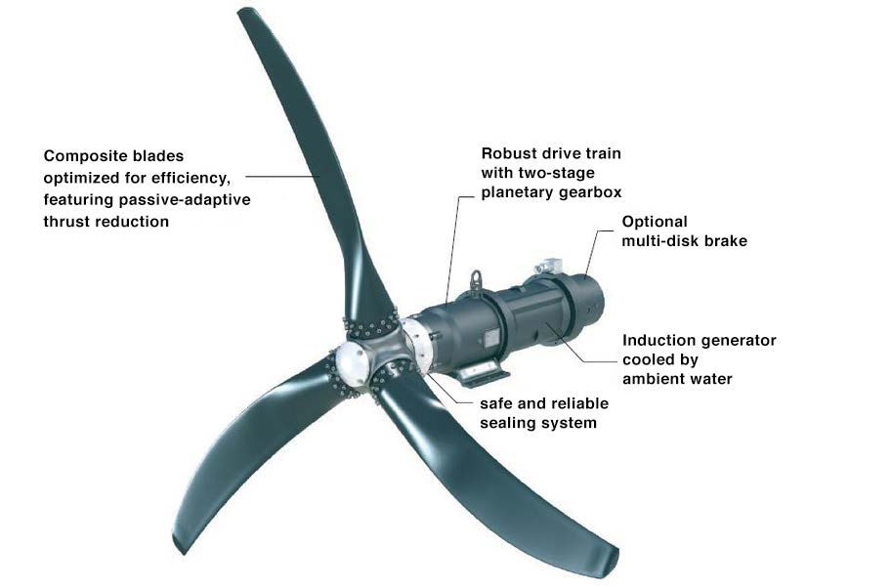

Figure 4: *Schottel instream turbine*

This proposal was not funded on the single ground that ‘it was not ambitious enough.’ Whether or not this evaluation did justice to it, the same will certainly not apply to its revival, this time in the United States. The Dublin and California researchers have joined forces under the leadership of a successful entrepreneur and round-the-world yachtsman, to incorporate the many important advances in the relevant technologies that have been made in recent years,including:-

Sailing boat design has reduced ‘drag’ on hulls, so that racing yachts can now move faster than the wind that drives them - one has been sailed around the world at an average speed of 27 knots. The ‘crewless ship’ concept has been widely used for offshore data collection, and has now reached the stage where an unmanned craft is expected to cross the Atlantic in 2022.[8]

Remote control of sails from the cockpit can be adapted to control from a shore base. Battery storage of electricity has made great progress, and hydrogen can now be obtained from sea water directly, thus saving the energy needed to desalinate it first. Independent testing of this technique shows that it is 95% effective.[9] It can now be stored as a hydride at a third of the cost and more safely than as a gas, according to the firm developing the technology.[10] Instream turbines have been widely proved in river and tidal power applications. ‘Traction’ sails have been developed to a claimed level of power of 2 megawatts to reduce cargo ship fuel costs:-

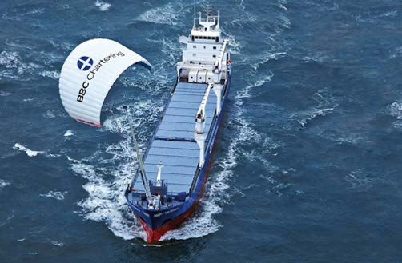

Figure 5: *Additional sail-power development – high altitude traction sails.[11]*

These developments reinforce four important basic advantages which the sailboat approach has over offshore wind turbines. These are, firstly that it is the only possible way of capturing all but a small fraction of the world’s wind energy; secondly it needs no costly and delaying planning and foreshore permissions; thirdly, it can suffer no objections from environmentalists; and fourthly, it can use shrouded turbines, which can increase efficiency by up to five times.[12] Shrouded turbines on the top of high pylons tor wind energy capture are problematical, but fit well in water.

The planned ‘wind over water’ research will use multihull vessels, using the great amount of information now available from the development of high speed racing yachts, to produce a modular design which can be produced in large numbers by builders all around the world. The practicality of shrouded turbines will be tested, and battery storage will be compared with obtaining hydrogen from sea water by the new method of electrolysis, or with previous desalination. Since these boats will have to be unmanned, all possible means of remote control of the entire range of onboard systems will be investigated. The US arrangements for public provision of seed capital are incomparably the best in the world, so that it is possible to foresee the prototype of ‘the green energy ship’ afloat within the next few years.

**Conclusion**

Completion of the research trajectories outlined above could therefore have a first result in the effectively limitless energy of the ocean waves which currently beat uselessly on **the** shorelines of the world, being harnessed for powerful mitigation of climate change effects.

At least an equally strong claim can be made for the research into autonomous sailboats moving turbines, which could eventually lead to capture of energy from the winds that blow over most of the globe’s surface, to make the hydrogen economy an economic reality. After reviewing the case for it, the US National Research Foundation has invited its proponents to submit a proposal which could lead to seed funding of more than $1 million.

(William Kingston is retired Professor of Innovation in Trinity College, Dublin).

**wkngston@td.ie**

**+3531 269 2659**

1. **Kingston**, William. **Prometheus (Routledge)**. June,

   2017, Vol. 35 Issue 2, p145-158.
2. The Queens University of Belfast (1998-20002) Report on Contract No.

   JOR3-CT98-0312 for Islay LlIMPET Wave Power Plant.
3. Patent GB2582713, and see UK Patent Office Opinion in its documents list. on citation in related PCT Application.
4. Department of Trade and Industry (2004) The Potential for using disused coastal mineshafts to exploit wave energy. URN 04/1791.
5. Climeworks.com/roadmap/orca
6. The Green Energy Ship Project (2021). Springer Briefs in Applied Science and Technology.
7. The full text of the proposal is a available at
8. Mayflower400uk.org
9. See Patent Application GB2589074.
10. See plasmakinetics.com
11. See skysails-marine.com
12. See Chapter 21 of Reference 6, \and US patents 11022088 and 111174829.