Order no: Y100008291

Yfs_order_date table below shows YCD_FTC_PROMISE_DATE of 2022-04-27 (EXPECTED_DATE and ACTUAL_DATE) on the line.

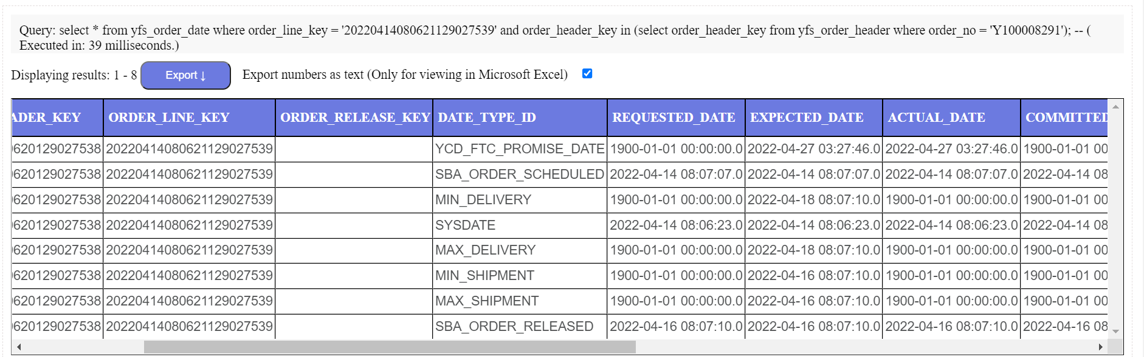

YCD_FTC_PROMISE_DATE is not available in Order Hub.

