As traditional IBM SCM on premise applications have read only access, we need similar read only permission for the SIM UI as well.

We suggest Read Only users have access to the below screen, where the user has the ability to only view the details and will not have permission to edit or delete or add, please feel free to add any other screens/options that can be provided for Read Only users without edit, delete and add access.

1. Search
2. Advanced Search
3. Listing with filter and sorting
4. Summary screen and action menu will not be enabled.

Please find below the sample screens which need to be leveraged to Read Only users, **please consider all OOO product provided screens and check the feasibility of enabling the read only access. Please add configuration screens as well with read only mode, so that read only users will have visibility on the configured data, and will not have permission to change.**

**Pick Order: -** provide access search, hyperlink access for the below screen

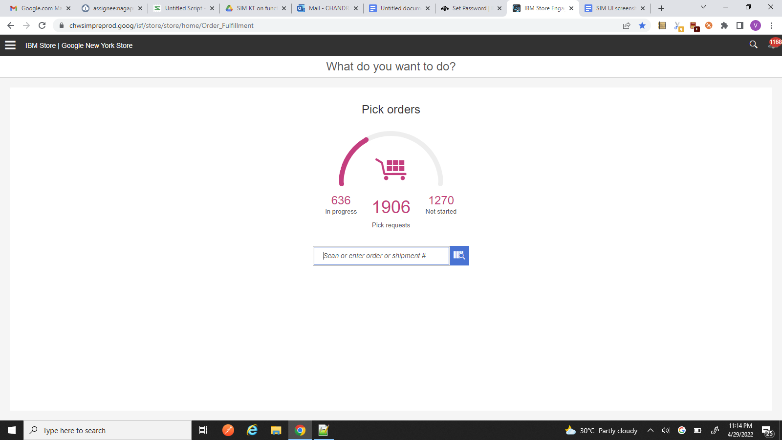

**Walk_in Pick Order list :-**  Disable Pick Order button to avoid picking the order, but enable pick hyperlink to view Pick Summary screen with filter and sort options.

**Note:**  if IBM feel the pick execution screen can be provided with read only mode, we are fine with that too.

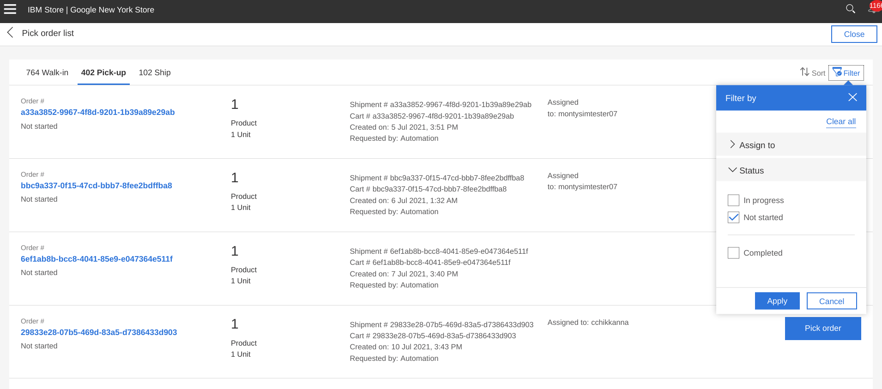’

Click of hyperlink will open the below Pick summary screen, disable all action menu as below

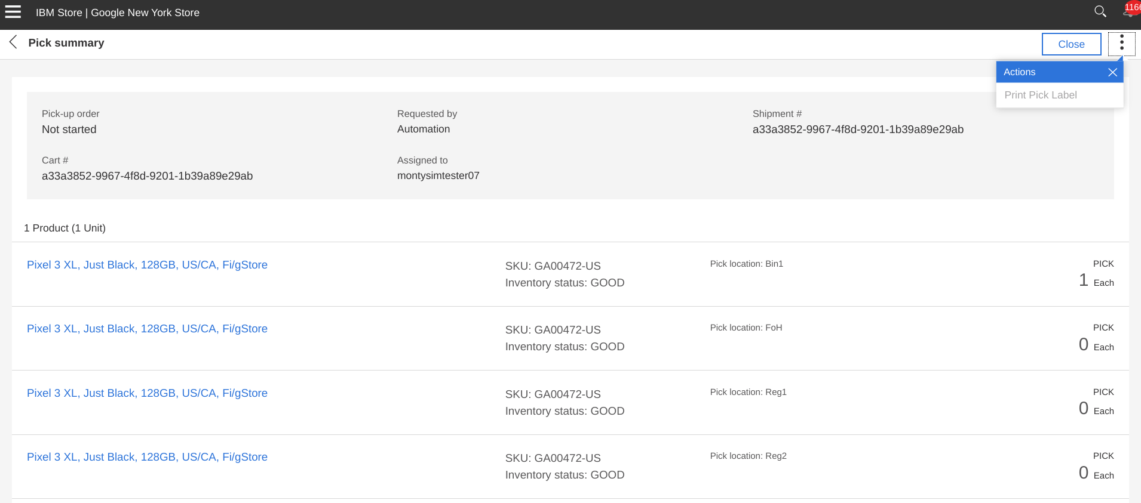

Enable simple search and Advanced search for the read only user

