UNH UNT Syntax 4 SI Control number configuration

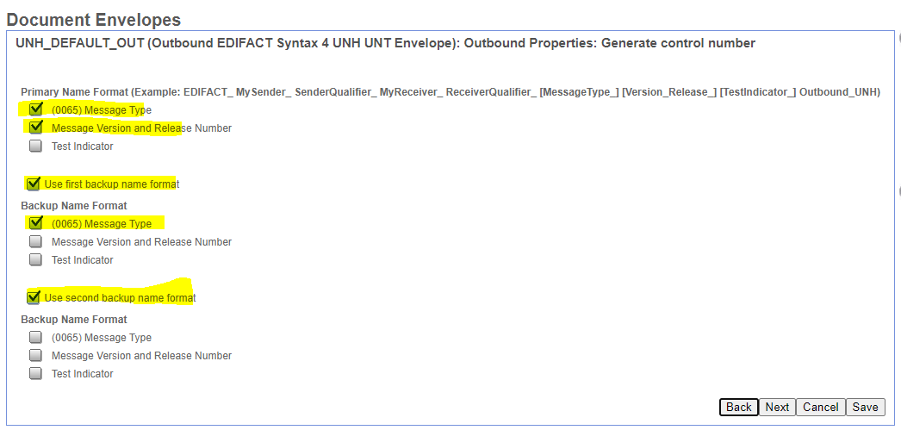

After import to ITXA the Control number configuration looks like this

