We are not looking for anything fancy just the ability to get to the data via SQL queries. Thanks.

**Inbound Transmission:**

Drilling down in the Inbound Data:

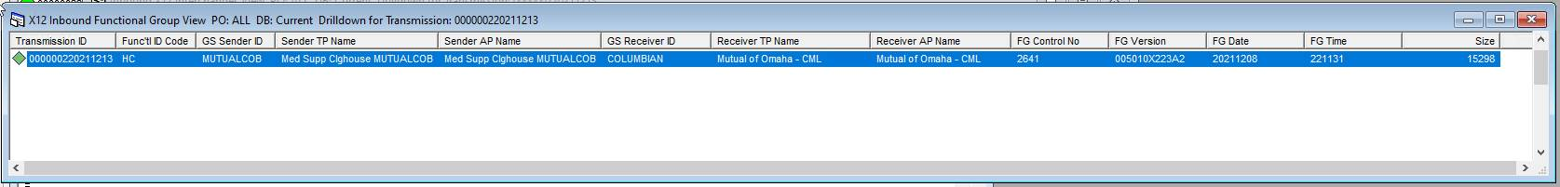

**Outbound Transmission:**





