As per our requirement for procurement orders, Within the distribution group US_COLL_P1,

* First priority should be given to the node which is within 200 miles away from collection store
* Second priority should be the node which is within 500 miles away from collection store
* third priority should be the node which is within 1000 miles away from collection store

Current configuration of procurement rule:

DOM🡪Cross Application🡪Order promising🡪Sourcing and scheduling🡪Procurement🡪Sourcing rules

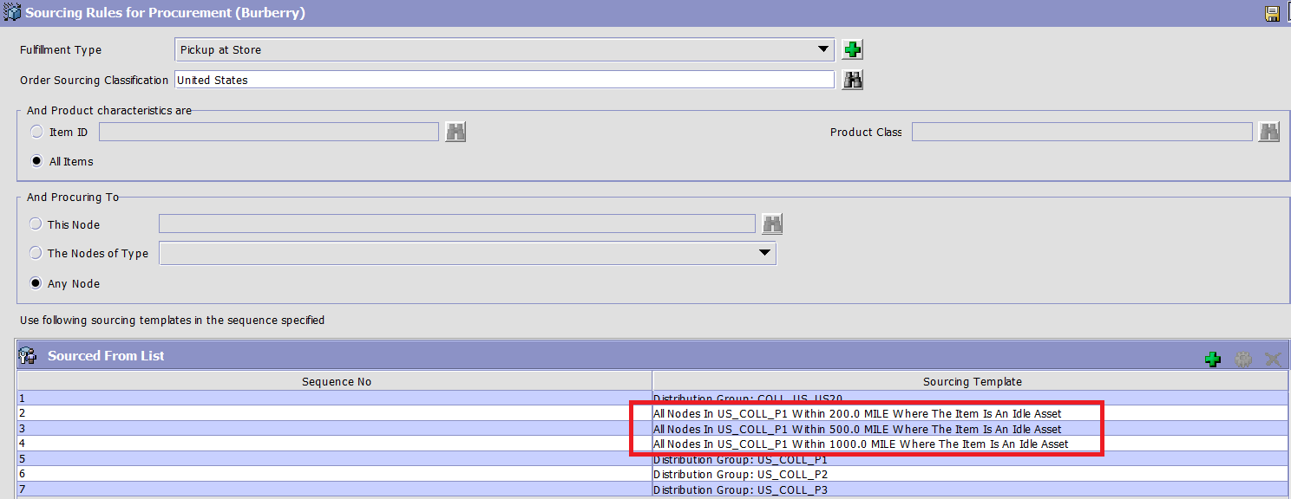

Sourcing template details

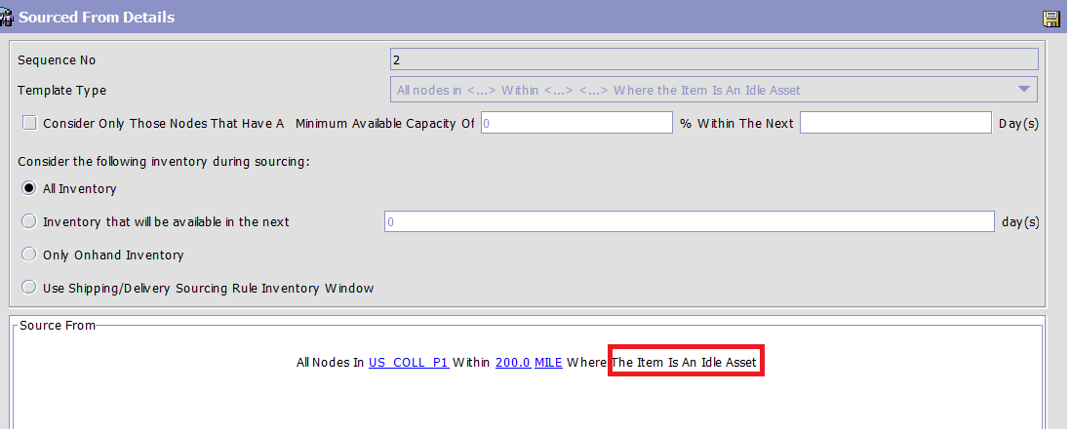

As highlighted in the above screenshot sourcing template says “All Nodes In US_COLL_P1 within 200.0 MILE where the Item Is An Idle Asset”

This template would work(it would consider the distance) only if item is marked as idle asset, Otherwise it does not work as found from our testing.

**Request For Enahancement(RFE):**

**We need Procurement rule where the sourcing template is only based on the distance and not tagged with idle asset flag.**

We would like to use the distance-based procurement for our implementation without considering the idle asset configuration.

**Screenshot of Sample sourcing template that we are expecting:**

As shown in the below picture we would like to have a procurement rule without tagging any idle asset configuration with the distance. **Sourcing should be purely based on the distance.**

