Contents
Application Details 1
Requirement 1
Challenges 1
Business Benefit 1
Additional Notes 1
Screen Shots 1
Configuration Available at Present 1
Suggested/Proposed 2

Application Details

Version: IBM Sterling OMS V10
Fix Pack: 27

Requirement

Business user wants to configure a coupon rule which can provide payment type discounts as listed below.

- If payment type is American Express provide 5% discount
- If payment type is Master Card provide 10% discount

Challenges

- At present coupon configuration allows specifying only one payment type.
- Due to this restriction business user must configure multiple coupon rules for each payment type for which discounts are to be given.
- We are also required to notify customers about coupon ids for each payment type.

Business Benefit

- Reduced effort for business users to set up and validate.
- Less customer campaign emails.
- Customers need not remember multiple coupon codes to while placing orders

Additional Notes

- All other criteria should work the way it is now.

Screen Shots

Configuration Available at Present

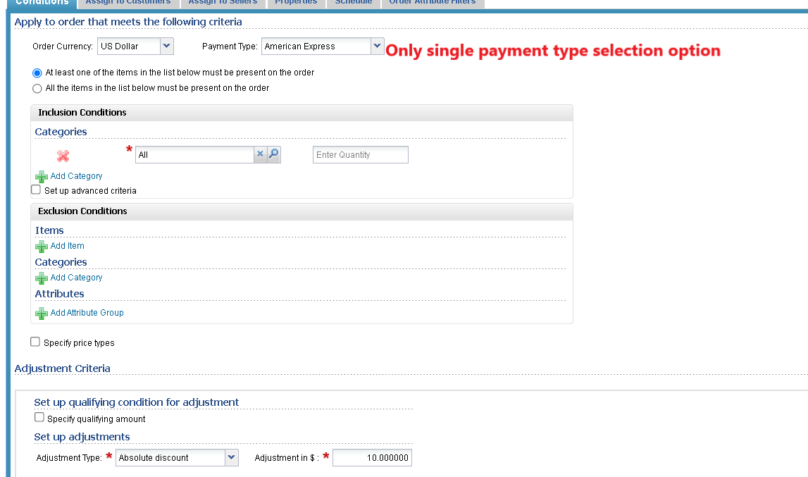

Suggested/Proposed

