Step 1: Create order with XML below. Order has 3 lines, 2 of which have line hold applied.

|  |
| --- |
| API: createOrder  Input:  <Order AllocationRuleID="MAT_B2B_SR" PaymentRuleId="DEFAULT" BillToID="ABC305000" ShipToID="ABC305001" ShipToKey="2021111805031518422530" BillToKey="2021111805030718422136" EnterpriseCode="B2B" EntryType="EDI" DocumentType="0001" BuyerReceivingNodeId="VKK01346" CustomerPONo="AB21346" AutoCancelDate="2021-12-18 13:07:55.0">  <OrderLines>  <OrderLine DeliveryMethod="SHP" OrderedQty="1" PrimeLineNo="1" FulfillmentType="MATTEL_SHIP_B2B_SOURCING" ValidateItem="Y">  <Item ItemID="GVF11-11111" ProductClass="GOOD" UnitOfMeasure="EACH"/>  <OrderHoldTypes>  <OrderHoldType HoldType="B2B_LINE_TEST"/>  </OrderHoldTypes>  </OrderLine>  <OrderLine DeliveryMethod="SHP" OrderedQty="1" PrimeLineNo="2" FulfillmentType="MATTEL_SHIP_B2B_SOURCING" ValidateItem="Y">  <Item ItemID="GVF11-33333" ProductClass="GOOD" UnitOfMeasure="EACH"/>  <OrderHoldTypes>  <OrderHoldType HoldType="B2B_LINE_TEST"/>  </OrderHoldTypes>  </OrderLine>  <OrderLine DeliveryMethod="SHP" OrderedQty="1" PrimeLineNo="3" FulfillmentType="MATTEL_SHIP_B2B_SOURCING" ValidateItem="Y">  <Item ItemID="GVF11-44444" ProductClass="GOOD" UnitOfMeasure="EACH"/>  </OrderLine>  </OrderLines>  </Order> |

Step 2: Login to Order Hub. Navigate to Orders->Outbound->Search outbound orders and search for order no: Y100004136. Order details page shown below comes up. Lines 1 and 2 should be marked in UI that holds are applied but it is not.

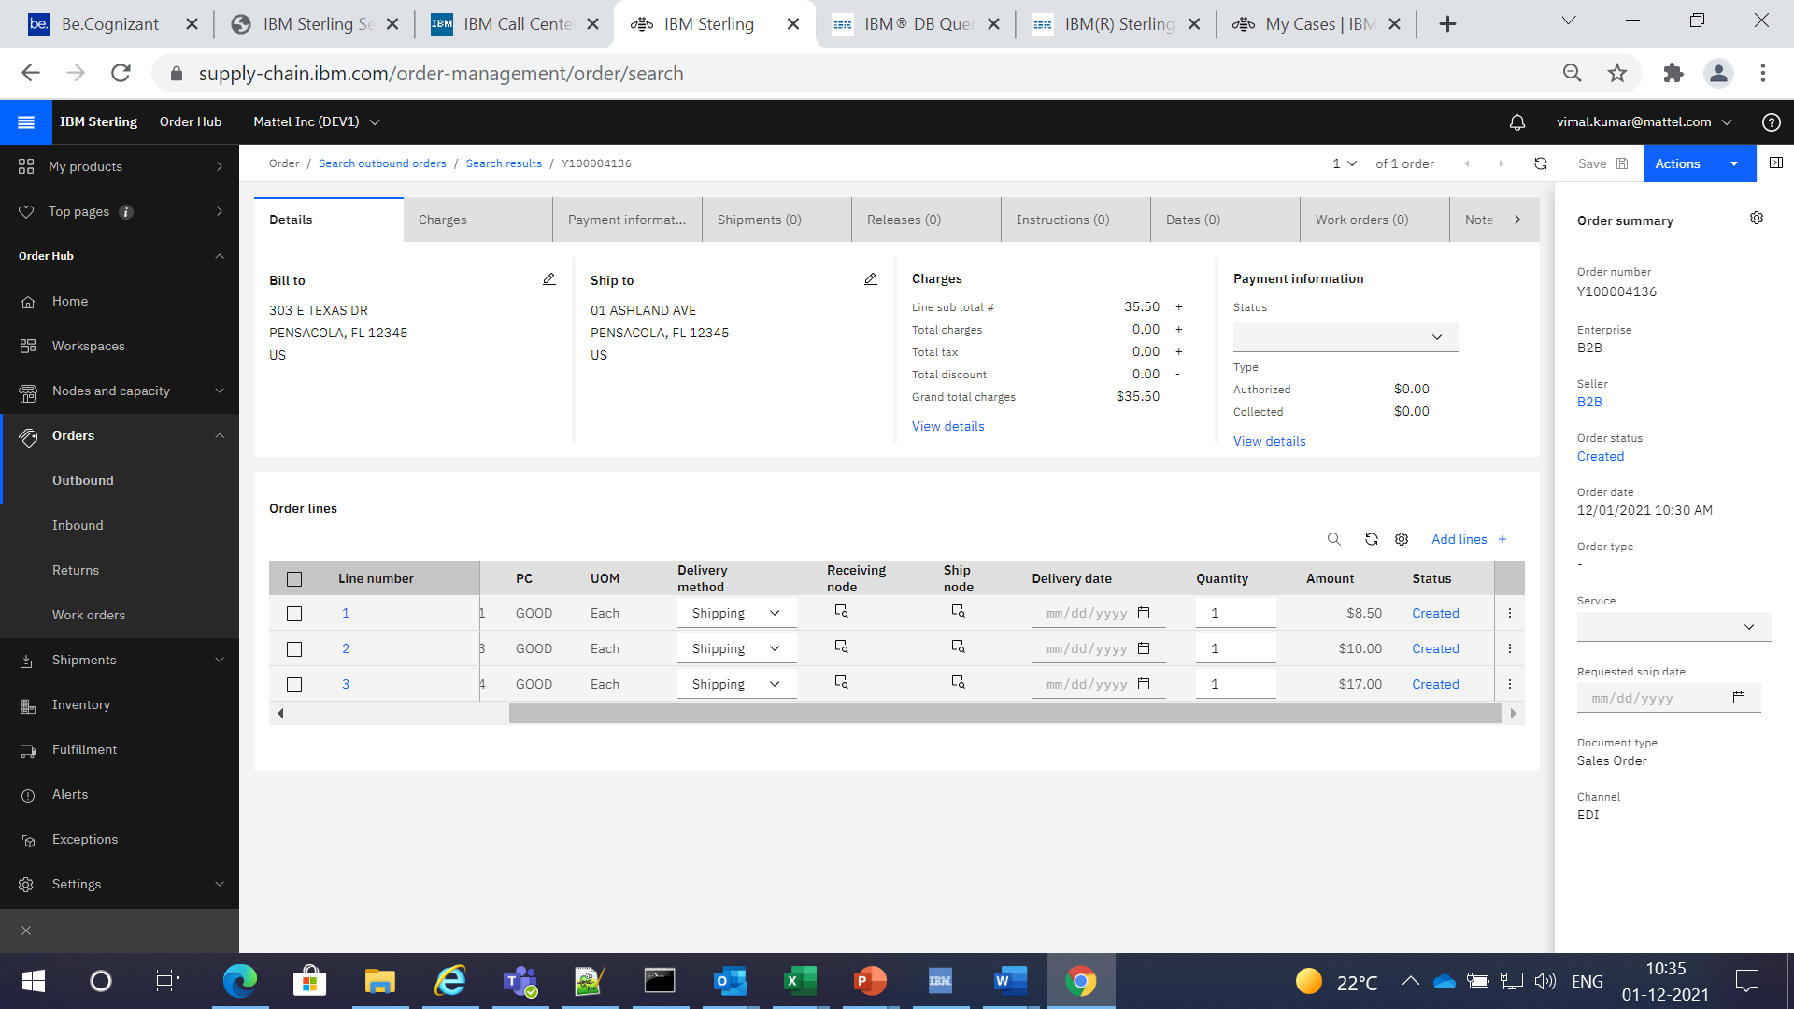

In the Order->Holds tab, only order level holds are displayed.

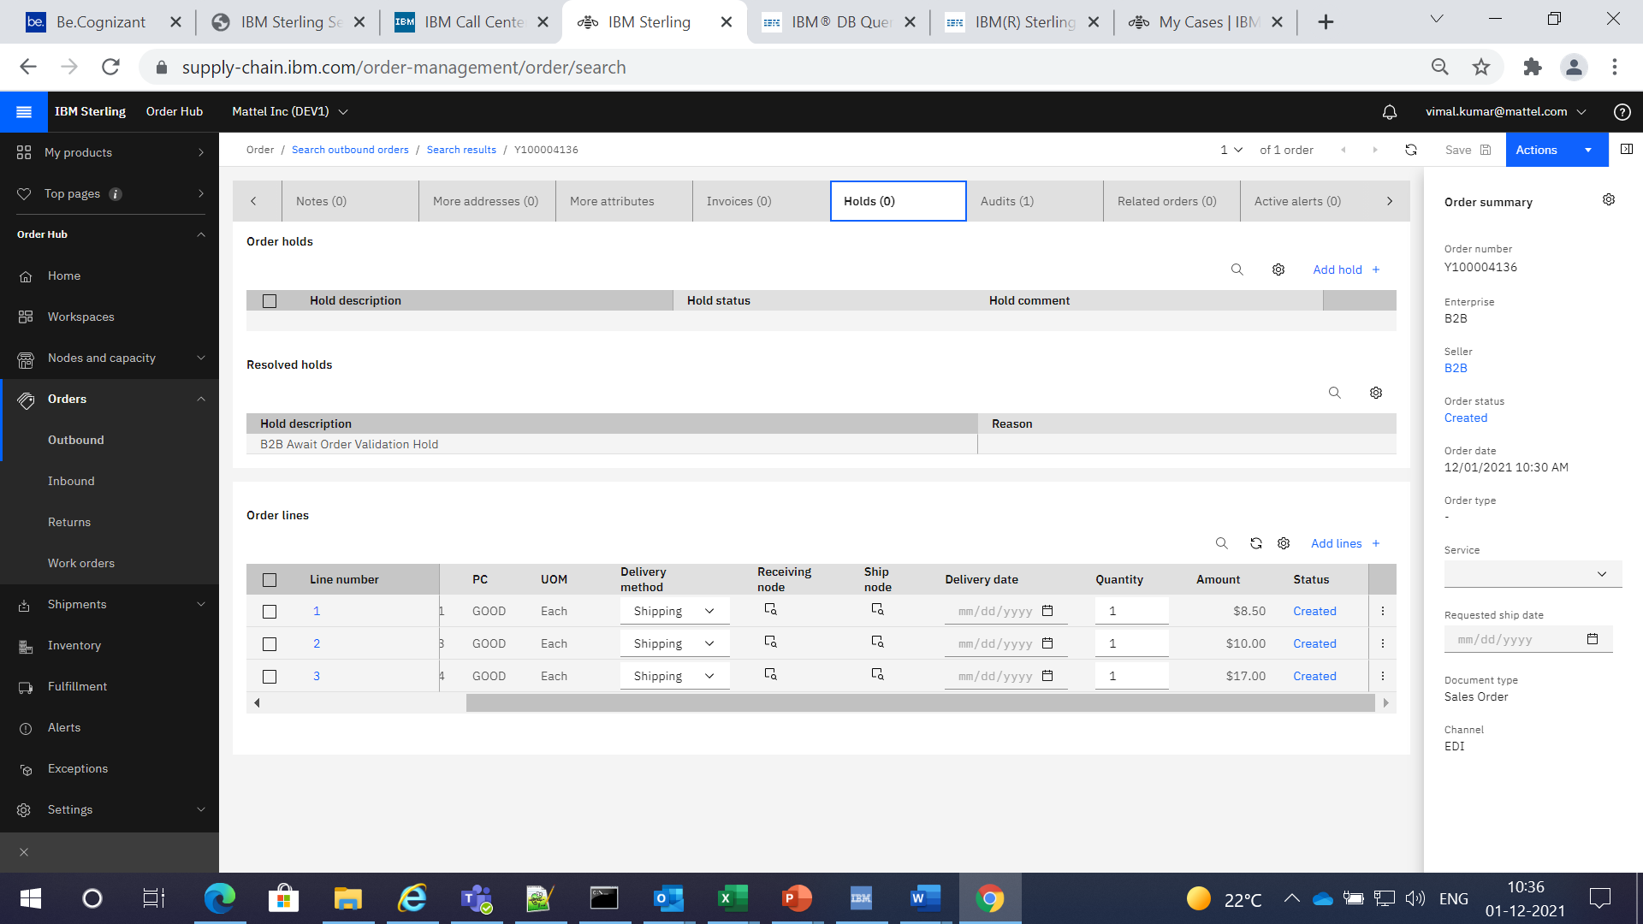

On going to order line details, there is no option to view/resolve/add line level holds.

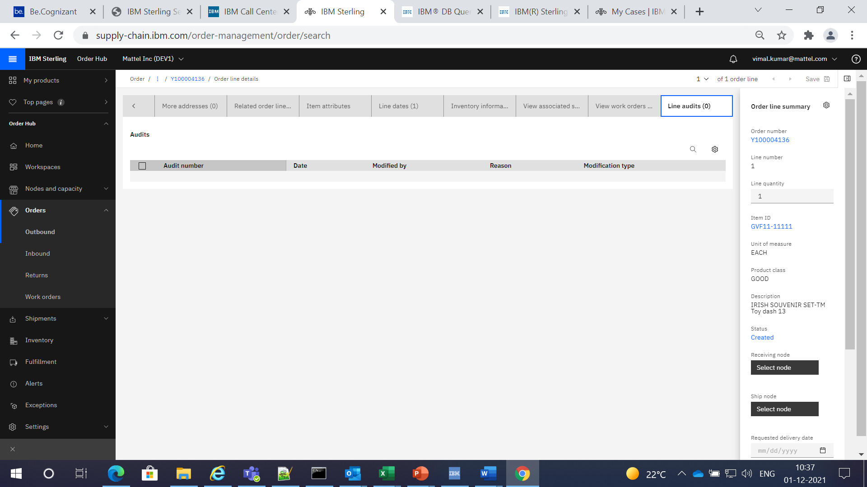

Step 3: Login to Call Center and search the same order. Order details page is displayed below. Note that status of lines 1 and 2 show holds symbol.

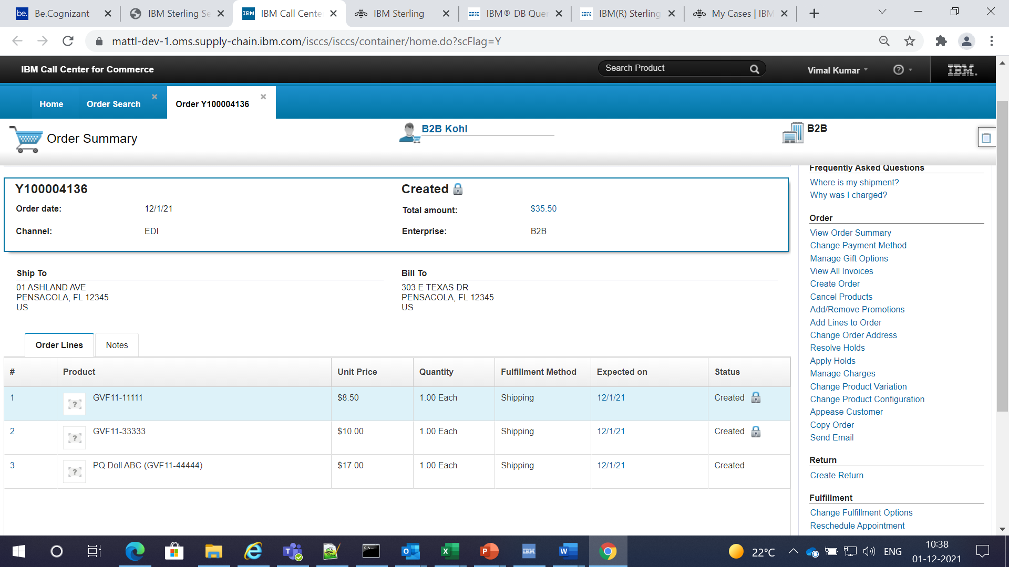

Selecting ‘Resolve Holds’ under Order from the right hand window pane above leads to page below. Page shows both order and line level holds and gives an option to resolve the line level holds.

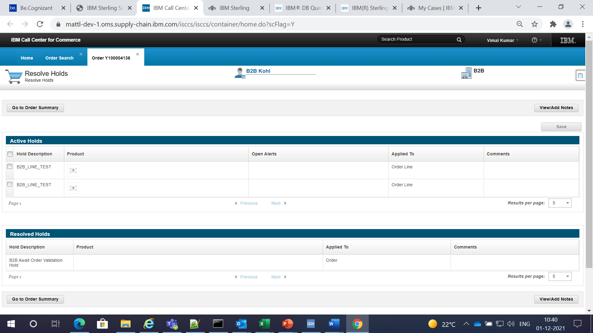

Select ‘Apply Holds’ option under Order. Following page comes up. It gives an option to add line level holds on the order.

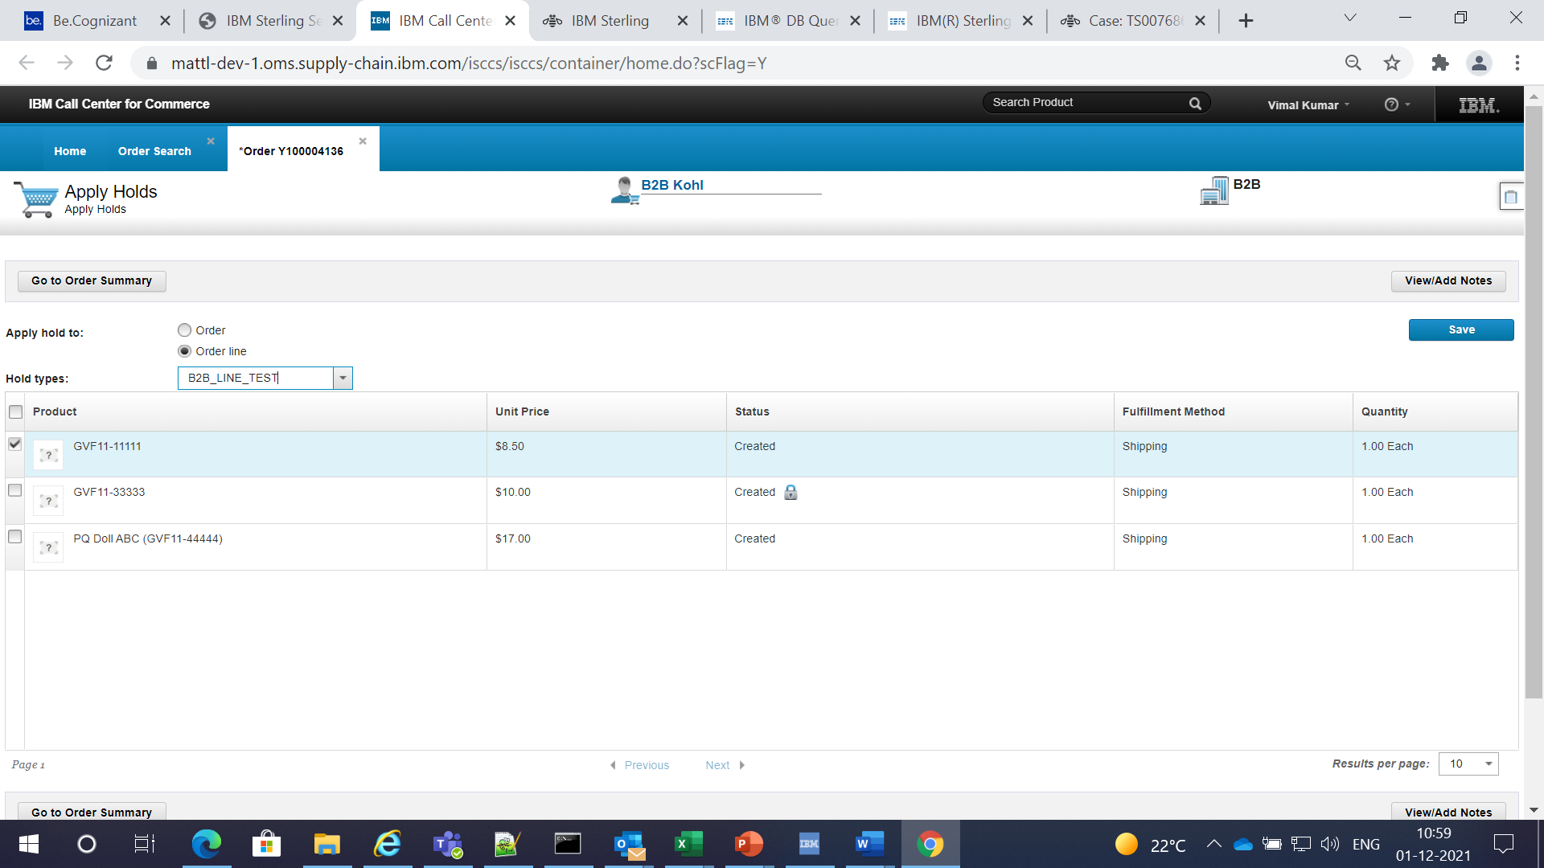

Step 4: Navigate to OrderHub. Orders->Outbound->Search outbound orders.

Under Search by Status, select Hold type and from the drop down, select ‘B2B_LINE_TEST’ hold type which is configured as line hold. Click on Search button.

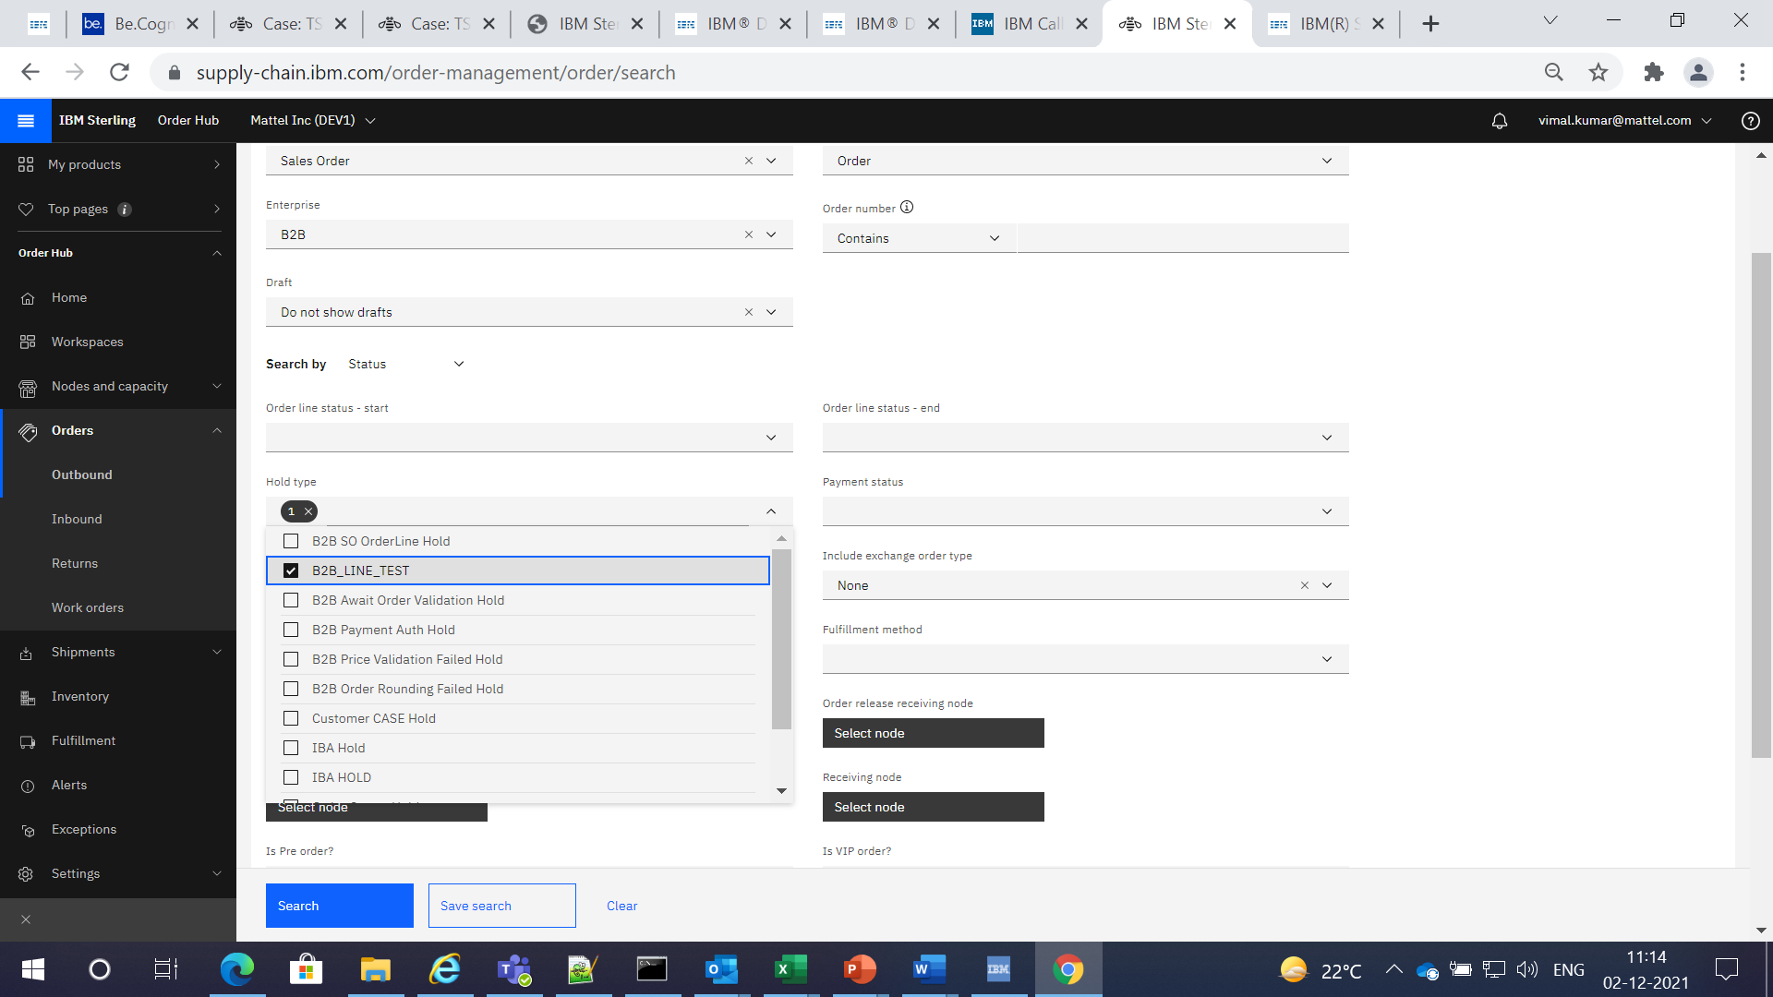

No orders are displayed which is the issue. There are many orders in DOMS with lines on ‘B2B_LINE_TEST’ hold.

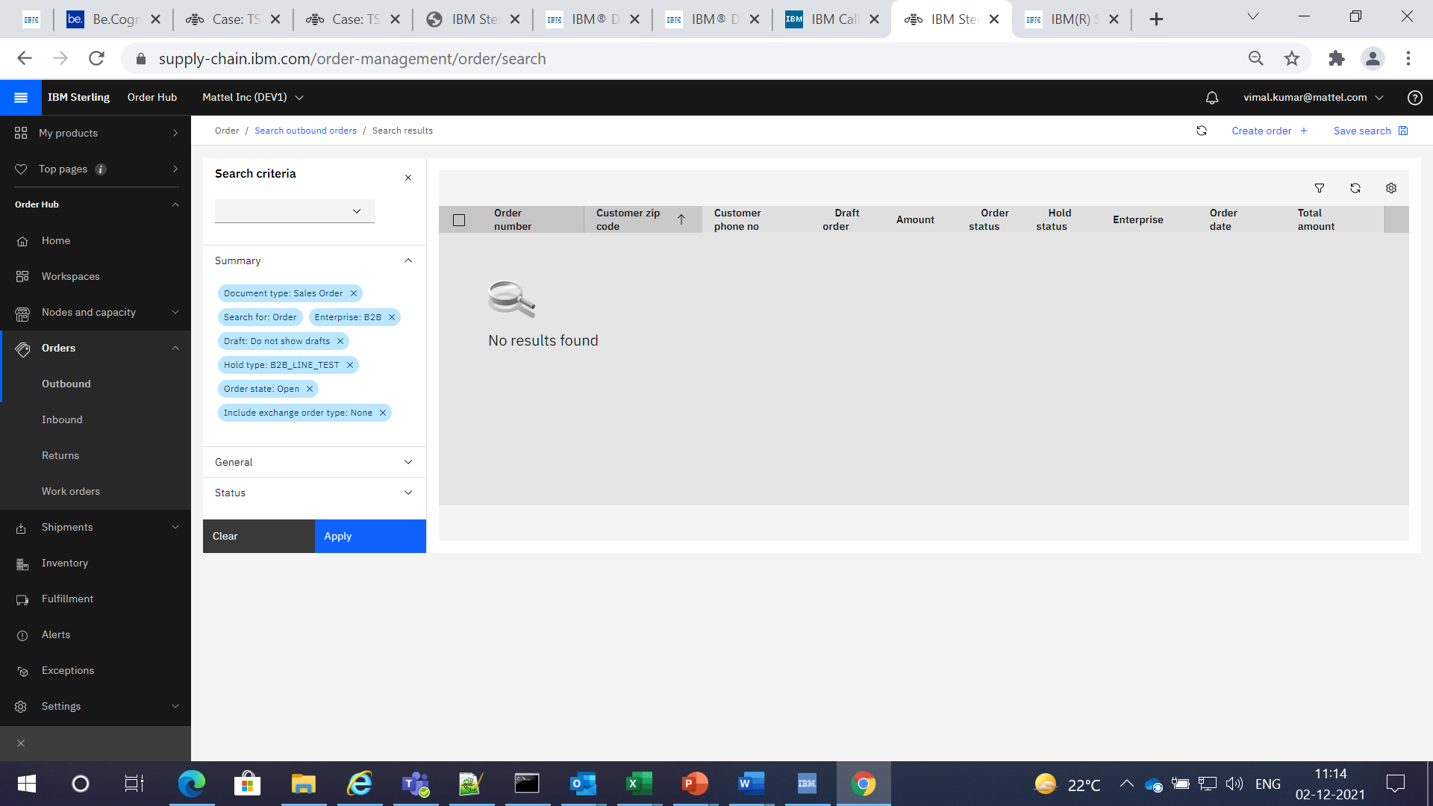

Step 5: Login to Call Center. Select Order Search console and enter Enterprise and select ‘B2B_LINE_TEST’ from Hold Types dropdown. Click on Search.

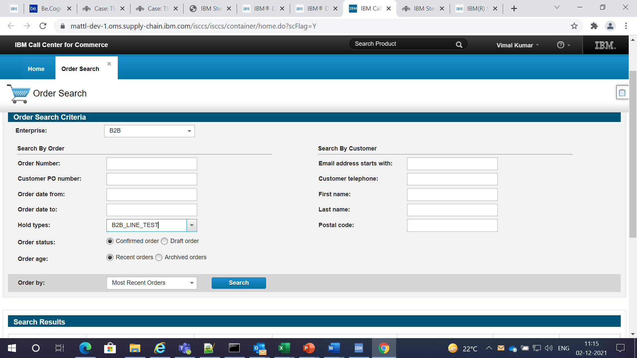

List of order with lines on ‘B2B_LINE_TEST’ hold are displayed.

