Login to DOMS application console and navigate to Create Order console as shown in snapshot below:

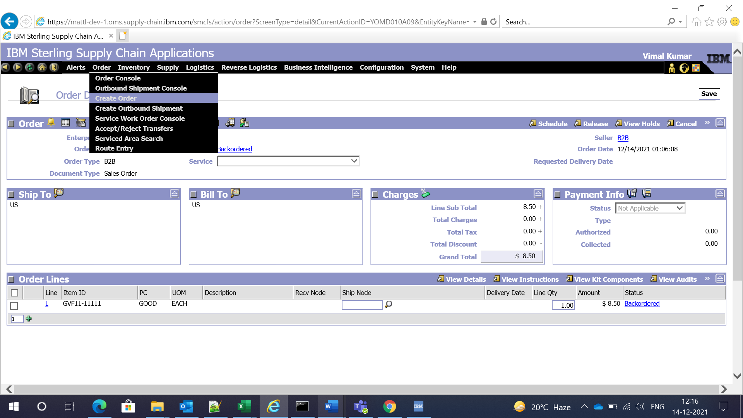

Enter details as shown below and click on Create Order link:

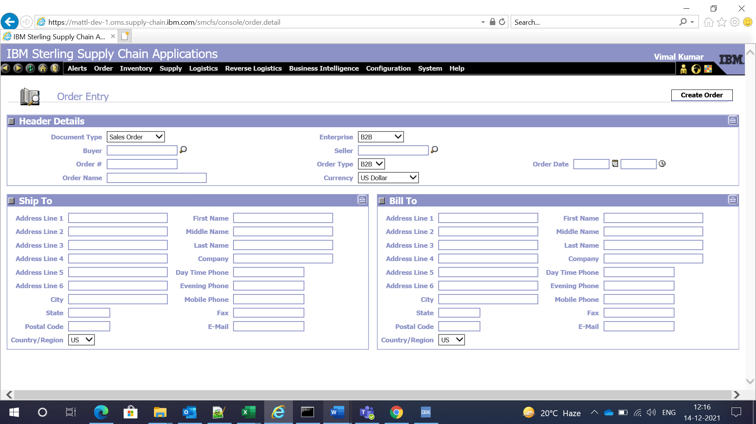

Navigate to More Attributes tab.

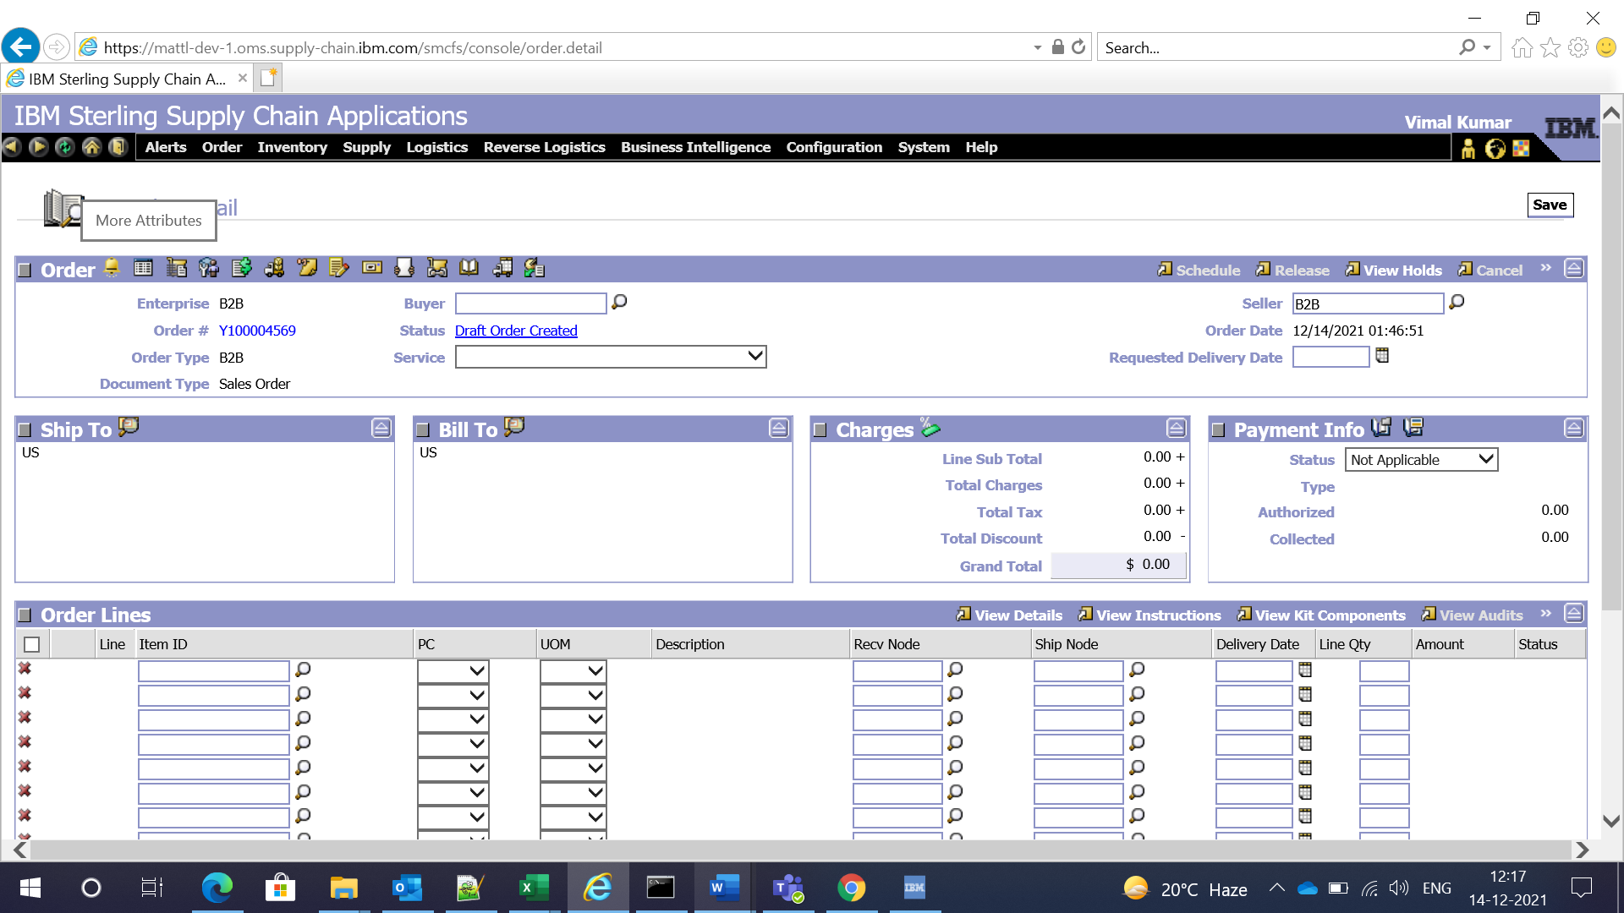

In this page, we can enter Customer PO # and Source. Auto Cancel Date is also available but it is not editable. Click on Save button.

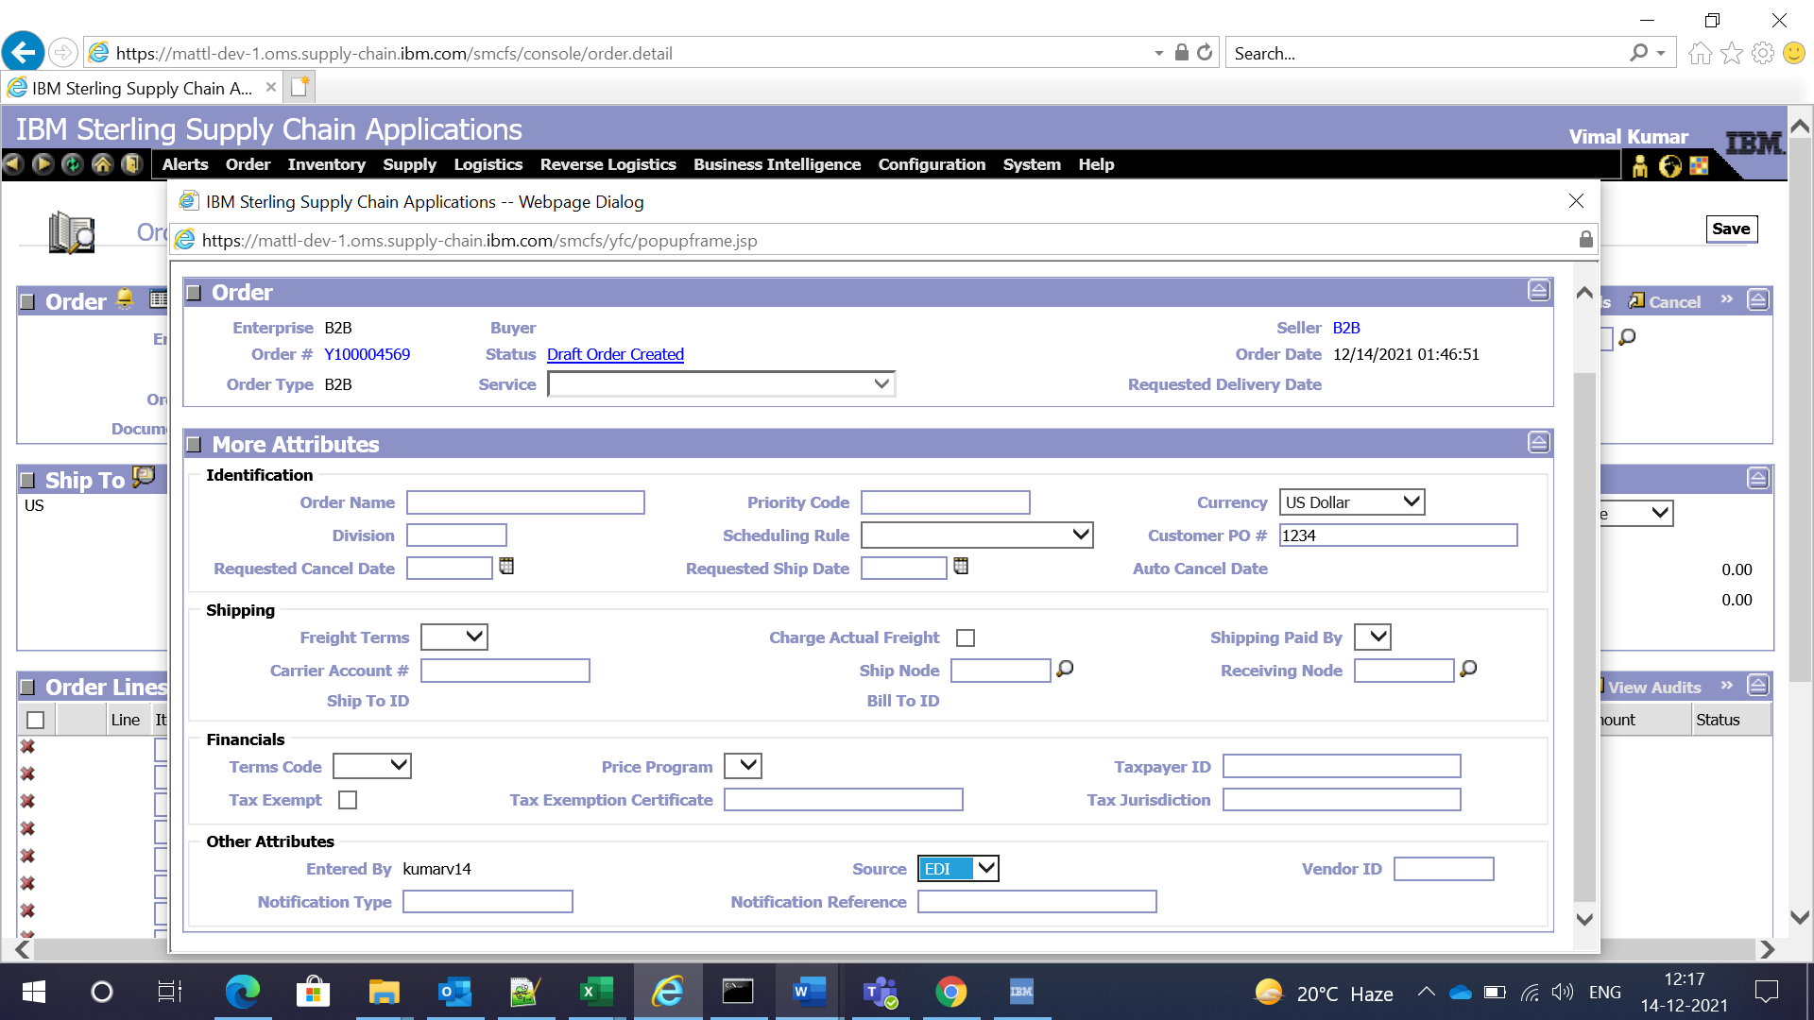

Enter order line details and click on Save:

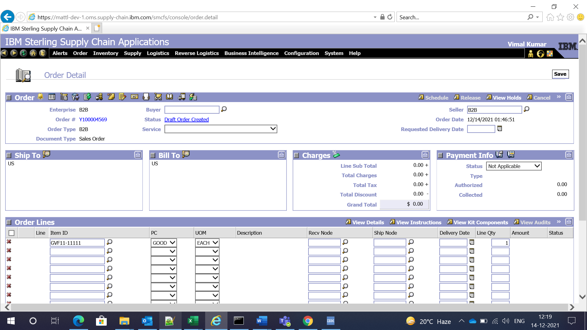

Go to order line details. Page gives option to enter Requested Ship Date. Click on Save button.

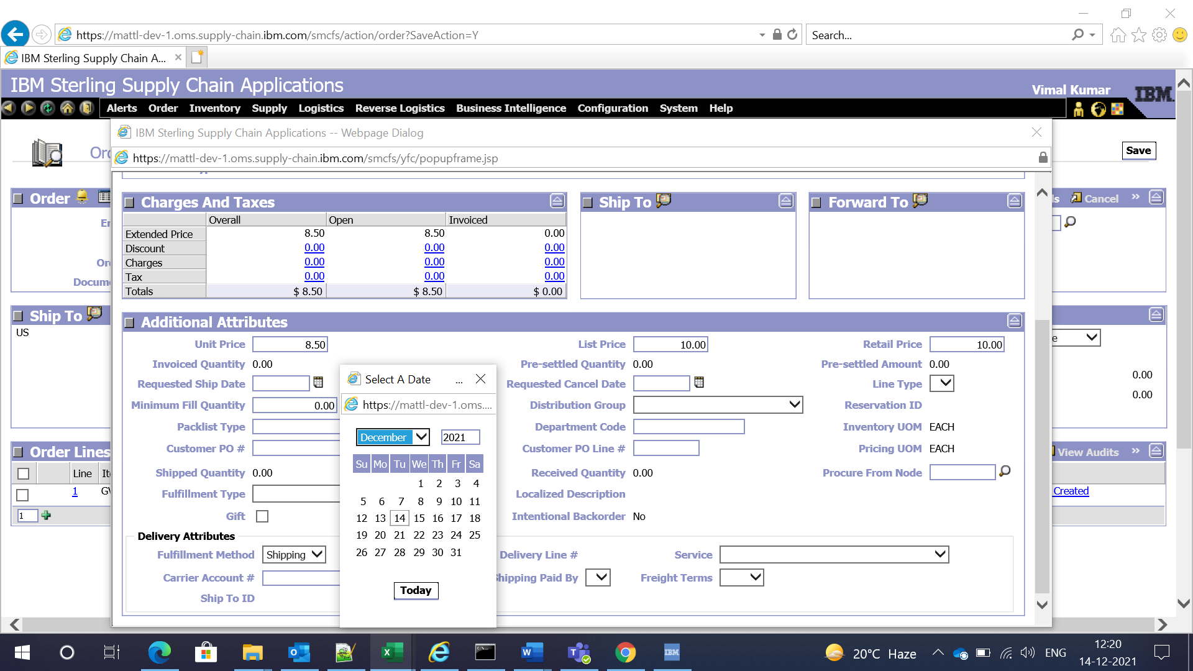

Entered data is save properly as shown in yfs_order_header and yfs_order_line snapshots below:

