Use Case. How to get from Node exception to Node’s order list?
- A node threshold alert is generated or the user spots a low performing node in his/her workspace
- User investigates the node as part of research and double click
- User wants to see the orders in WIP at the node, so when the user contacts the Node he/she can provide the list and age of pending orders, aka evidence of the late orders.
1 | 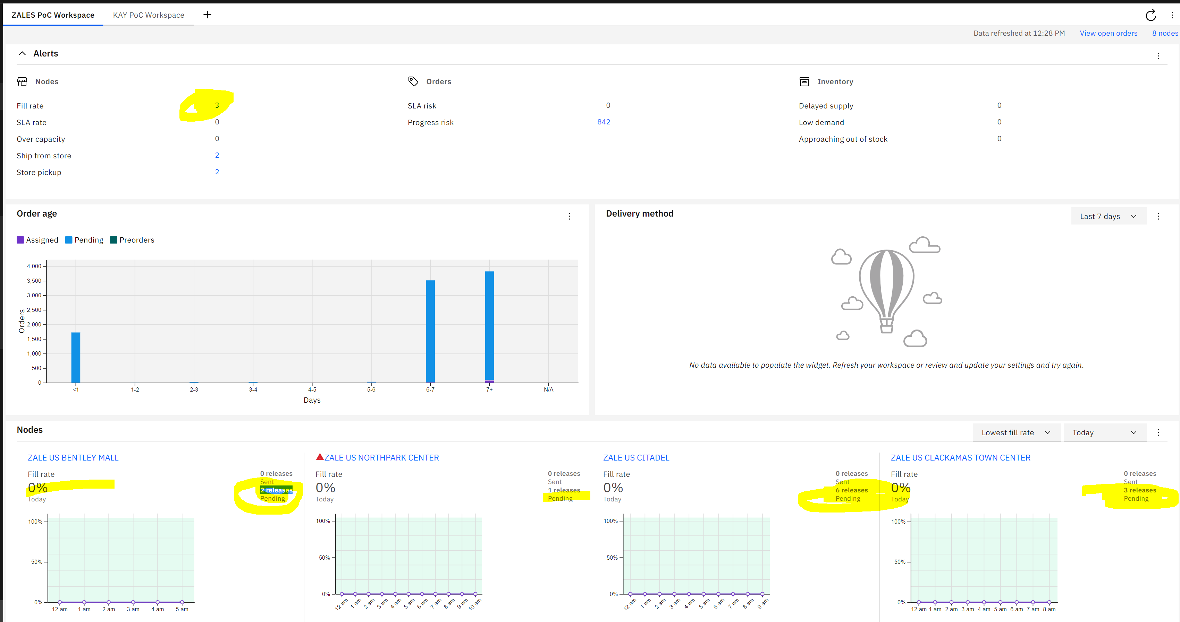
2 | 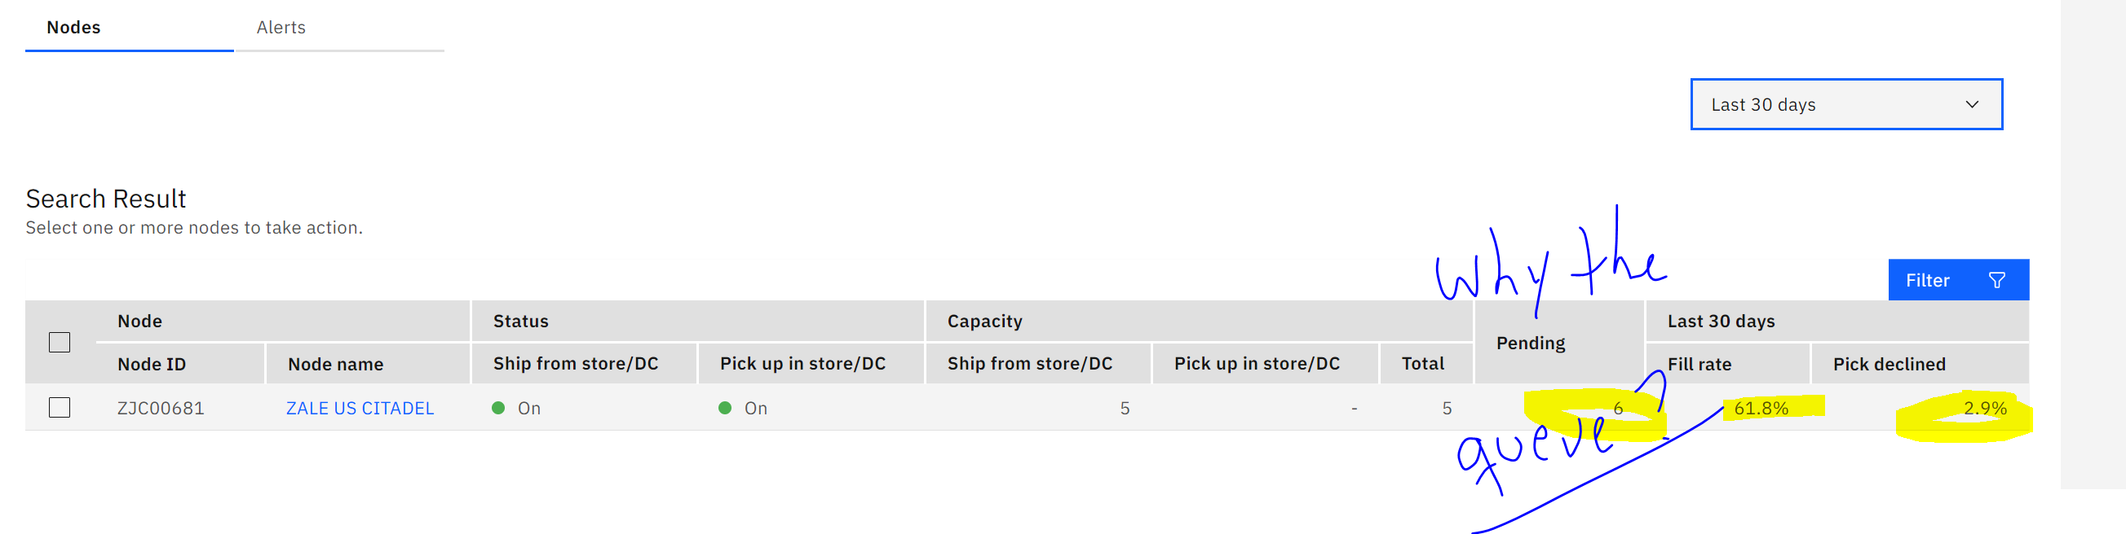
2 | 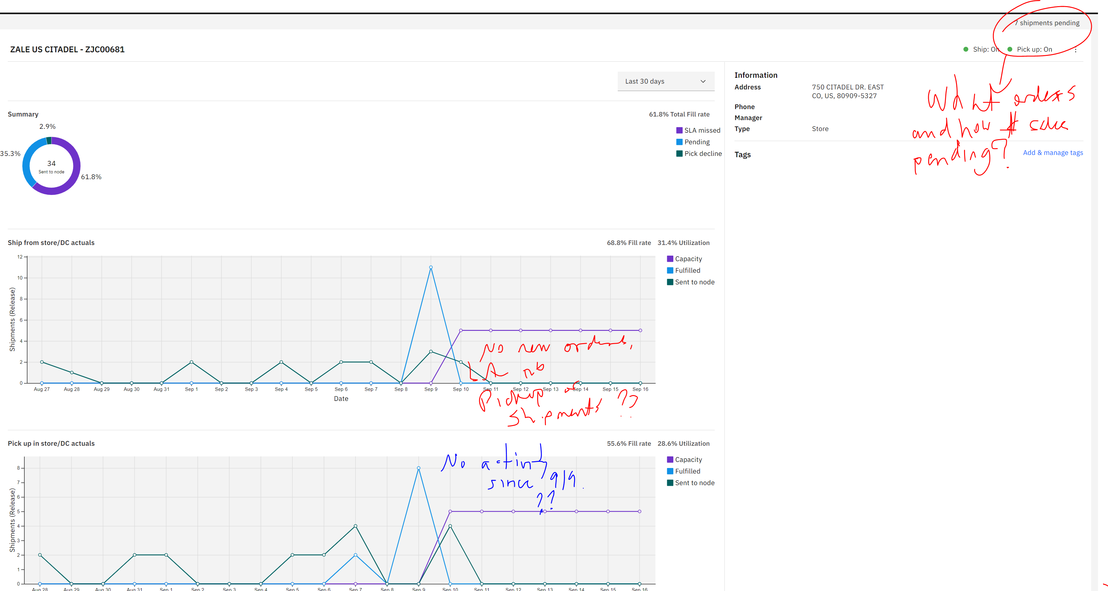
3 | Obtain the order list so I can see their age and their $ when I reach out to the Store to check on their delays.

