Use Case. How to group/sort/filter order alerts by Node?
- A number of order alerts are generated for a Workspace that has several hundred nodes assigned.
- User wants to take action for which he/she needs to
  - 1) Identify orders by age/priority
  - 2) Identify which stores have the most alerts
- User wants to reach out to Stores to remind (or alert them) of the orders they have on Alert.
Note, the user does not have a means to see Node’s orders either, per Case # TS004219190

 | 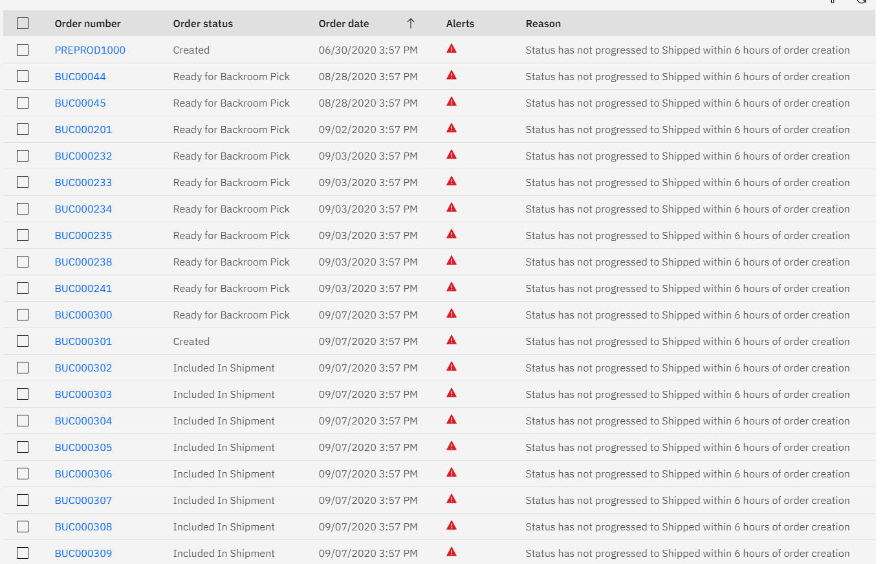 | 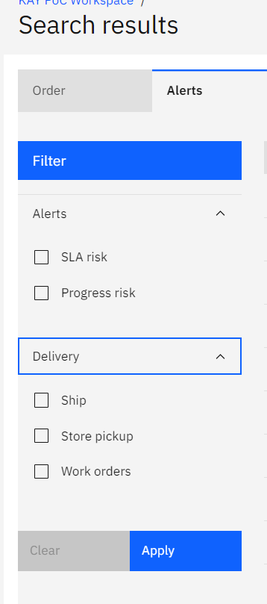
2

