# PEM Provisioner – UI Activity Monitoring Enhancements

## Summary Screen Elimination:

1. Eliminate this screen as it provides little value

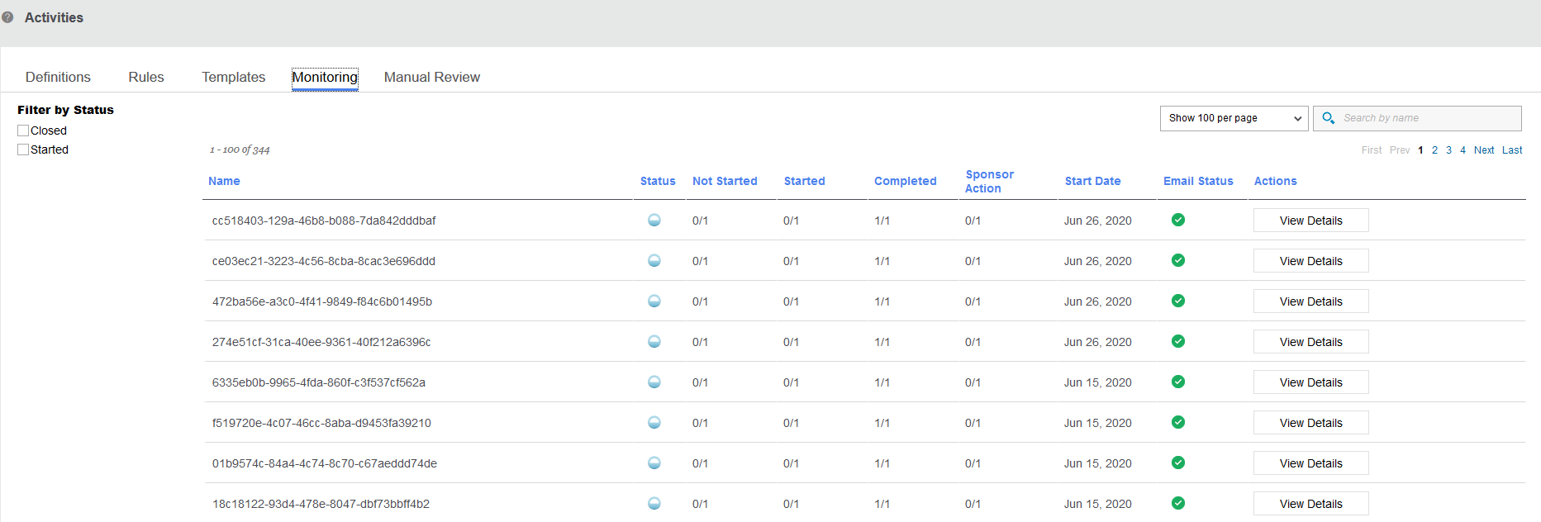

## Participant Activity Progress Screen Changes:

1. Pull the Overview components (Start Date, Description, Activity Definition) down into the progress statistics section and make this be the main monitoring screen for all activities.
2. Add filter options on this screen
3. For errored instances, allow option to go directly to error under View Details (instead of having to step through tasks)
4. Expand search options past participant name
5. Enable filterable report exports of monitoring details

See mockup below:

