# PEM Portal – UI Activity Monitoring Enhancements

## Summary Screen Changes (Partner Rollouts):

1. Show count of errored instances
2. Show count of delayed instances
3. Enable filterable report exports of monitoring details

See mockup below:

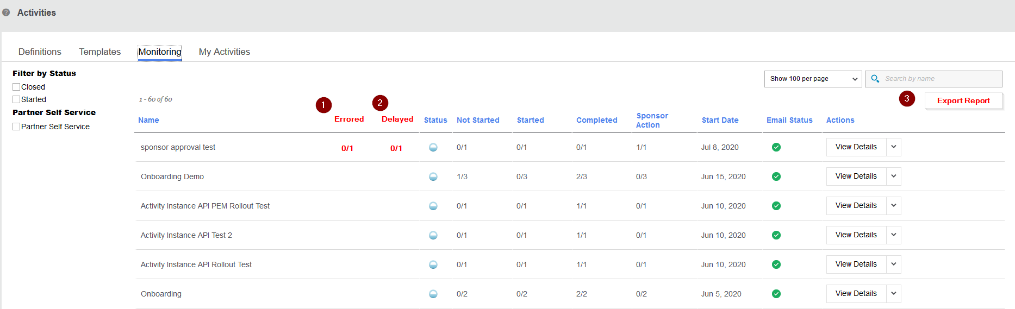

## Summary Screen Changes (Partner Self-Service):

1. Consolidate multiple instances of the **same** self-service activity to track under one summary line
2. Add Name Search
3. Show count of errored instances
4. Enable filterable report exports of monitoring details

See mockup below:

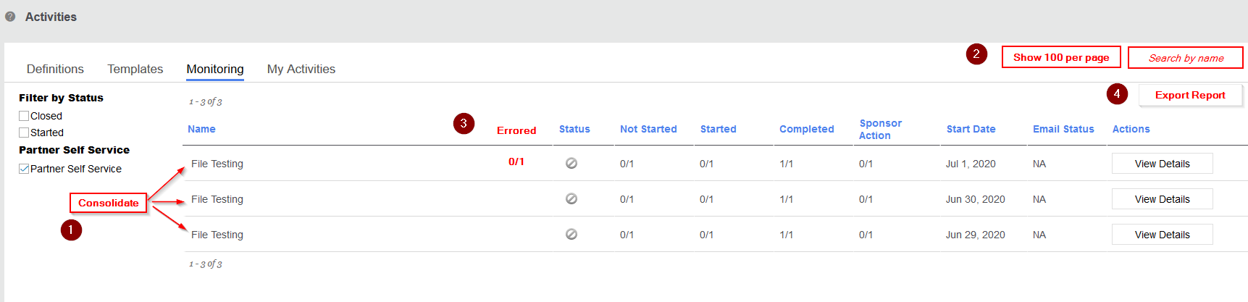

## Participant Activity Progress Screen Changes:

1. Show count of errored instances at top
2. For errored instances, allow option to go directly to error under View Details (instead of stepping having to step through tasks)
3. Expand search options past participant name
4. Enable filterable report exports of monitoring details
5. Allow sponsor to send alerts for more than one partner at a time

See mockup below:

