User rights within the management console

The problem is when using the management console you don’t uses your own rights to connect to a launcher. This will be showed in the following example.

# Environment

##### Host

[root@oqsoel15074 wtx]# uname -a

Linux oqsoel15074.ont.belastingdienst.nl 3.10.0-1062.12.1.el7.x86_64 #1 SMP Thu Dec 12 06:44:49 EST 2019 x86_64 x86_64 x86_64 GNU/Linux

##### Users

[root@oqsoel15074 ~]# id wtx

uid=58005(wtx) gid=58005(wtx) groups=58005(wtx)

[root@oqsoel15074 wtx]# id user1

uid=59898(user1) gid=59899(user1) groups=59899(user1),58005(wtx)

[root@oqsoel15074 wtx]# id user2

uid=59899(user2) gid=59900(user2) groups=59900(user2),58005(wtx)

##### ITX software

ITX v10.0.0.0

# Configuration

## Create launcher

I created a launcher on a Lunix system. To connect to this launcher I used the following command:

[wtx@oqsoel15074 wtx]$ . /opt/wtx/itx-10.0.0.0/setup

DTX_HOME_DIR (IBM Transformation Extender Home Directory):

/opt/wtx/itx-10.0.0.0

DTX_TMP_DIR (IBM Transformation Extender Temp Directory):

/opt/wtx/itx-10.0.0.0/tmp

LD_LIBRARY_PATH:

/opt/wtx/itx-10.0.0.0/libs:/opt/wtx/itx-10.0.0.0/GSKit/lib64:/opt/wtx/itx-10.0.0.0/java/bin:/opt/wtx/itx-10.0.0.0/java/bin/classic:/opt/wtx/itx-10.0.0.0/java/lib/amd64:/opt/wtx/itx-10.0.0.0/java/lib/amd64/classic::/opt/mqm/lib64:/opt/wtx/itx-10.0.0.0/unixODBC/linux/lib

PATH::

/opt/wtx/itx-10.0.0.0/bin:/opt/wtx/itx-10.0.0.0/GSKit/bin:/opt/wtx/itx-10.0.0.0/java/bin:/usr/local/bin:/bin:/usr/bin:/usr/local/sbin:/usr/sbin:/sbin:/opt/wtx/bin

[wtx@oqsoel15074 wtx]$ launcheradmin.sh -auto -separate -mrc /opt/wtx/itx-10.0.0.0/config/resource.mrc -ini /opt/wtx/itx-10.0.0.0/config/dtx.ini -lport 5015 -prange 7000:7299 -firewall enable -fsport 4638 -fcport 4639

===================================================================================

IBM Utility : launcheradmin (Launcher Administration command line utility)

Version : 10.0.0.0(51)

StartTime : Thu Mar 05 07:54:14 CET 2020

The new settings have been saved successfully.

===================================================================================

[wtx@oqsoel15074 wtx]$ launcheradmin.sh -adduser "user:wtx;login:wtx;pwd:password;access:gss,gpr,gm"

===================================================================================

IBM Utility : launcheradmin (Launcher Administration command line utility)

Version : 10.0.0.0(51)

StartTime : Thu Mar 05 07:55:54 CET 2020

The new settings have been saved successfully.

===================================================================================

[wtx@oqsoel15074 wtx]$ launcher.sh -start

Successfully started Launcher

# Configure management console

Add launcher with wtx user

[wtx@oqsoel15074 wtx]$ mgmtconsole.sh -add "name:launcher1;host:localhost;port:5015;login:wtx;pwd:password"

====================================================================================

IBM Utility : mgmtconsole (Management Console command line utility)

Version : 10.0.0.0(51)

StartTime : Thu Mar 05 07:57:59 CET 2020

The new settings have been saved successfully.

===================================================================================

Now I can start the management console, with the wtx user and its rights for launcher1

[wtx@oqsoel15074 wtx]$ mgmtconsole.sh

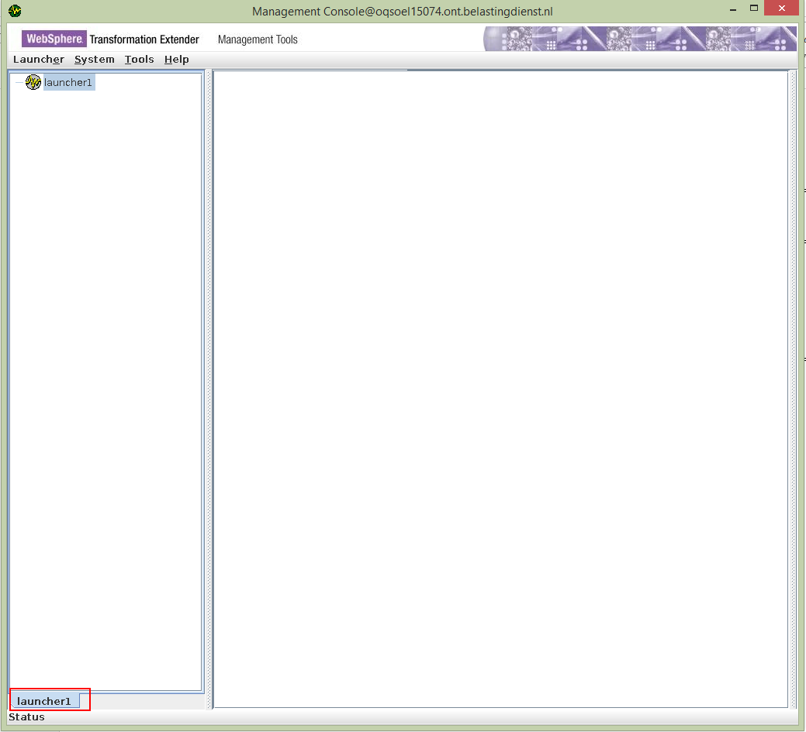

I can connect to the Launcher

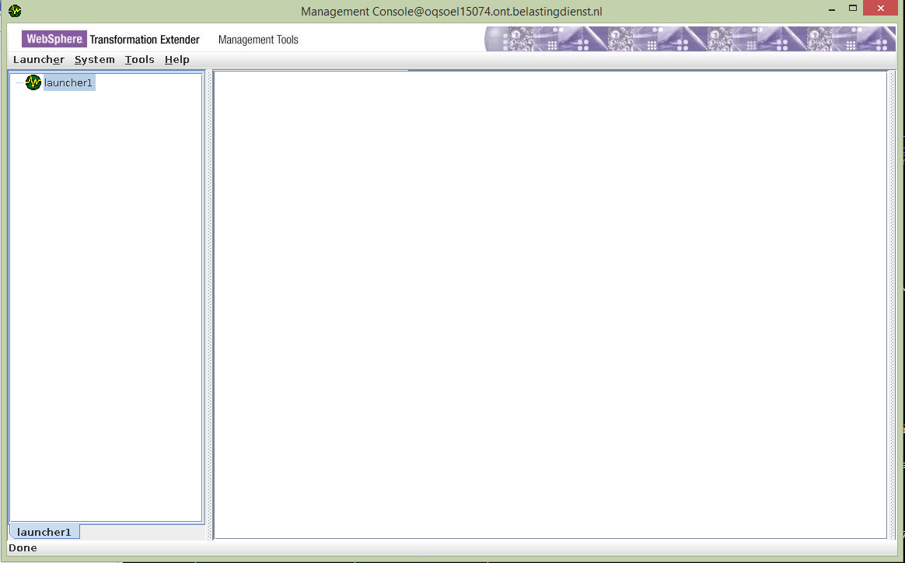

# Test

If I login as user1 and start the management console, I see:

[user1@oqsoel15074 ~]$ . /opt/wtx/itx-10.0.0.0/setup

DTX_HOME_DIR (IBM Transformation Extender Home Directory):

/opt/wtx/itx-10.0.0.0

DTX_TMP_DIR (IBM Transformation Extender Temp Directory):

/opt/wtx/itx-10.0.0.0/tmp

LD_LIBRARY_PATH:

/opt/wtx/itx-10.0.0.0/libs:/opt/wtx/itx-10.0.0.0/GSKit/lib64:/opt/wtx/itx-10.0.0.0/java/bin:/opt/wtx/itx-10.0.0.0/java/bin/classic:/opt/wtx/itx-10.0.0.0/java/lib/amd64:/opt/wtx/itx-10.0.0.0/java/lib/amd64/classic:/opt/wtx/itx-10.0.0.0/unixODBC/linux/lib

PATH::

/opt/wtx/itx-10.0.0.0/bin:/opt/wtx/itx-10.0.0.0/GSKit/bin:/opt/wtx/itx-10.0.0.0/java/bin:/usr/local/bin:/bin:/usr/bin:/usr/local/sbin:/usr/sbin:/sbin:/home/user1/.local/bin:/home/user1/bin

sed: couldn't open temporary file /opt/wtx/itx-10.0.0.0/libs/sedOYkiBv: Permission denied

sed: couldn't open temporary file /opt/wtx/itx-10.0.0.0/restapi/sedjV69qv: Permission denied

[user1@oqsoel15074 ~]$ mgmtconsole.sh



I can connect to the launcher without login. I use the rights (login from the wtx user) of the wtx user.

There will be nothing logged also, see command line:

[user1@oqsoel15074 ~]$ java.io.FileNotFoundException: /opt/wtx/itx-10.0.0.0/logs/MgmtConsolelog-2020-03-05-08-28-55_oqsoel15074.log (Permission denied)

at java.io.RandomAccessFile.open0(Native Method)

at java.io.RandomAccessFile.open(RandomAccessFile.java:333)

at java.io.RandomAccessFile.<init>(RandomAccessFile.java:257)

at java.io.RandomAccessFile.<init>(RandomAccessFile.java:135)

at com.ibm.websphere.dtx.util.Logger.<init>(Unknown Source)

at com.ibm.websphere.dtx.mgmtconsole.gui.Logger.<init>(Unknown Source)

at com.ibm.websphere.dtx.mgmtconsole.gui.MgmtConsoleControl.<init>(Unknown Source)

at com.ibm.websphere.dtx.mgmtconsole.gui.MercMgmtConsole.<init>(Unknown Source)

at com.ibm.websphere.dtx.mgmtconsole.gui.MercMgmtConsole.main(Unknown Source)

at com.ibm.websphere.dtx.mgmtconsole.gui.MercMgmtCmdConsole.main(Unknown Source)

That is not right!