Dashboard

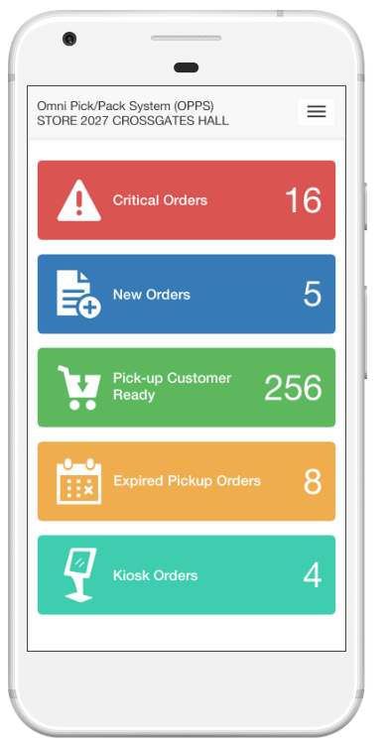

From main menu select ‘Search for Order’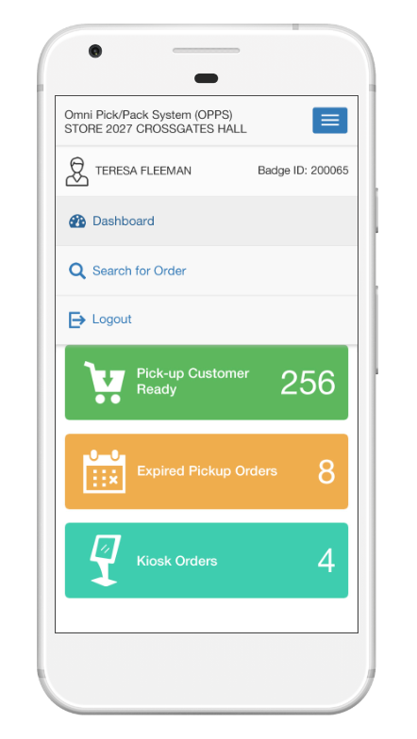

Select search by ‘Activity Date’

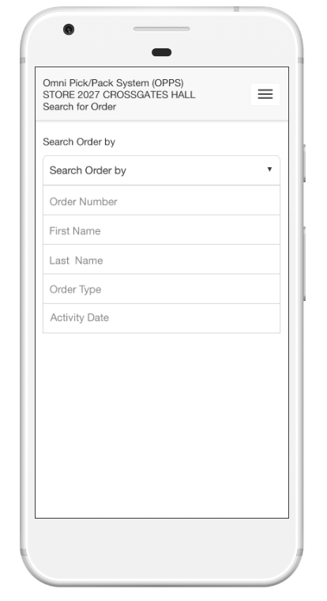

Select Activity Date:

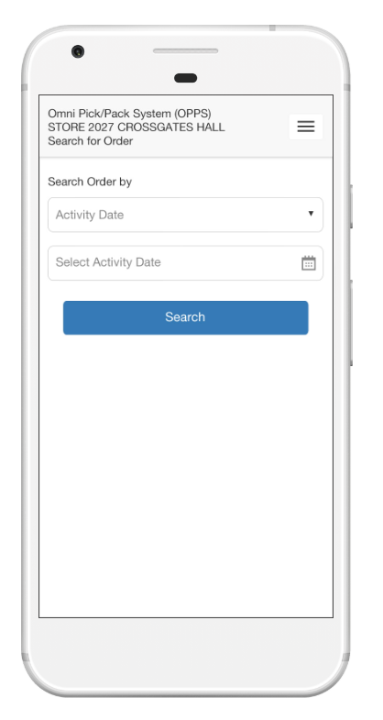

Select Activity date from Pop-up calendar

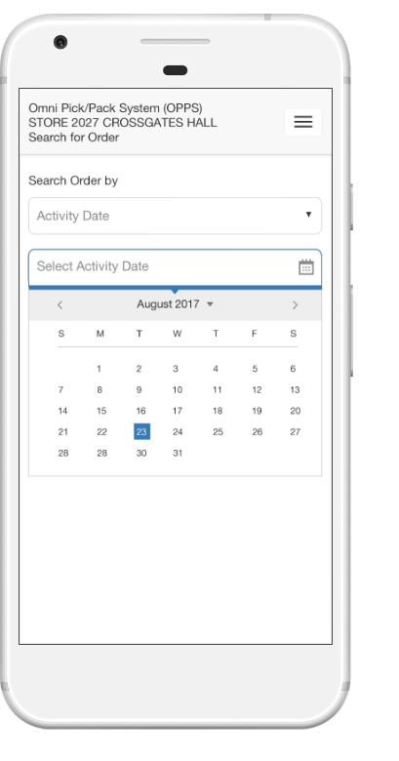

Click ‘Search’ button

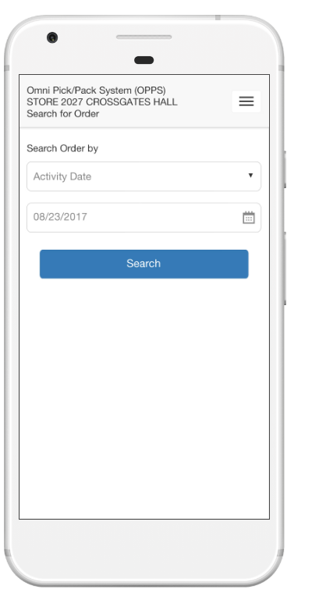

Display order list.

If order status in not packed or shipped – display checkbox on the left

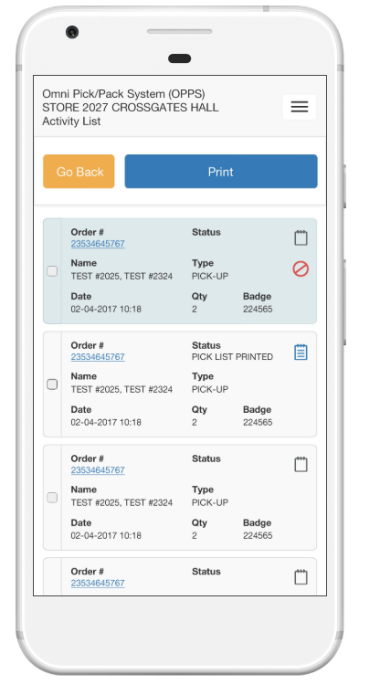

User can select one or more orders to print ‘pick list’ by selecting checkbox for a given order(s):

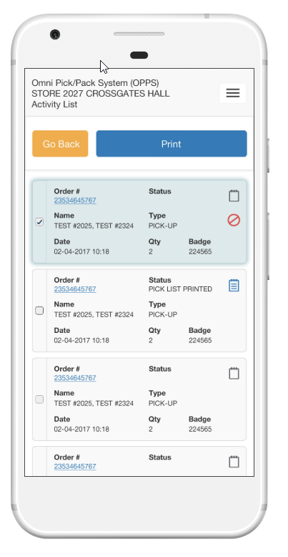

Click Print button on top – pick list for selected orders generated. This functionality will allow batch printing of pick list without asking user to go to order detail page

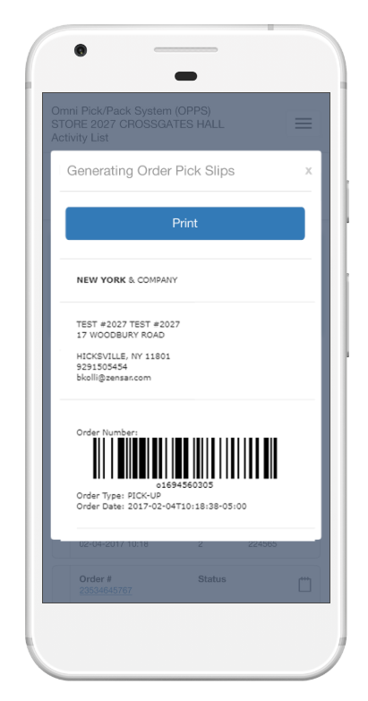

Click Print button on pop-up window will send data to a printer and close pop-up bringing user to the same list.

