**Problem Statement:** OMS to WCS RTAM Integration fails.

monitorItemAvailability API does not populate OrganizationCode as per OOB REALTIME_AVAILABILITY_CHANGE_LIST.xml which is breaking OMS to WCS RTAM Integration.

**Ref :** YFS_REALTIME_ATP_MONITOR.REALTIME_AVAILABILITY_CHANGE_LIST.xml

# System Stack

Sterling OMS version: V10

Java version: 1.8

**Configuration:**

We have verified on customer environment and OOB v10 environment to simulate this behavior for RTAM REALTIME_AVAILABILITY_CHANGE_LIST event with default OOB template.

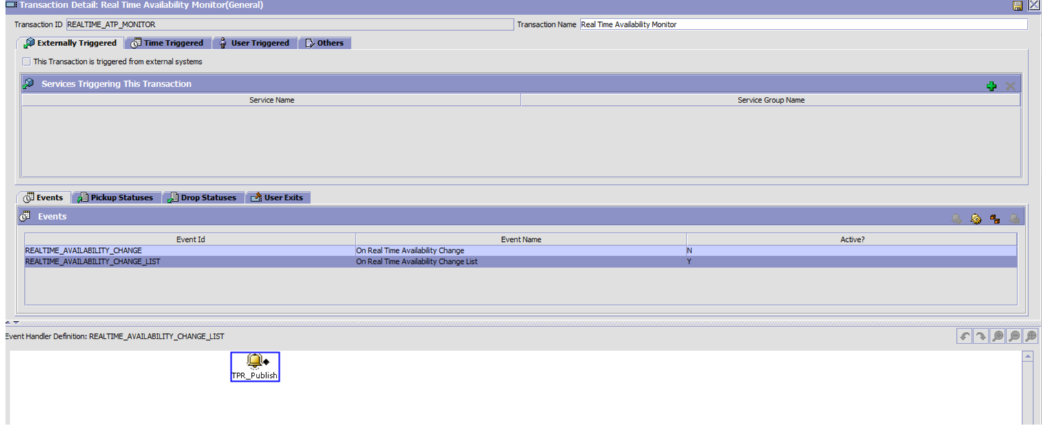

Sample OOB Event xml attached does not populate **OrganizationCode populated** in the event .xml

**OrganizationCode** attribute needs to be populated by the product since its not picked from YFS_INVENTORY_ITEM Table, even though there is data present in this table for given item.





**Solution:**

OOB RTAM REALTIME_AVAILABILITY_CHANGE_LIST event xml template needs to be updated to use **InventoryOrganizationCode** instead of **OrganizationCode then the product stamps the InventoryOrganizationCode which is used by SendAvailabilityChangeToSyncInventoryAvailability.xsl to facilitate information update necessary for WCS where InventoryOrganizationCode is mapped to StoreId on WCS**

Sample Event Template(RTAM REALTIME_AVAILABILITY_CHANGE_LIST.xml):

<InventoryItem ItemID="" **InventoryOrganizationCode=""** UnitOfMeasure="" ProductClass="">  
    <Item ItemGroupCode="" ItemID="" ItemKey="" OrganizationCode="" UnitOfMeasure=""/>  
    <AvailabilityChanges>  
        <AvailabilityChange OnhandAvailableQuantity="" OnhandAvailableDate="" FutureAvailableQuantity=""  
            FirstFutureAvailableDate="" FutureAvailableDate="" AlertQuantity="" AlertType="" AlertLevel="" AlertRaisedOn=""  
            MonitorOption="" AgentCriteriaId="" Node="">  
        </AvailabilityChange>  
    </AvailabilityChanges>  
</InventoryItem>

**Request Product to update the RTAM REALTIME_AVAILABILITY_CHANGE_LIST.xml template and the documentation.**