1. Create Order with 2 line item .
2. Only one item should have inventory . Other should not have .
3. Configure Scheduling rule as following :-    
   ​

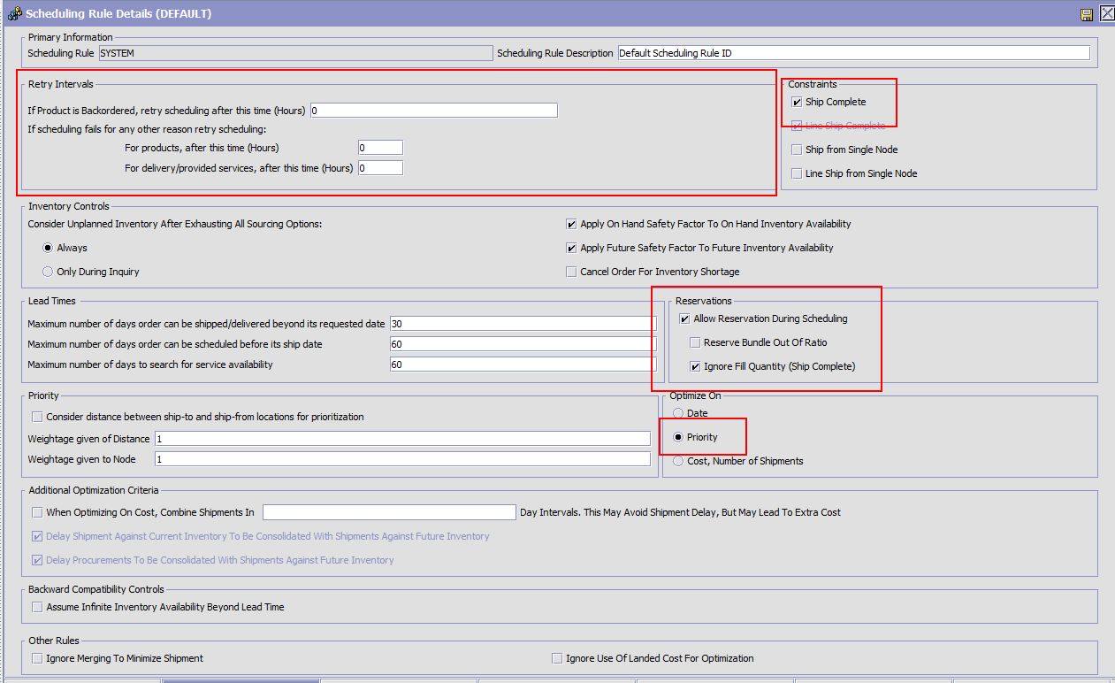

1. Schedule the Order One line item should move into reserve state and another one should get back ordered as following :-

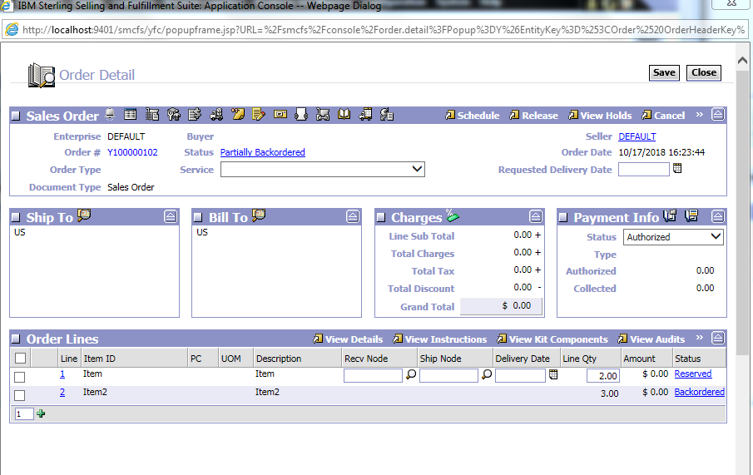

1. Try to schedule Order again and again every time new entry will be created against reserved line item :-
2. 