Response XML from ITXA

<?xml version="1.0" encoding="UTF-8"?>
<DeenvelopeJobs xmlns:xlink="http://www.w3.org/1999/xlink">
<DeenvelopeJob _id="ADMINIB-BOOBHOD:node1:4597339f-6b8b-4813-be67-e123af0b21d9" xlink:title="DeenvelopeJob(ADMINIB-BOOBHOD:node1:4597339f-6b8b-4813-be67-e123af0b21d9)" xlink:type="simple" xlink:href="http://localhost:9080/spe/svc/deenvelopejobs/ADMINIB-BOOBHOD&#37;3Anode1&#37;3A4597339f-6b8b-4813-be67-e123af0b21d9" state="Completed" startTime="2016-06-23T11:03:32.376-0400" endTime="2016-06-23T11:03:41.361-0400" id="ADMINIB-BOOBHOD:node1:4597339f-6b8b-4813-be67-e123af0b21d9">
<SPEResponse>
<Response AdvancedStatus="Resource X12-0: Transaction-Non-Compliant" Reason="-1" Report="Resource x12in-multi-bad.txt: Extracting EDIFACT interchanges...%0d
0 interchanges extracted%0d
Extracting TRADACOMS interchanges...%0d
0 interchanges extracted%0d
Extracting X12 interchanges...%0d
X12 between 0 and 869
1 interchanges extracted%0d
%0d
Resource X12-0: %0d
I0000 Interchange unique id: NoUniqueID%0d
I0001 Group index: 1, control number: 1%0d
I0002 Transaction index: 1, control number: 0001%0d
E0198 One or more segments in the transaction are in error.%0d
E0153 Mandatory segment missing at segment position 4, segment id &#39;PO1&#39;.%0d
%0d
Transaction [GROUP-1-123123123-456456456-850-0001] is non-compliant.

&lt;?xml version=&quot;1.0&quot; encoding=&quot;UTF-8&quot;?&gt;%0d
&lt;InterchangeComplianceReport&gt;%0d
&lt;Header warnings=&quot;0&quot; errors=&quot;0&quot;&gt;Compliance Report&lt;/Header&gt;%0d
&lt;Information&gt;%0d
&lt;ReportEntry code=&quot;528&quot; description=&quot;TA1 Data&quot; &gt;%0d
&lt;Info&gt;%0d
&lt;InfoEntry code=&quot;504&quot; description=&quot;Interchange Header Control Number&quot;&gt;000000001&lt;/InfoEntry&gt;%0d
&lt;InfoEntry code=&quot;508&quot; description=&quot;Interchange Date/Time&quot;&gt;Tue Jun 07 07:12:00 EDT 2011&lt;/InfoEntry&gt;%0d
&lt;InfoEntry code=&quot;503&quot; description=&quot;Interchange Receiver ID&quot;&gt;YOURCOMPANY&lt;/InfoEntry&gt;%0d
&lt;InfoEntry code=&quot;502&quot; description=&quot;Interchange Sender ID&quot;&gt;MYCOMPANY&lt;/InfoEntry&gt;%0d
&lt;InfoEntry code=&quot;553&quot; description=&quot;Interchange Envelope Name&quot;&gt;X12 Deenvelope Sample ISA IEA&lt;/InfoEntry&gt;%0d
&lt;InfoEntry code=&quot;529&quot; description=&quot;Interchange Ack Code&quot;&gt;A&lt;/InfoEntry&gt;%0d
&lt;InfoEntry code=&quot;530&quot; description=&quot;Interchange Note Code&quot;&gt;000&lt;/InfoEntry&gt;%0d
&lt;/Info&gt;%0d
&lt;/ReportEntry&gt;%0d
&lt;/Information&gt;%0d
&lt;GroupComplianceReport&gt;%0d
&lt;Header warnings=&quot;0&quot; errors=&quot;1&quot;&gt;Compliance Report&lt;/Header&gt;%0d
&lt;Information&gt;%0d
&lt;ReportEntry code=&quot;500&quot; description=&quot;Envelope Information&quot; &gt;%0d
&lt;Info&gt;%0d
&lt;InfoEntry code=&quot;510&quot; description=&quot;Group Application Sender ID&quot;&gt;123123123&lt;/InfoEntry&gt;%0d
&lt;InfoEntry code=&quot;511&quot; description=&quot;Group Application Receiver ID&quot;&gt;456456456&lt;/InfoEntry&gt;%0d
&lt;InfoEntry code=&quot;512&quot; description=&quot;Group Functional ID Code&quot;&gt;PO&lt;/InfoEntry&gt;%0d
&lt;InfoEntry code=&quot;509&quot; description=&quot;Group Version Release ID&quot;&gt;006010&lt;/InfoEntry&gt;%0d
&lt;InfoEntry code=&quot;517&quot; description=&quot;Group Date/Time&quot;&gt;Tue Jun 07 07:12:00 EDT 2011&lt;/InfoEntry&gt;%0d
&lt;InfoEntry code=&quot;513&quot; description=&quot;Group Header Control Number&quot;&gt;1&lt;/InfoEntry&gt;%0d
&lt;InfoEntry code=&quot;515&quot; description=&quot;Group Number Of Transactions Reported&quot;&gt;2&lt;/InfoEntry&gt;%0d
&lt;InfoEntry code=&quot;516&quot; description=&quot;Group Number Of Transactions Actual&quot;&gt;2&lt;/InfoEntry&gt;%0d

This is not the complete XML. This is shown for illustration

Current rendering in PEM that is possible today:
This is for the XML response that is displayed

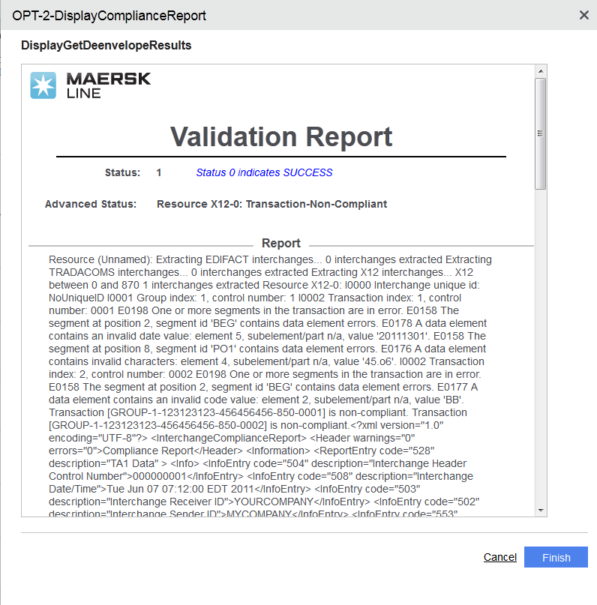

What we would like to see rendered. This is a mockup and not possible in PEM today
The display can be further enhanced with XSLT to replace &quot; with “

